|  |  |
| --- | --- |
|  | **FPT ACADEMY INTERNATIONAL**  **FPT – APTECH COMPUTER EDUCATION** |

**Centre Name: ACE-HCMC-2-FPT.**

**Address: 590 Cach Mang Thang 8, District 3, Ho Chi Minh City, Viet Nam.**

AskMeMobile Ltd

|  |  |  |
| --- | --- | --- |
| **Supervisor.** | Phạm Thị Lánh | |
| **Batch.** | T1.2006.M1 | |
| **Group.** | Group 3 | |
| **Serial No.** | **Enrolment Number** | **Student Name** |
| 1. | Student1269828 | Lương Xuân Phát |
| 2. | Student1269332 | Phạm Trọng Nghĩa |
| 3. | Student1268779 | Lê Nguyên Triều |

September 2020

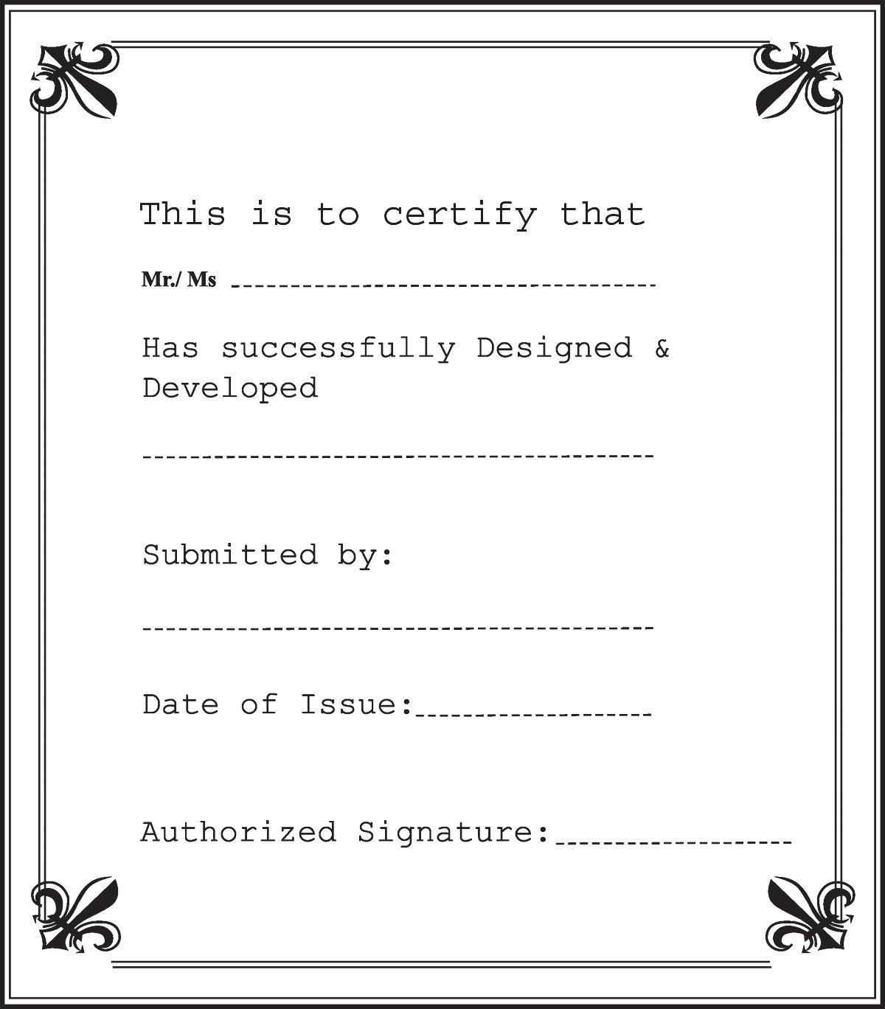

**Contents**

1. ACKNOWLEDGEMENT 5
2. SYNOPSIS 6
3. REVIEW 1 7
   1. REQUIREMENT SPECIFICATION 8
   2. PROBLEM DEFINITION 9
   3. CUSTOMERS REQUIREMENT SPECIFICATION (CRS) 9
   4. ARCHITECTURE & DESIGN OF THE SYSTEM 12
   5. SITEMAP 13
   6. WEBSITE LAYOUT 14
      1. HOMEPAGE 14
      2. CONTACT US 16
   7. TASK SHEET 1 18
4. REVIEW 2 19
5. PROJECT SNAPSHOTS 20
   1. Home Page 20
   2. Product details Page 21
   3. Contact Us: 22
   4. Footer 23
6. SOURCE CODE WITH COMMENT 23
7. USER MANUAL 25
   1. System Requirements 25
   2. Step by Step Instructions 25
      1. Starting Home Page: 25
      2. Using Search bars & Dropdown menu 26
      3. Browsing Products Gallery 28
      4. Product Details Page: 29
      5. CTA Buttons – Compare & Download 31
      6. CTA Buttons – Miscellaneous 32
      7. Contact Us 33
      8. Contact Us – Email & Geolocation 33
      9. Footer 34
8. DEVELOPER’S GUIDE 35
   1. Home page 35
      1. Bootstrap layout 35
      2. Logo Animation 37
   2. Top Nav Bar 39
      1. Hamburger Menu 39
      2. Navbar Auto hide on scroll 42
   3. Side Panel / Side navbar 43
      1. Search Bar & Searching Algorithm 43
      2. Drop Down Menus 47
      3. Side Panel Responsiveness on smaller screen 51
   4. Home Page - Hero Banner 52
      1. Header Text Animation 52
      2. Changing Background Image Animation 55
   5. Home Page - Main Section 57
      1. Main Section – Owl Carousel 57
      2. Main Section – Gallery with filter buttons 61
      3. Main Section - Compare & Download Modals 63
   6. Side Panel Call To Action Modals 69
   7. Product Details Page 72
      1. Youtube embedded promotional videos 72
      2. Product detail section 74
      3. Rating page 76
   8. Contact Us Page 79
      1. Contact Us - Hero Banner 79
      2. Contact Us – Feedback & Inquiries 81
      3. Contact Us – Geolocation/Google Map 84
   9. Footer 85
      1. Footer – Bootstrap Layout 85
      2. Footer – Lightbox Gallery 88
   10. Miscellaneous CSS/Animation Modules 92
       1. Hover.css by Ian Lunn 92
       2. Pin Construction Animation by Nikolay Talanov 93
9. TASK SHEET 2 94
10. CHECKLIST VALIDATION 95
11. REFERENCES 96

# 1 ACKNOWLEDGEMENT

The world is a better place thanks to people who want to develop and lead others. What makes it even better are people who share the gift of their time to mentor future leaders. We would like to acknowledge all those who have given us their support and knowledge sharing in the making of this project.

We wish to express our gratitude to the e-Project Team at the Head Office in India, who provided us with guidance and instructions. We would like to thank all the staff members at the Center in India for providing us the opportunity to work on this project and offering us their upmost encouragement through out the process.

We would like to express our special thanks of gratitude to our instructor, Mrs. Pham Thi Lanh at the Aptech Computer Education HCMC for her able guidance and support in completing our project. We would also like to extend our gratitude to the staff at the Aptech HCMC office for providing us with all the facility that was required.

Our acknowledgement to several people whom also helped with: the collections of pictures samples, CSS & JS libraries, the preparation of web development, sample code snippets and tutorials and they are all thanked for their contributions. Special mentions goes to the contributors of Bootstrap 4, the contributors and admins for tutorials sites such as W3C school, Tutorialspoint.com, GeeksforGeeks, and many other learning sites.

And Lastly, to our many friends and family, you should know that your support and encouragement was worth more than we can express on paper. Thank you to our moms and dads for breakfasts, lunch and dinners – we could not have finished the project without being provided with love and daily nourishments.

# SYNOPSIS

ASKME Ltd. Is a Multi National Company providing Information services to General People they have been providing information to people through Telephone calls which could include anything from Pin to Piano. Their major source of income comes from informing the customers about those products first for which ASKME is getting paid for.

The BOD’s in their annual general meeting proposed that they should launch a website by the name CELLINFO.com where the user will get all the information about the various cell phones available in the market of any brand on a click of a Button.

You are supposed to create a website for them with the below mentioned requirement specifications:

The website is to be developed to provide certain features according to specific requirements by the management.

The website is to be developed for the Windows Platform using HTML5, JavaScript and Geolocation. The site should work well in all leading browsers including Chrome, IE, Firefox etc.

# REVIEW 1

## REQUIREMENT SPECIFICATION

#### The Website CELLINFO.com is to be created based on the following requirements:

1. The Home Page should be neatly created with proper logo, menu and images.
2. A Menu should be created which would categorize all the information about the features provided in the Site For e.g. a Menu for Various Cell phones, a Menu for Features of Cell phones etc. etc. something like that.
3. The information should be categorized according to the Brand names of Mobiles like if a User wants to see only Nokia Phones then he click on Some Nokia Link/button and he will see only That Brand phones and so on.
4. A Brief summary of features of Individual phones should be displayed on the Web Page along with the Cell phone but detailed Features should be stored in Individual Word documents which can be downloaded or viewed by the User who wishes to see the same.
5. A Comparison Web Page should also be there where there is Phone comparisons done with various models of same brand or various models of various brands.

* The Comparison information should be provided in Tabular format comparing the features of different phones.
* This information would be for 5 Phones of similar brands and 2 phones of different brands for 1 month and then it will change so for the time being the Page should handle the above requirement.

1. The Colour Schemes should be soothing, more of Pastel Colours can be chosen for the same.
2. When a particular brand phones are being displayed the background image of the Web page should show the Logo of that brand for e.g. if Nokia Phones are being displayed then that page should have the Logo of NOKIA as the background image and the same in case of other Brands.
3. There should be a “Contact Us” page which will have the Address of the Company and the mail address which when clicked will invoke the local mail client from where they can send an email. Address of the Company should be displayed using GeoLocation API (eg. GoogleMaps)
4. The information on the mobile phones and all can be picked up from the Sites of Nokia, Samsung etc.
5. To avoid creation of html pages you can make use of layers, flash buttons and other components of Dreamweaver for creation of pages.
6. The appearance and organization of the site will carry more chances of your selection for getting the contract so both the factors are important to be considered.

## PROBLEM DEFINITION

After analyzing the Queries coming in form various Customers mostly are related to information regarding Cell phones which could be one or all of the follow

1. What is the Cell Phone Model Number with XYZ features?
2. What are the Features in XYZ cell?
3. What is the current price of the XYZ cell phone?
4. How is XYZ cell phone Different from ABC phone?
5. What is the approximate price of XYZ phone? And many more…

As you can see there are a lot of queries which cannot be answered online or would be very difficult for the Call executive to explain the entire features of the product which again would consume a lot of Call time of the executives as well.

Our Website should be able to solve this problem by providing an alternative mean for customers to seek out information at their own pace. The website will be referred to as self- serviced website for informational guidance and comparisons.

## CUSTOMERS REQUIREMENT SPECIFICATION (CRS)

* + 1. **Client: AskMe Ltd.**
    2. **Objectives:**
       - Provide a website to display information about products (Cell phones) categorizing product information according to brands and features.
       - The website should have soothing color with proper logo and images. A menu to show phone category and provide clickable links. A brief summary of phone features will be show. Users who wish to compare phone features across different brands will be able to link to a comparison table in which 5 phones of the same brand and 2 of different brands will be show on the table.
       - Users should be able to download information from the site to their computers. If users wish to send us an email or looking for our physical location, users should be able to do so in “Contact Us” page.
       - The keywords are “logo”, “menu”, “images”, “pastel color” “Category”, “Menu for various Cell phones”, “Menu for features of Cell phones”, “Brand”, “Comparison”, “Tabular Information”, “Contact Us” , “Send email”, “Geolocation”....
    3. **Inputs provided by clients:**
       - Click on clickable links from menu, or search menu.
       - Click to clickable links/images in “Products” session to link to third party websites.
       - Click “Compare” buttons for comparison between different phones.
       - Click “Download” buttons for downloading doc documents from CELLINFO.com .
       - Click “Contact Us” link to link to “Contact Us” webpage.
       - Click “send us an email” to send us email.
    4. **Hardware Requirement:**
       - A minimum computer system that will help you access all the tools in the courses is a Pentium 166 or better
       - 64 Megabytes of RAM or better
    5. **Software Requirement:**
       - Window 7/10 OS or higher
       - HTML5/CSS/JS supporting browsers
       - Visual Studio Code.
       - Bootstrap 4
       - JQuery
       - Notepad editor
    6. **Scope of the Work (in brief):**

Depending on the decision taken by the management regarding the CELLINFO application, following are the requirements based on which the software needs to be developed:

* + - * Displaying proper Logo, Images, Menu.
      * A Web-based GUI to be created for displaying hyperlinks and clickable Images. The menu will stay on the left side navigation bar, it is to be closed with a toggle button. The menu will provide links according to phone brands and features. There will be links to other pages as well as clickable images to direct Users to third party websites(Apple, Samsung, Nokia).
      * The users can view and visit the links to their favourite brands. When clicked, the hero banner will be changed to display the corresponding brand (Apple, Samsung, Nokia).
      * There will be a modal page for comparison of features, the information will be displayed when users click “compare” button.
      * There will be a “download” button where users can download doc documents from the site.

o A “Contact Us” to be created to provide link to email to users, Our office location will be displayed using Geolocation API embedded in the HTML.

## ARCHITECTURE & DESIGN OF THE SYSTEM

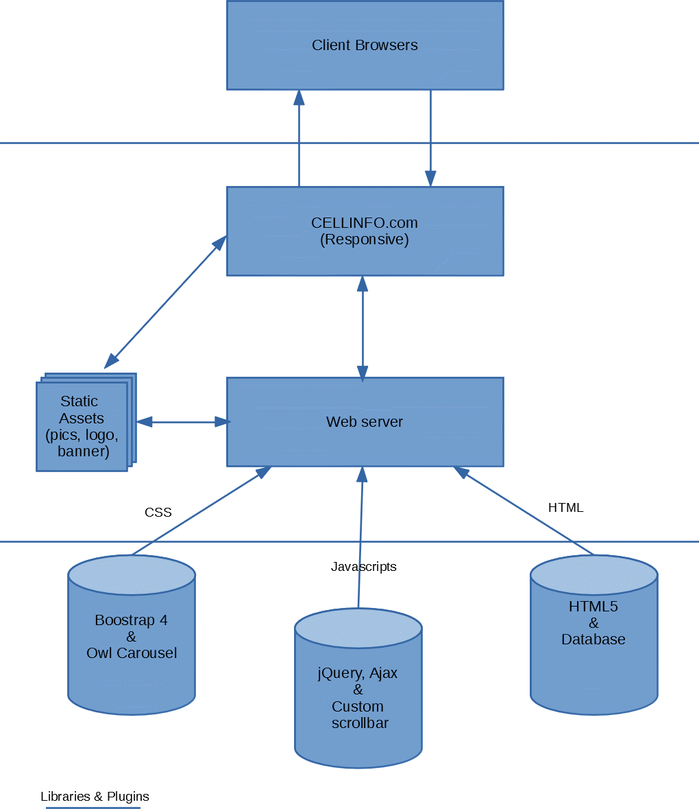

## SITEMAP

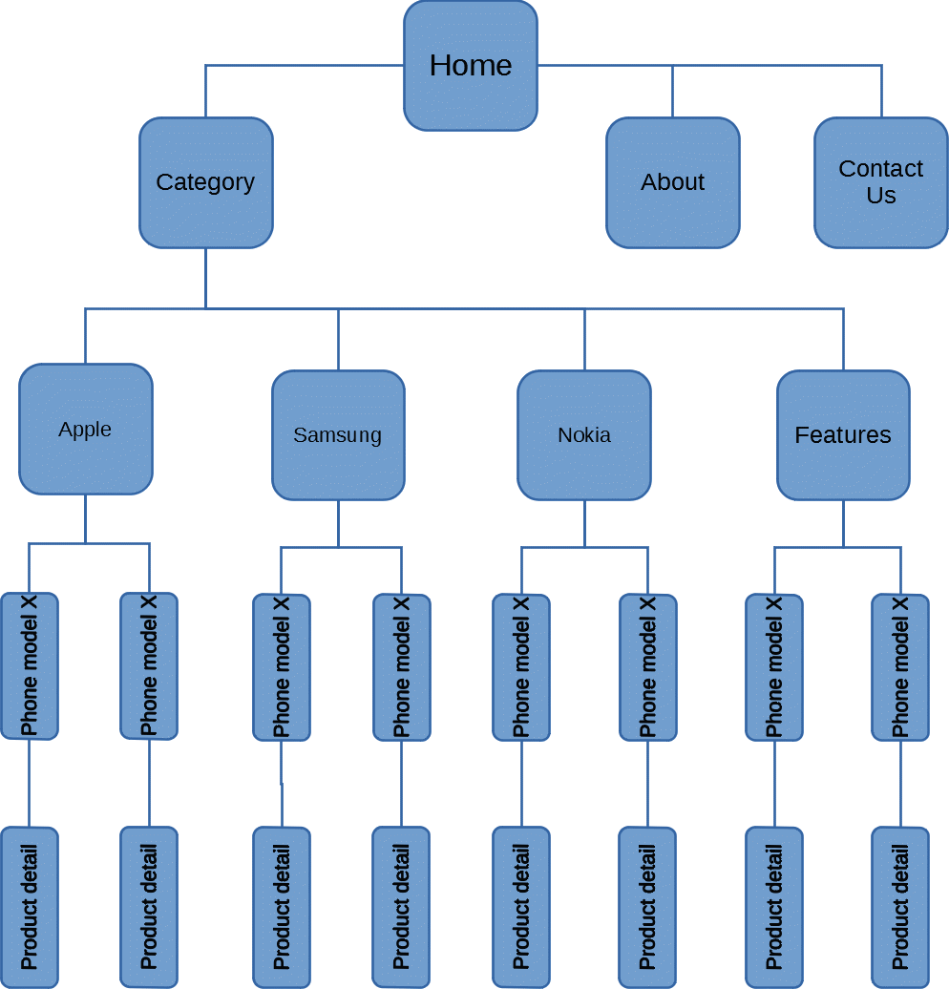

## WEBSITE LAYOUT

The website layout is to be designed with a SIMPLE but ELEGANT design. Because of the objective is to QUICKLY and SYSTEMICALLY deliver information to the site visitors, the main focus of our webpage will be on the main landing page where all the information will be stored and represented. The site users will have a variety of interactions such as performing search function on a search bar, searching using dropdown menus, comparing phone features, downloading Word documents, links to third party websites.

The websites will also have a few complimentary pages such as About, Contact Us which contain introductory information about our team and our office address.

### HOMEPAGE

This layout below describes our Home Landing Page which contains three important part:

* The Top navigation bar and Side navigation bar:

There will be two navigation bars to work in synergy. The top bar will have a Hamburger toggle button for the side menu (side panel) and Hyperlinks on the right.

When click to Hamburger button, a side menu will come out from the left screen side, the side menu is the MOST IMPORTANT part of our project since this is where Users will have the most interactions. There will be Our company’s logo on top, and several dropdown menu incorporated within the side panel, a functional search bar, and buttons to link to our Website’s other pages.

* Hero/Jumpotron:

A large Hero banner to populated in the main content area, the banner will be interactive meaning the title and small heading will be changed according to which brand the users currently be viewing.

* Main Content:

A phone brand will placed on top of the main content along with a brief description of the phone company. Next will be several carousel slide that will showcase the phone products and features. Each carousel will have several product cards which will contain a brief summary of features and hyperlink buttons.

There will be two hyperlink buttons, a “compare” button and a “download” button. The “compare” button will link to a modal table which will compare current phone with 5 phones of the same brand and 2 of another brands. The download button will provide a link to download phone features in Word Docs.

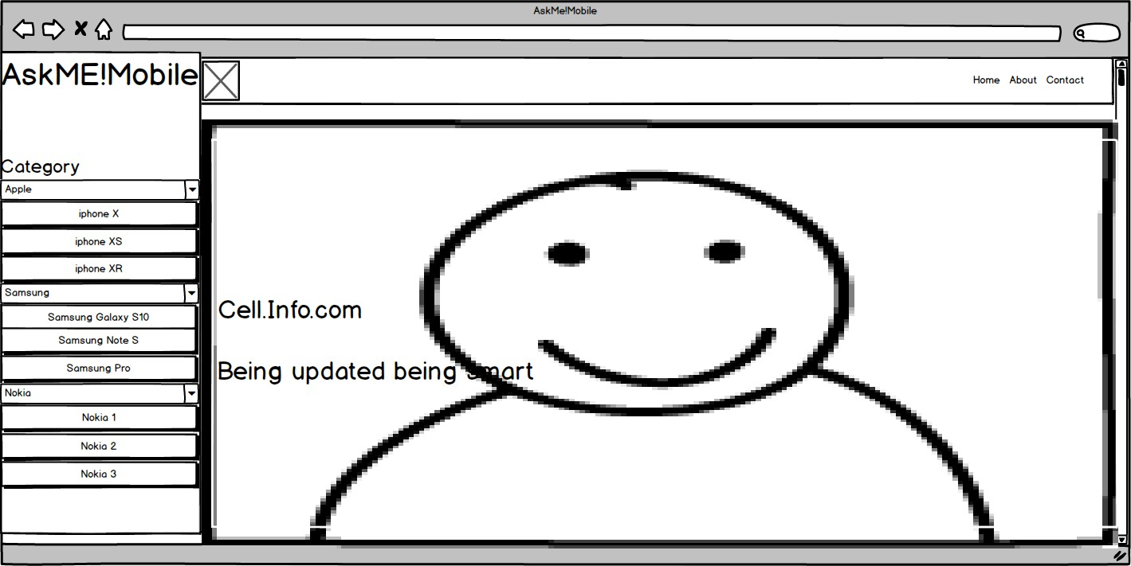

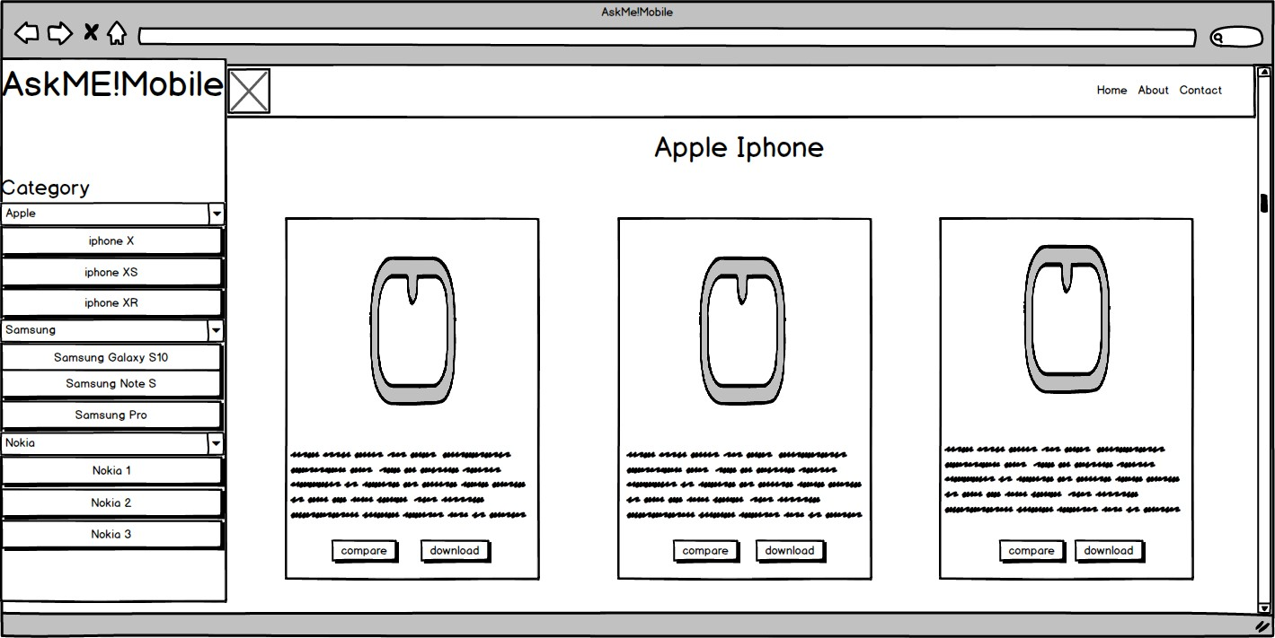

### CONTACT US

The contact us layout will have be simple, there will be a main hero banner on top and below are the headings and email link to our office, a feedback form to be populated using Ajax, and our office address along with a geolocation API showing our office location. The topnav menu will become “Active” to show which page users are currently in.

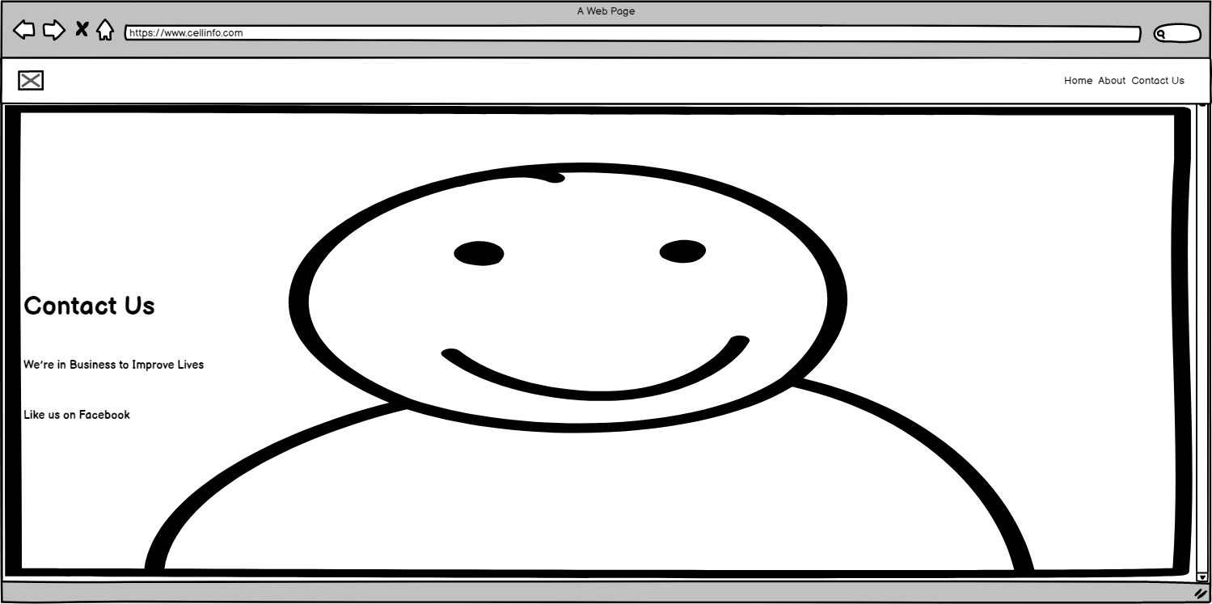

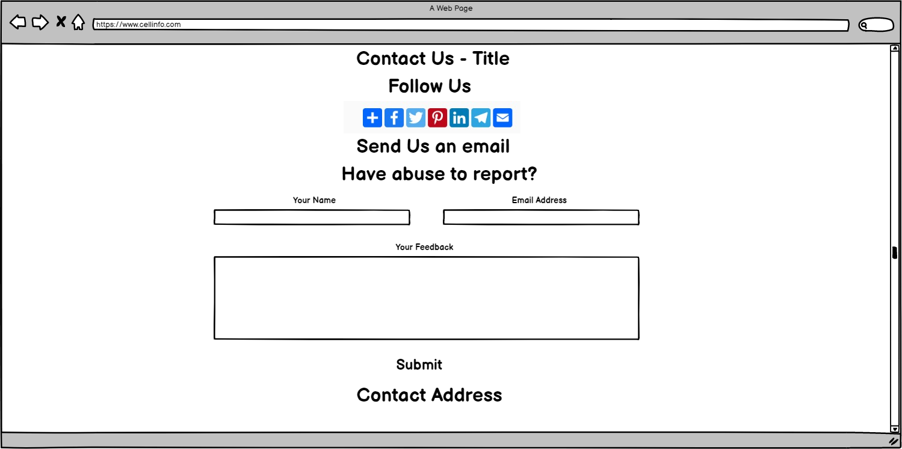

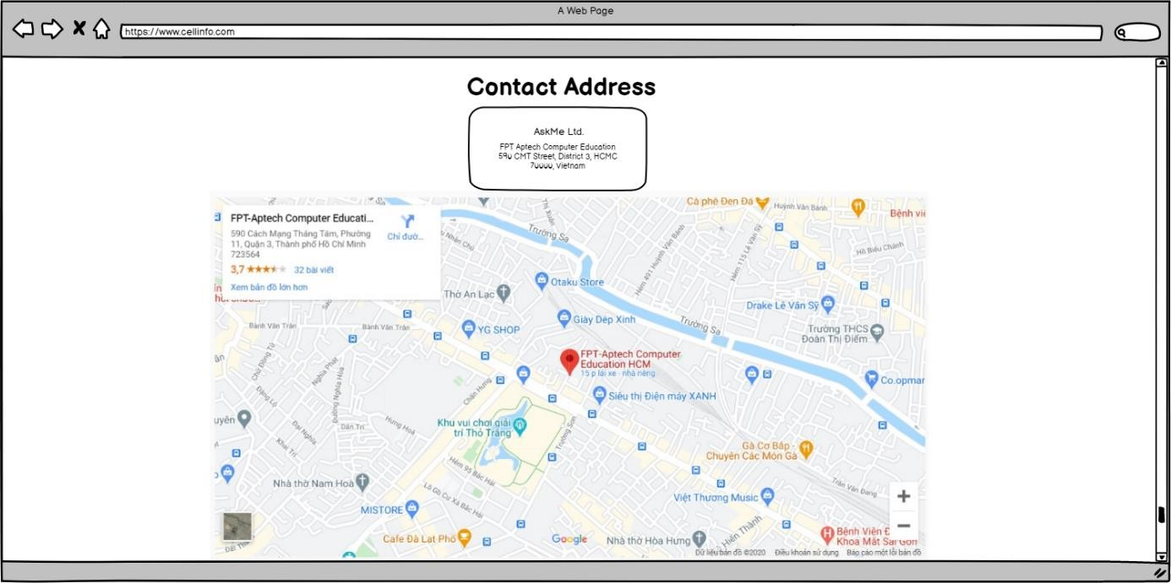

## TASK SHEET 1

|  |  |  |  |  |  |  |
| --- | --- | --- | --- | --- | --- | --- |
| **Project Ref No.** | **Project Title – Ask Me Mobile** | **Activity Plan Prepared**  **by** | **Date of preparation of Activity Plan** | | | |
| **Task** | **Actual Start Date** | **Actual Days** | **Teammate Names** | **Status** |
| Brainstorming ideas for  layouts, and Project Objective | | Phát, Triều,  Nghĩa | 05/09/2020 | 1 day | Phát, Triều,  Nghĩa | Completed |
| Draw site maps and  architecture design | | Phát | 03/09/2020 | 1 days | Phát | Completed |
| Wire framing general page  layout. | | Phát, Triều | 05/09/2020 | 4 days | Phát, Triều | Completed |
| Collect static assets (pictures,  mp4, documentation) | | Phát, Triều,  Nghĩa | 05/09/2020 | 3 days | Phát, Triều,  Nghĩa | Completed |
| Design & Build Home Page | | Phát | 03/09/2020 | 8 days | Phát | Completed |
| Design & Build Contact Us  Page | | Nghĩa | 05/09/2020 | 2 days | Nghĩa | Completed |
| Design & Build About Us Page | | Triều,  Nghĩa | 08/09/2020 | 4 days | Triều,  Nghĩa | In Progress |
| Design & Build Footer Session | | Triều | 12/09/2020 | 2 days | Triều | In Progress |
| Write project report Review 1 | | Phát | 09/09/2020 | 3 days | Phát | Completed |

|  |  |
| --- | --- |
| Signature of Faculty | Signature of Team Leader |
|  |  |

# REVIEW 2

# PROJECT SNAPSHOTS

## Home Page

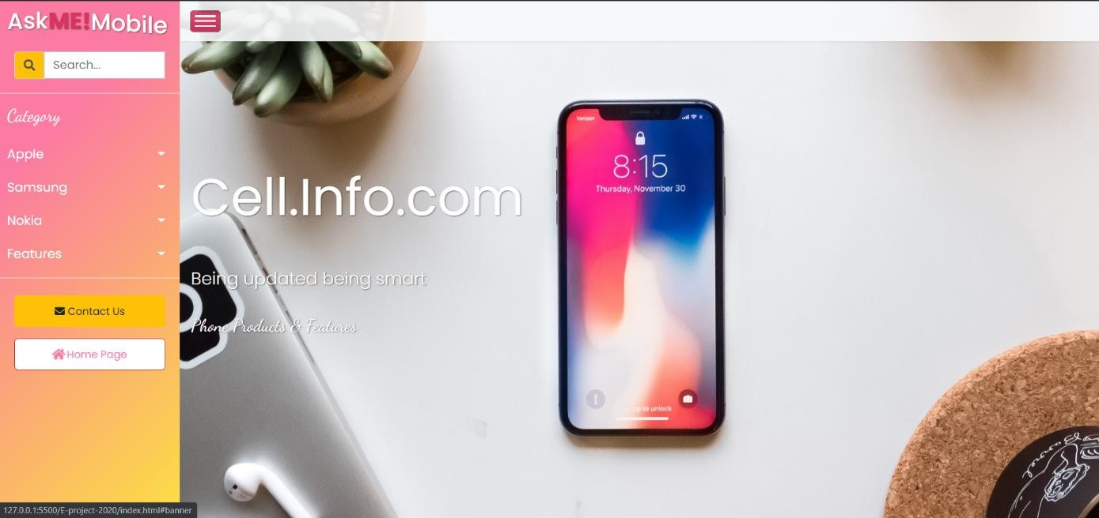The following snapshots illustrate the creation of CELL INFO.COM home page:

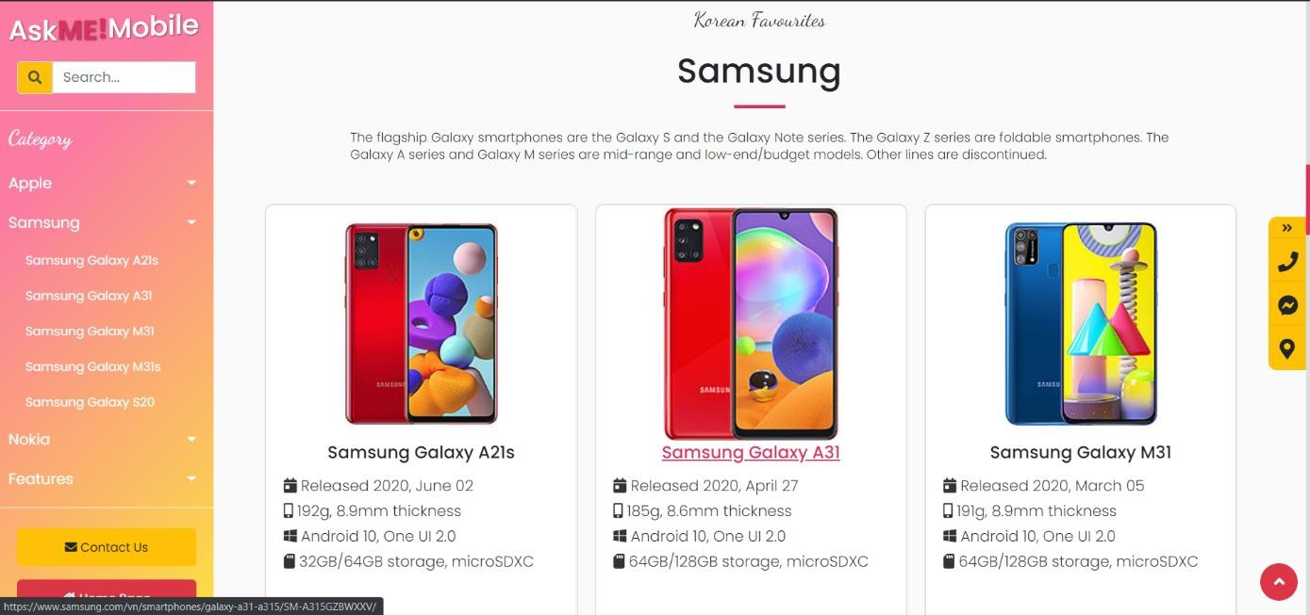

## Product details Page

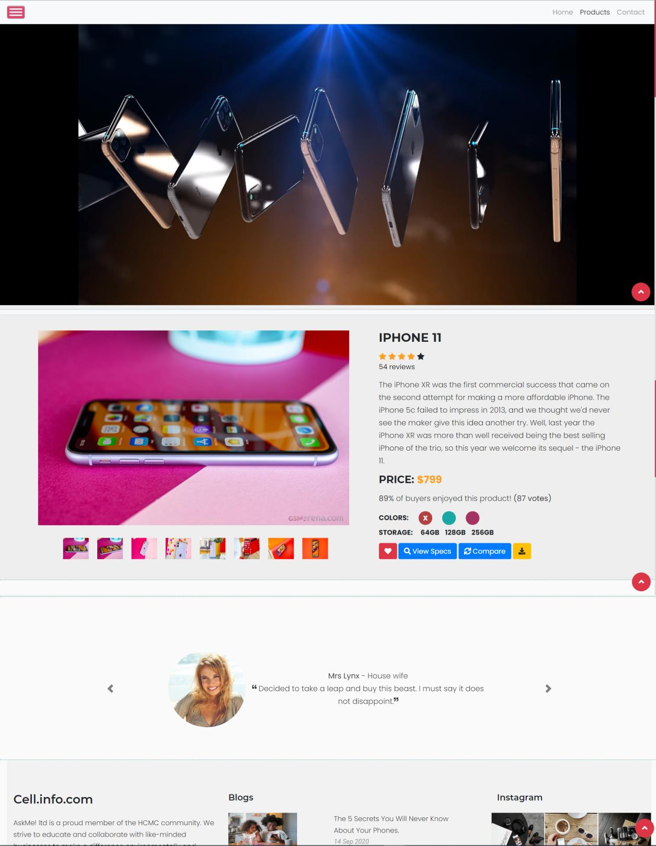

## Contact Us:

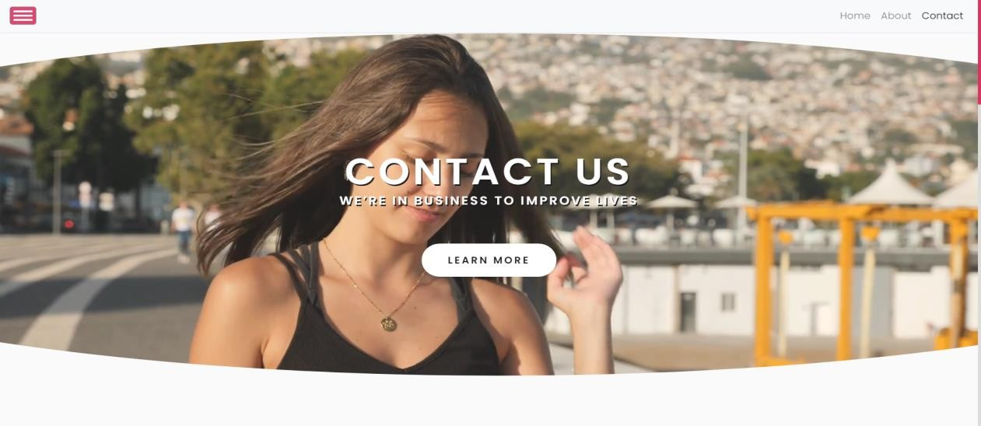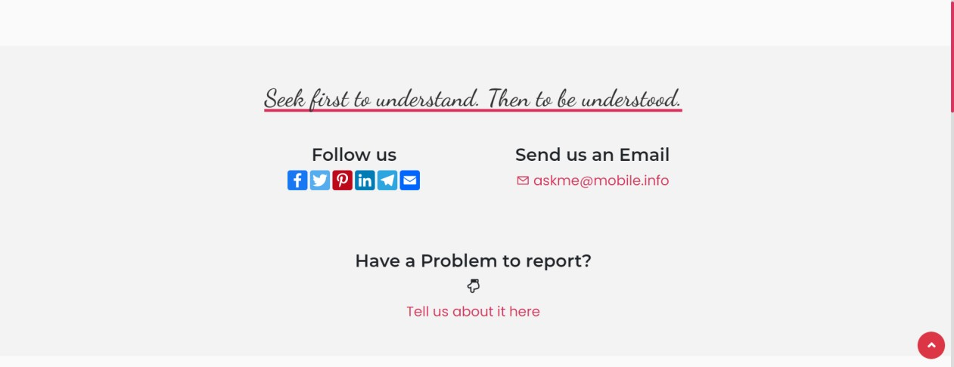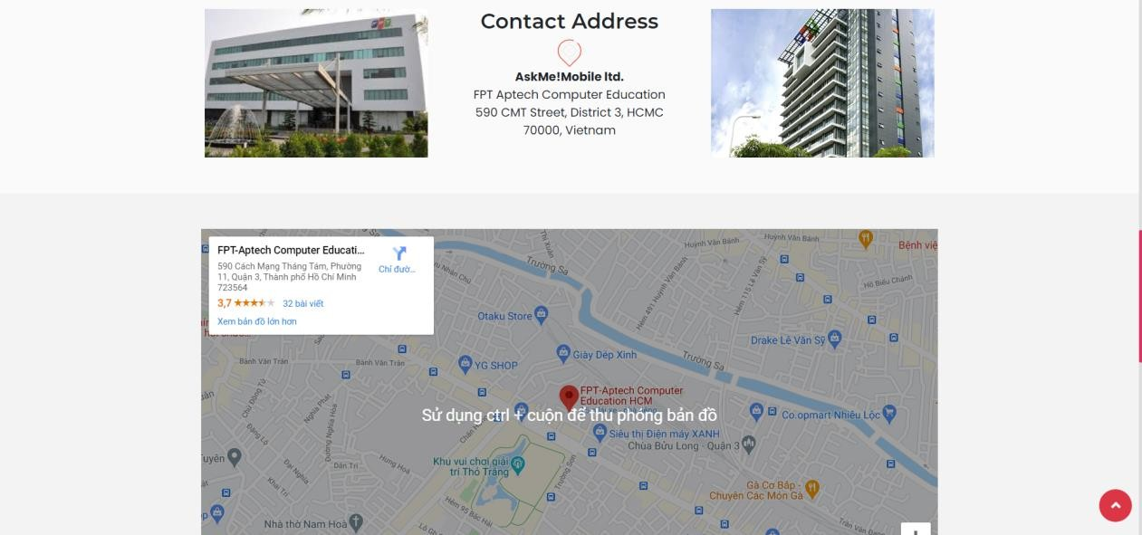The following snapshots illustrate the creation of CELL INFO.COM contact us page:

## Footer

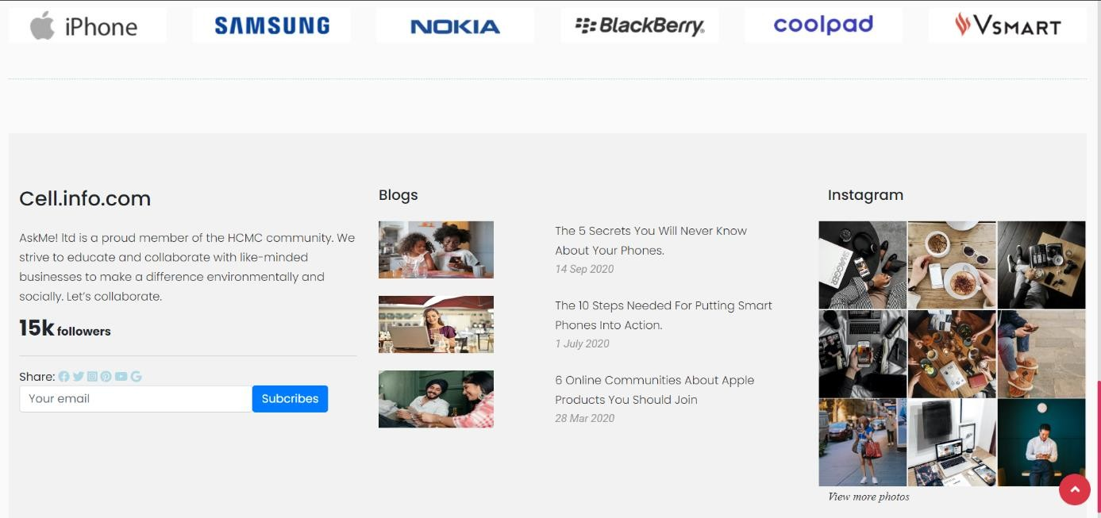The following snapshot illustrates the creation of CELL INFO.COM footer session:

# SOURCE CODE WITH COMMENT

The project is built based upon the Bootstrap 4 frame work. However, our developer team also heavily modify this website using custom plug-ins and our own HTML/CSS/JS codes. Below is the illustration of important source codes and libraries that we are using for our project.

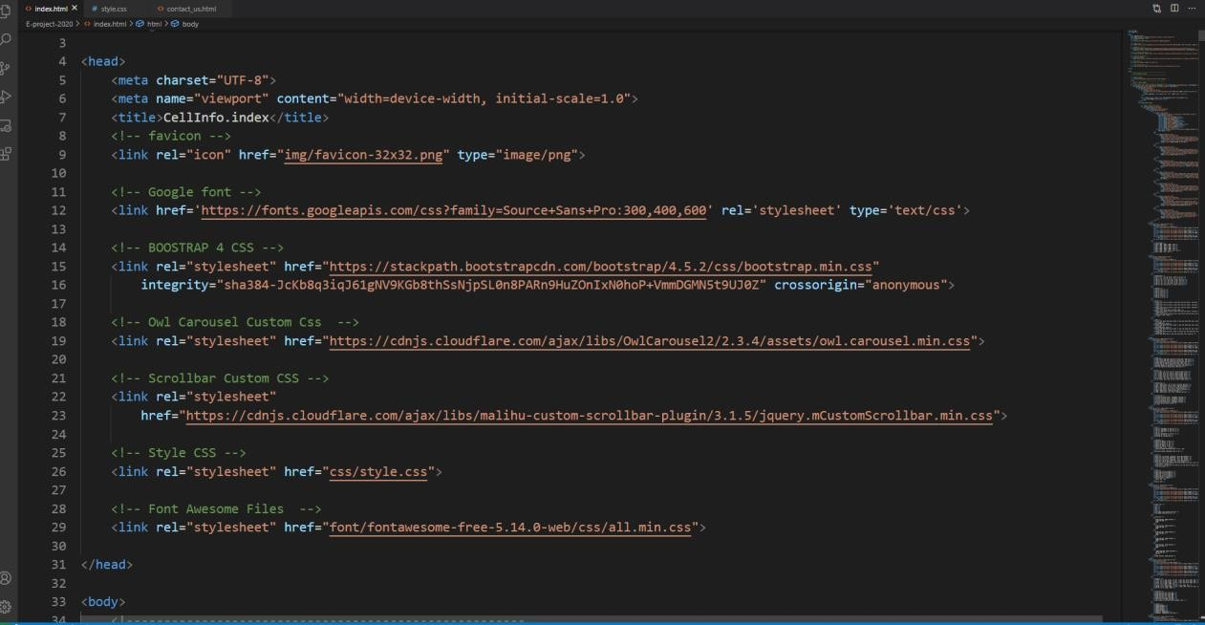

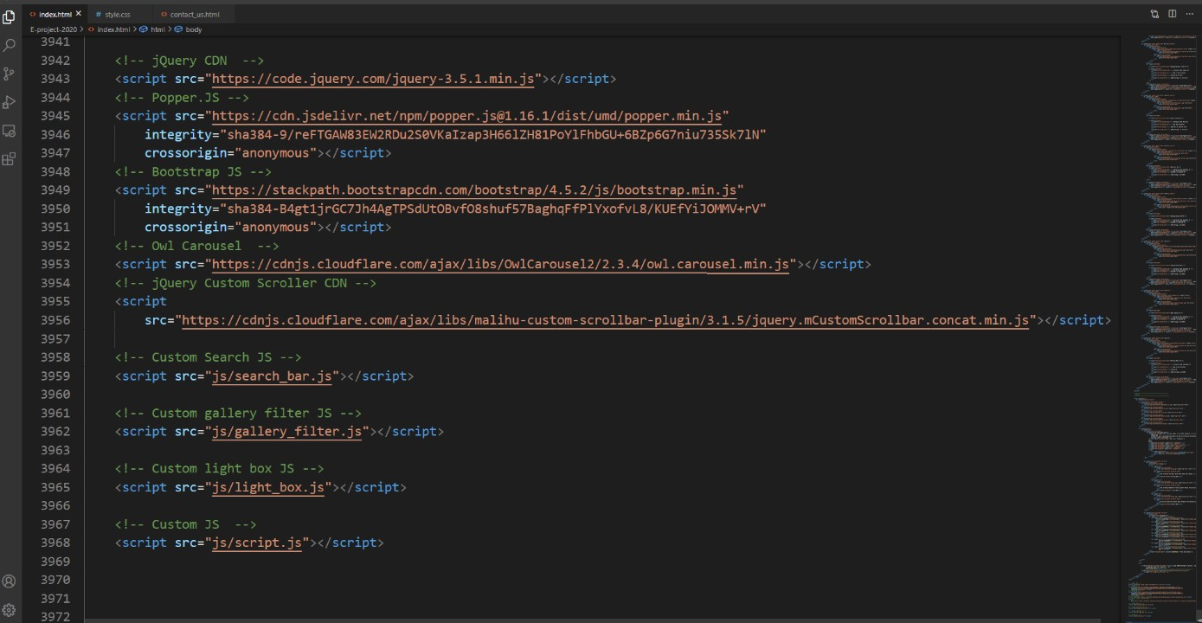

We will go through each module in greater details following our Developer guide.

# USER MANUAL

## System Requirements:

|  |  |  |
| --- | --- | --- |
| **No.** | **Items** | **Description** |
| 1 | Operating System | Android, iOS, window 7 or higher. |
| 2 | Supporting  Browsers | Chrome, Firefox, Microsoft Edge, IE10+, Opera |

## Step by Step Instructions:

### Starting Home Page:

Users will have access to the website by typing to domain name CELLINFO.com, After a brief loading screen user will have access to a top navigation bar and a side menu.



Side panel will have a functional search bar and several dropdown

Links to help with navigation.

After preload - users will have access to Home Page

### Using Search bars & Dropdown menu

From the side panel, users can start searching for products specifically by typing keywords into search bar. If the users prefer to browse first, there are several dropdown menu categorizing phone products according to brands and features.

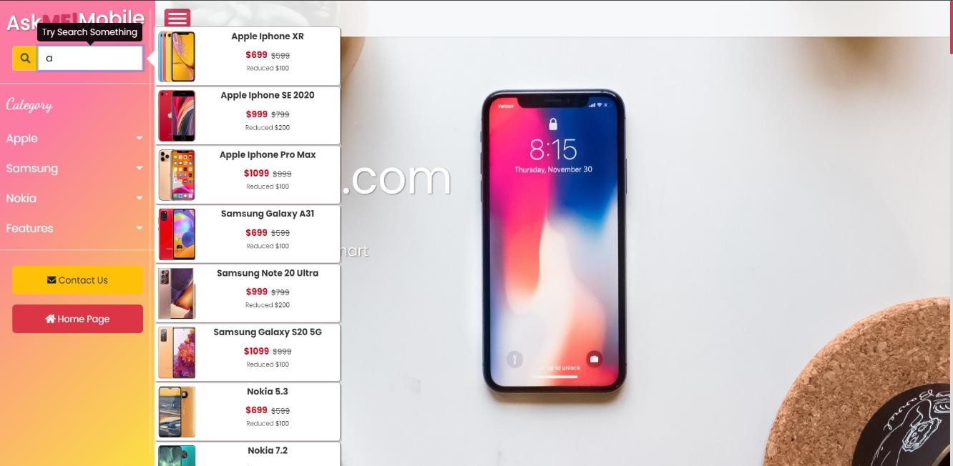

By typing the first letter,

users will activate the search algorithm on the

List of products are categorized according to brand name and prices.

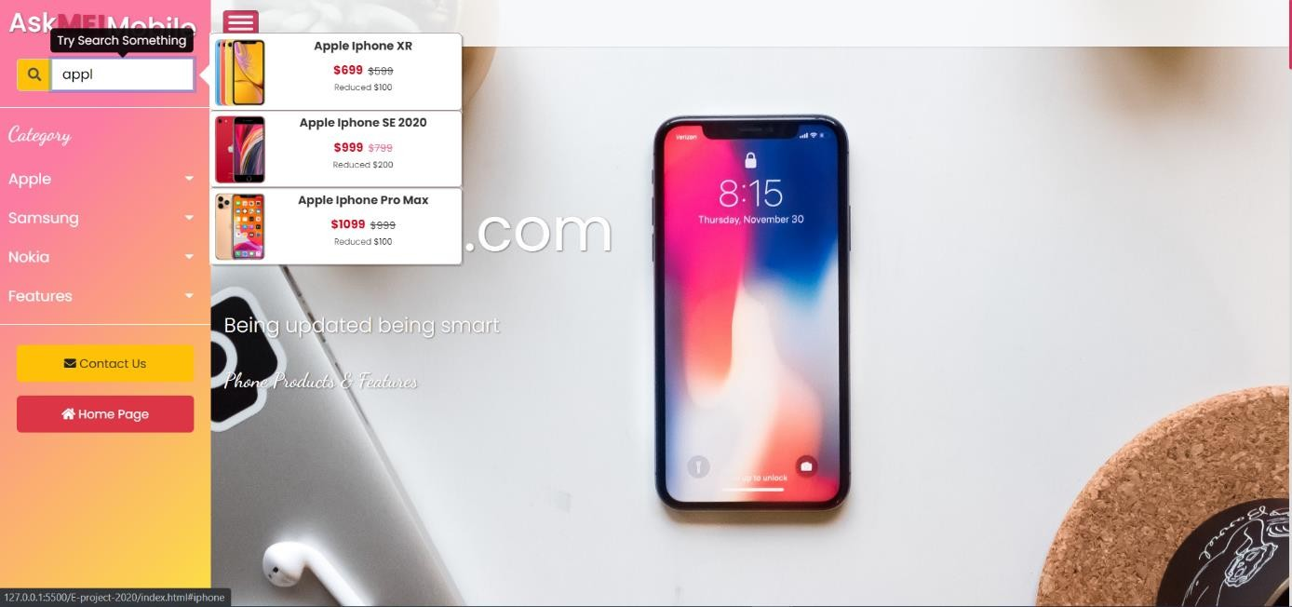

Search filter out products brands according to matching key words

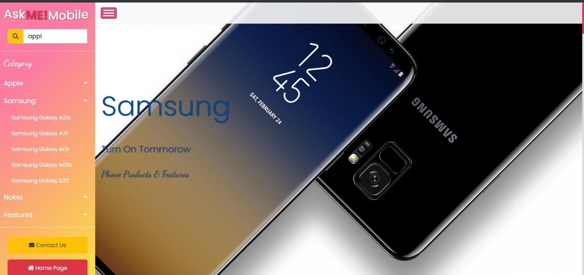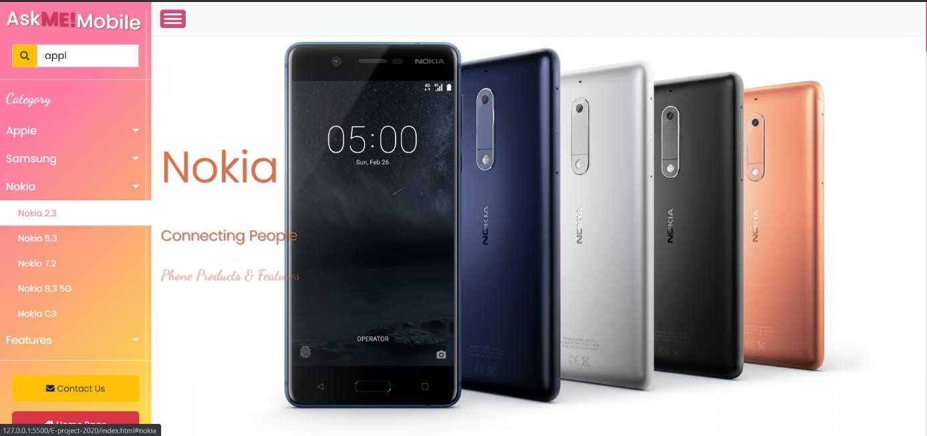

Background images will also changed each time according to which brand the users is currently

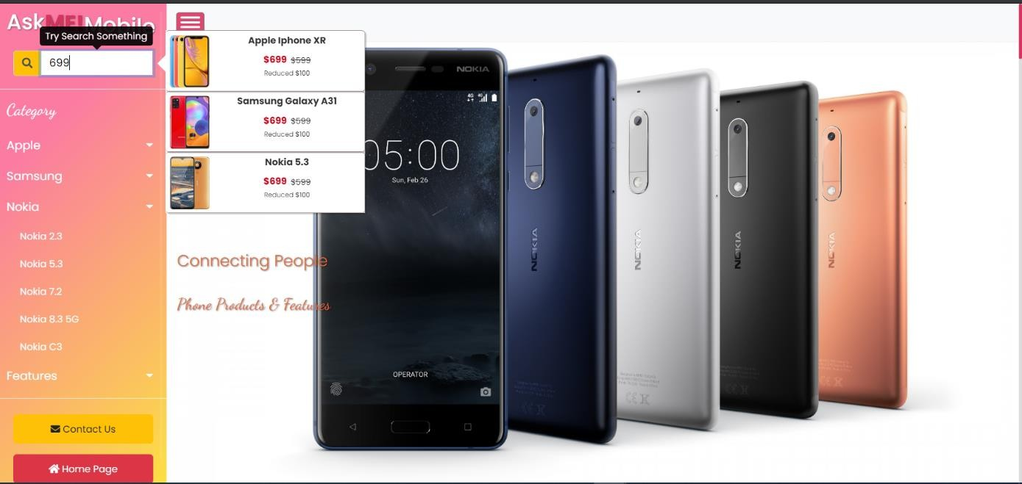

Numbers can also used as keywords

### Browsing Products Gallery:

After clicking to certain phone model in drop down menu, Users will be guided to the product carousels.

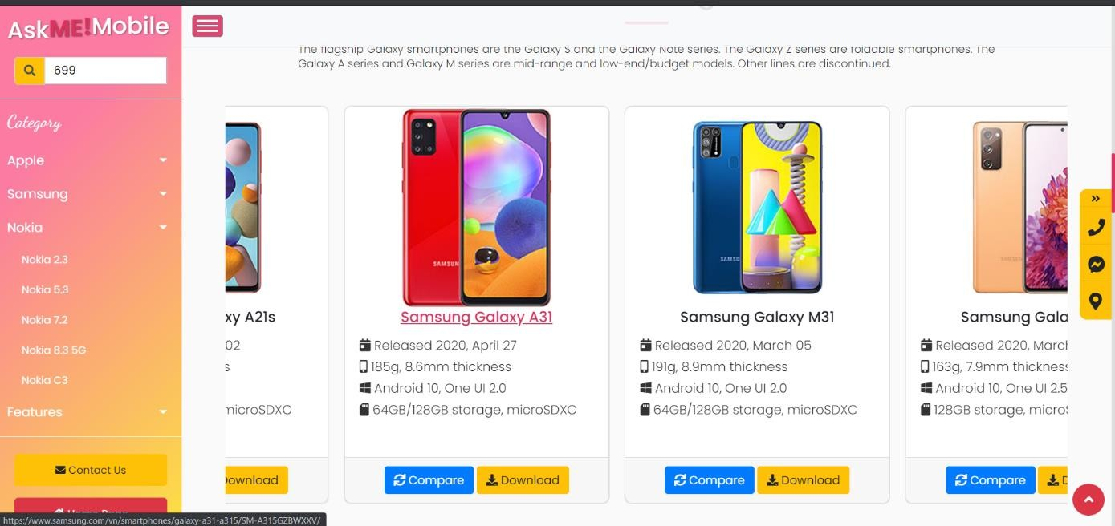

Users can perform browsing by clicking and dragging the product cards to any left/right direction.

Each product card will contain a brief summary of phone features

Two CTA buttons at the bottom. The blue button will open a comparison table, the yellow one will prompt users to download Word docs containing full spec information of the phone model

### Product Details Page:

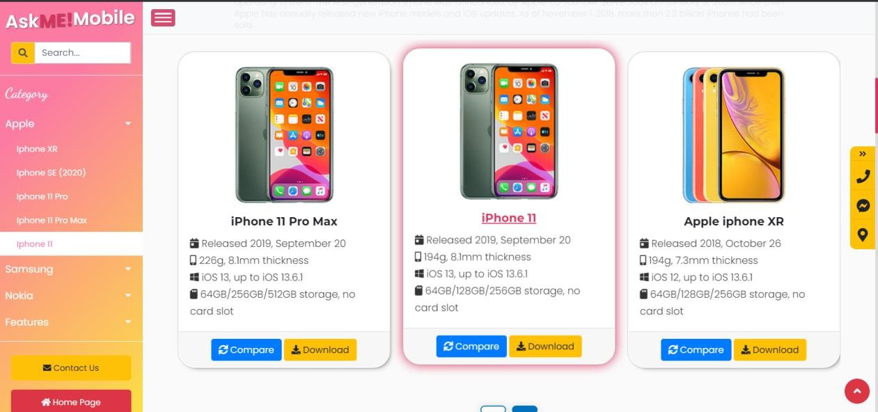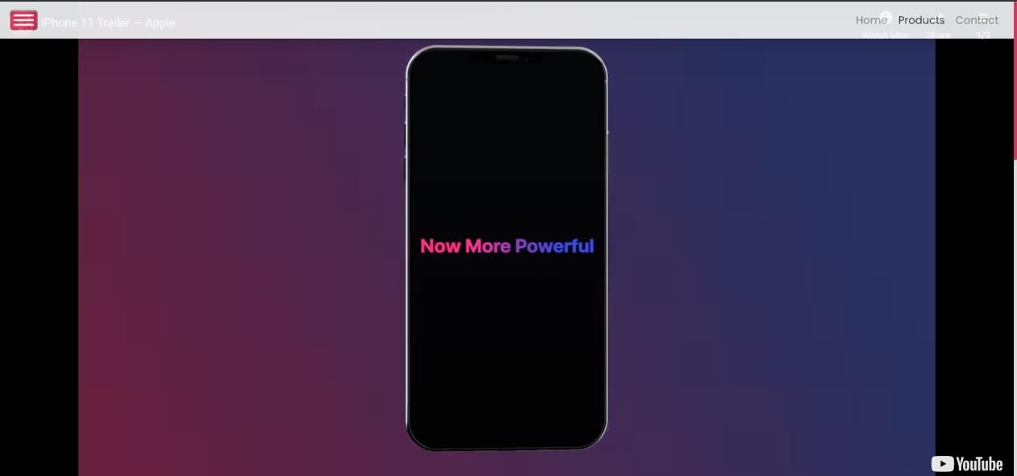

Clicking on the product card will prompt users to open a product details window.

pg. 29

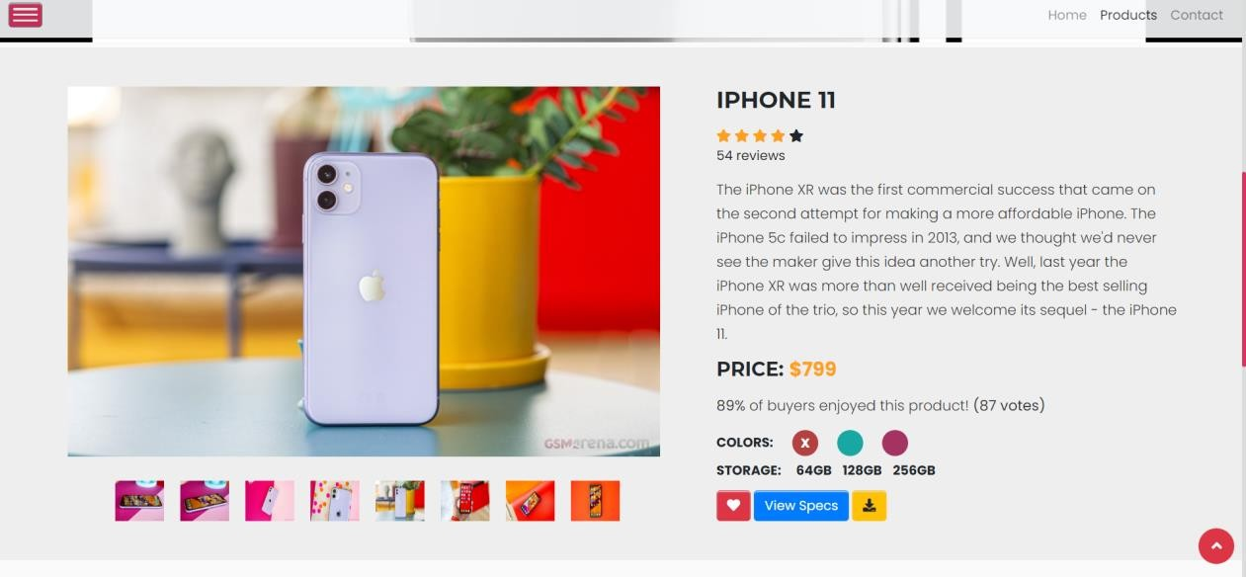

Users can leave a review or view/download phone specs by clicking at CTA buttons.

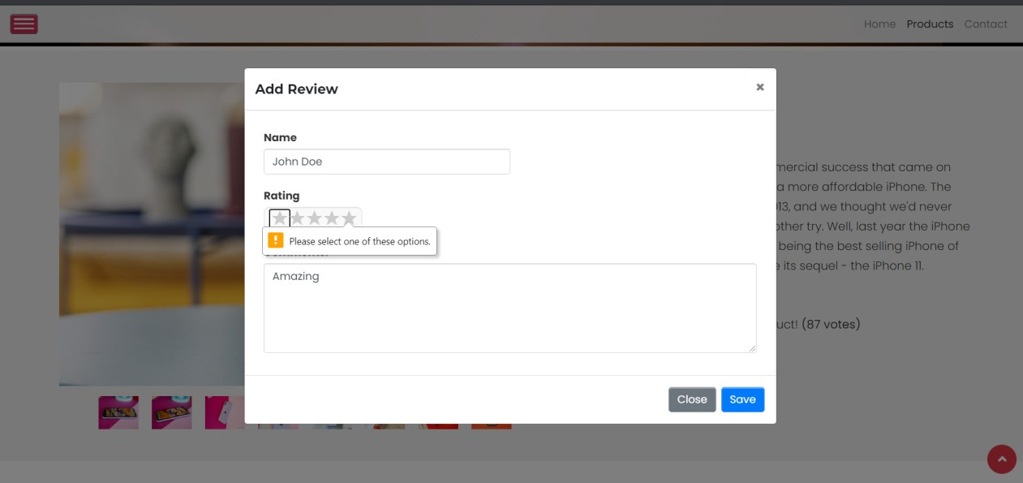

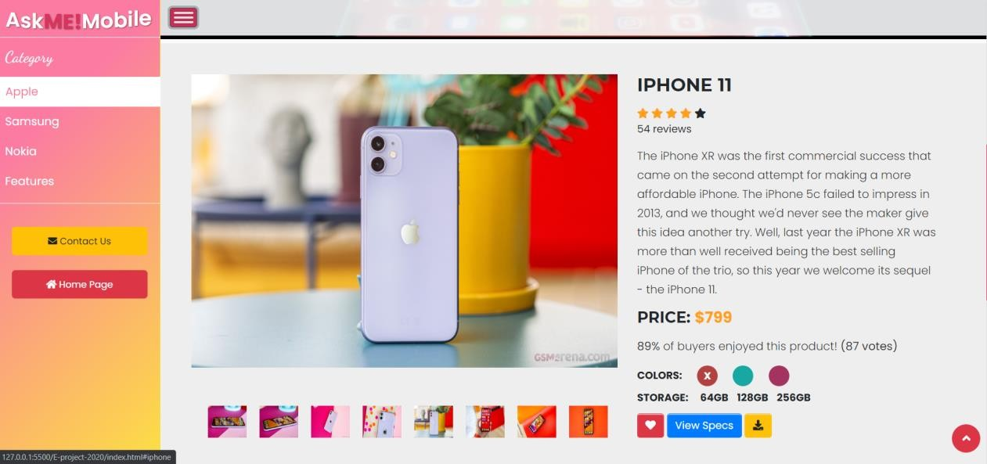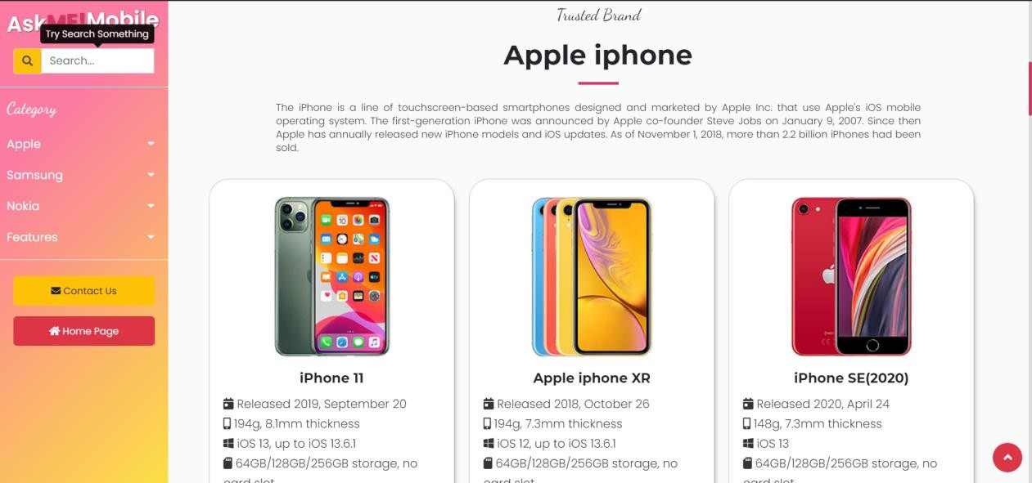

Clicking Link on the right will return users to the Home Page.

### CTA Buttons – Compare & Download

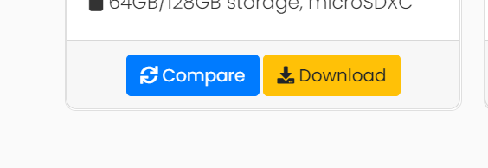

Clicking The blue button will prompt users to open a modal window.

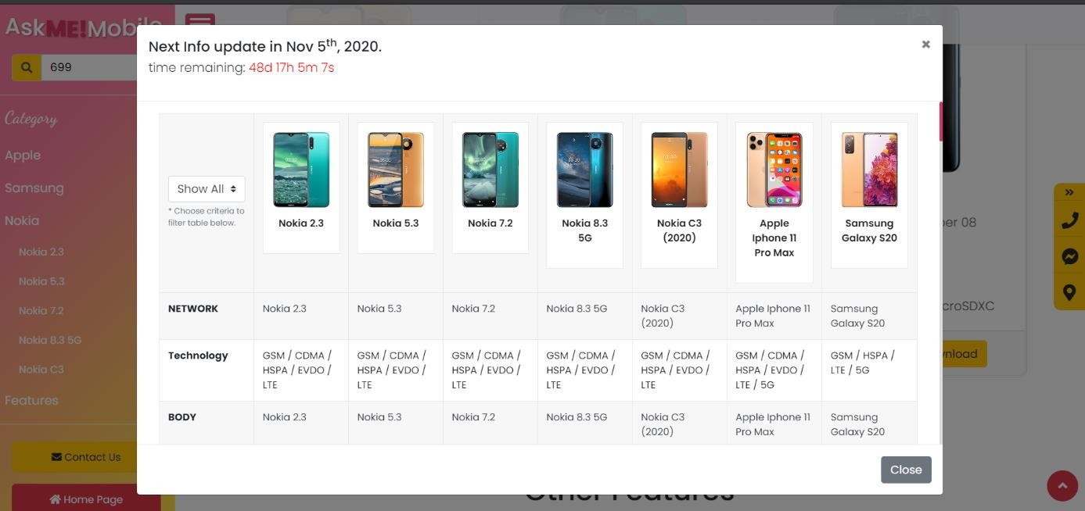

Users can compare 5 phone models of the same brand and 2 phone models of other brands.

All info will be categorized according to phone features to help with accessibility.

Info will be updated every month at the end of the countdown

A table modal will be opened.

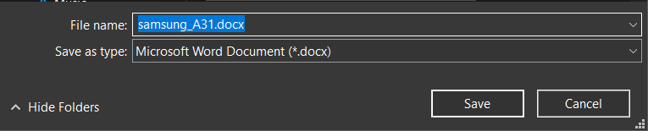

Clicking ‘donwload’ button prompt the users to down Word docx file containing a full spec description of that phone model

### CTA Buttons – Miscellaneous

There are several CTA buttons on the right side of the browser window. These buttons will only pop out when users start scrolling to main content of the home page.

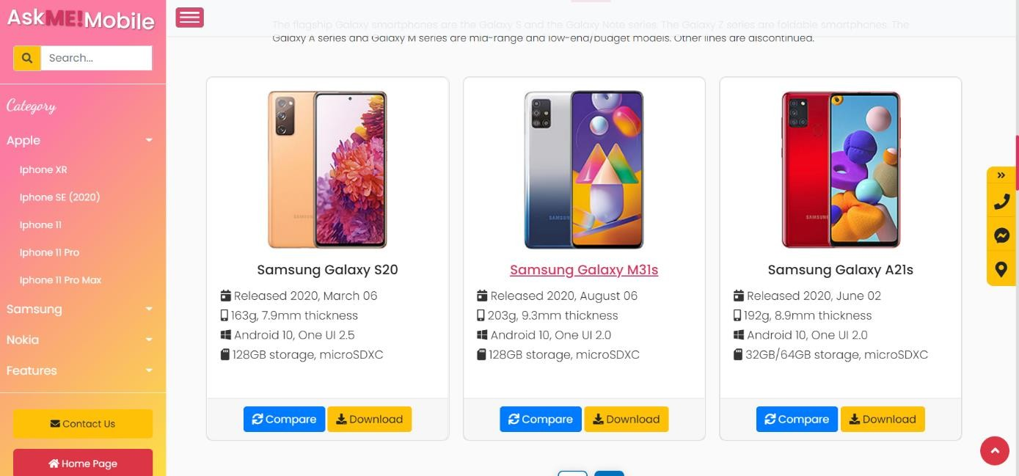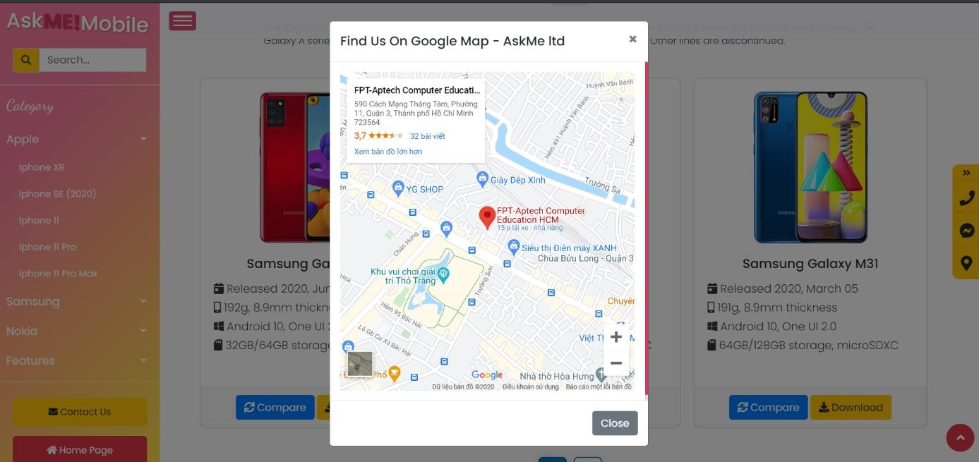

The CTA buttons provide more functionality to our Homepage, users can submit a Contact form, open Messenger, or find our location on

Google map.

CTA buttons on the right side panel help navigate to other pages on our

These CTA buttons only appear when users scroll down the page.

### Contact Us

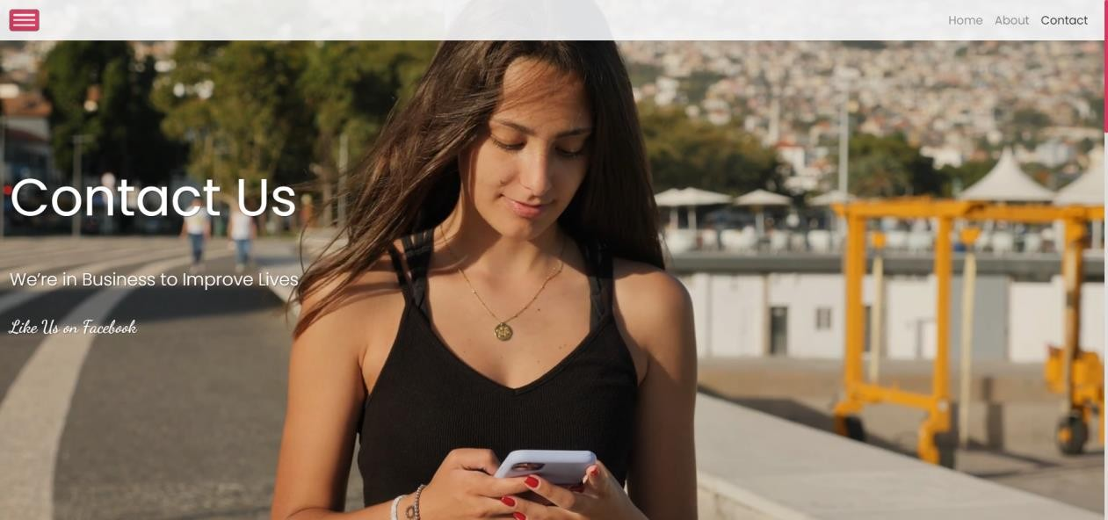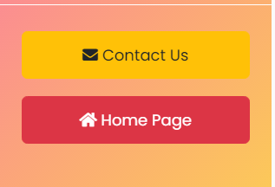

Users can either use the yellow CTA to open Contact us page or clicking the top menu item on Navbar.

### Contact Us – Email & Geolocation

In the Contact Us page, users are provided with several link to connect with us through Social Media. If they wish to directly send us an e-message, there are two links to provide users with options to connect with us through emails or a submit form.

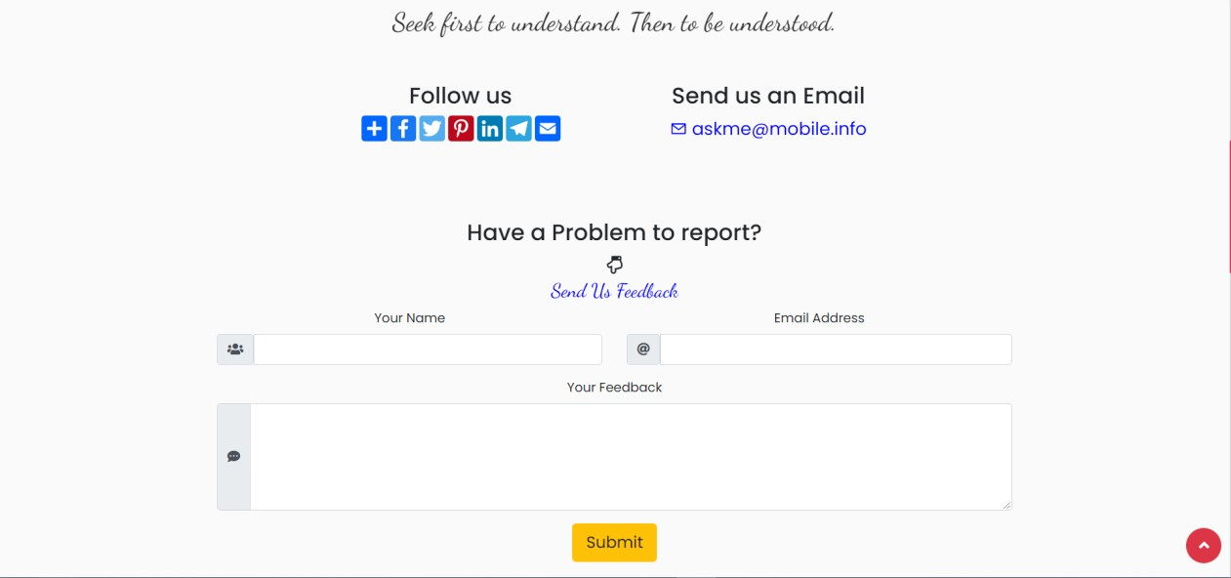

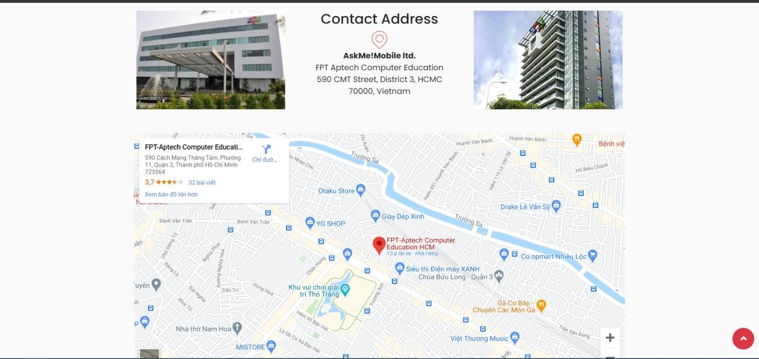

Our office location can be found at the bottom of Contact Us page

### Footer

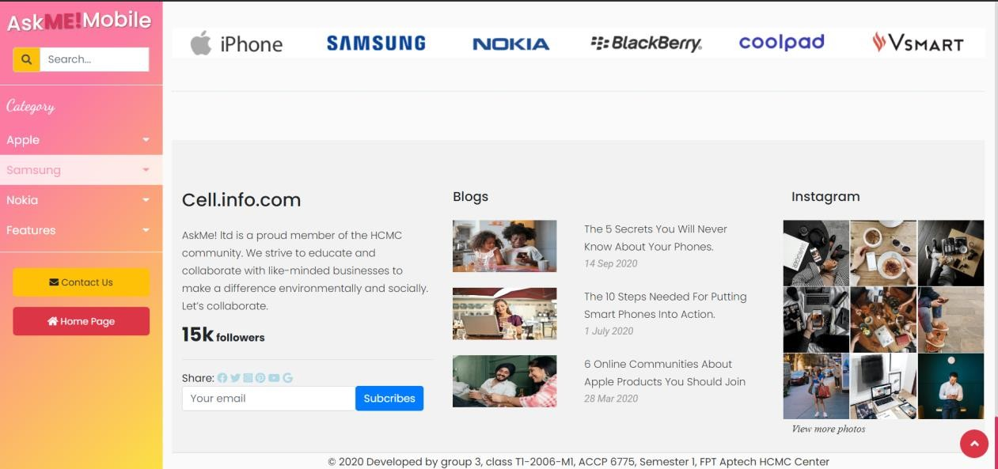More information about our website and company will be displayed in the footer session.

# DEVELOPER’S GUIDE

## Home page

### Bootstrap layout

Cell INFO.COM is built using Bootstrap 4 Framework, The Home Page template is the standard template with navigation bar on top, a fixed side menu, main content will be in the middle and footer section at the bottom of the page.

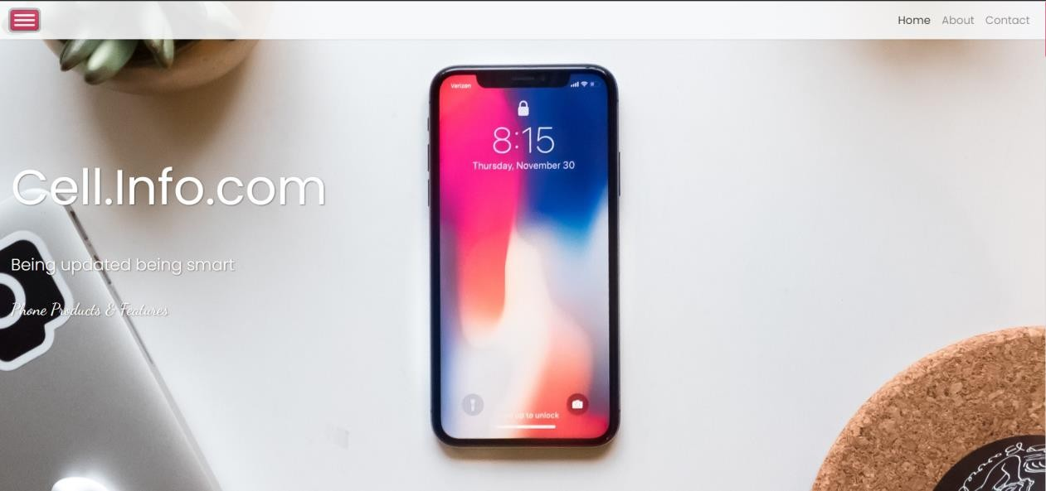

Hamburger menu can be toggle on/off to hide the side panel

Top Navbar is in fixed position. Interestingly, the parent container of Navbar is a flexbox. Thus, Navbar will move to the left when side

panel is closed.

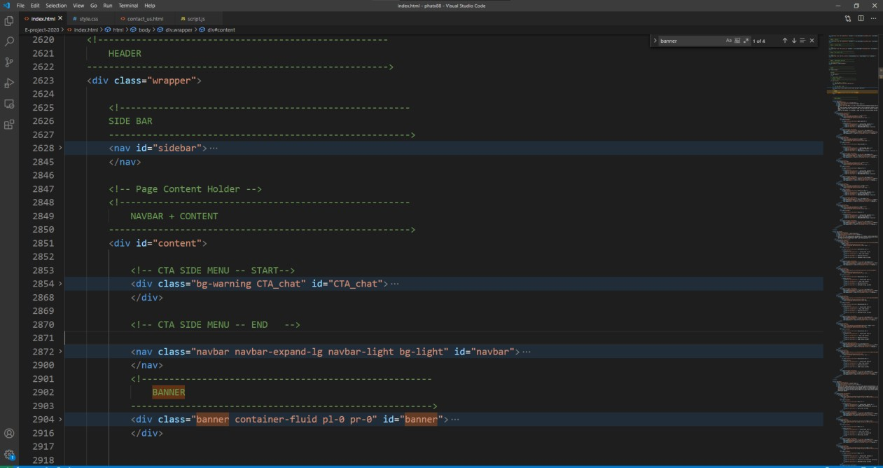HTML codes:

CSS:

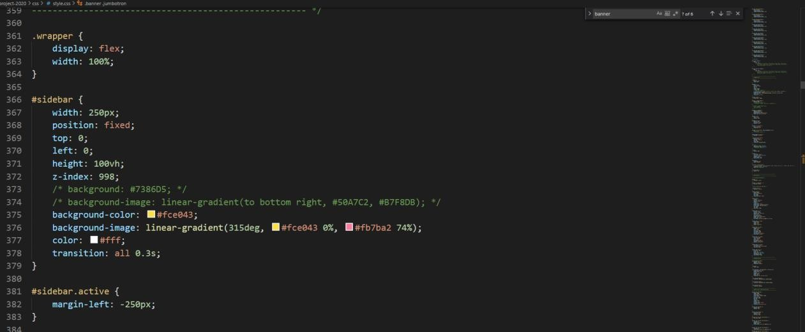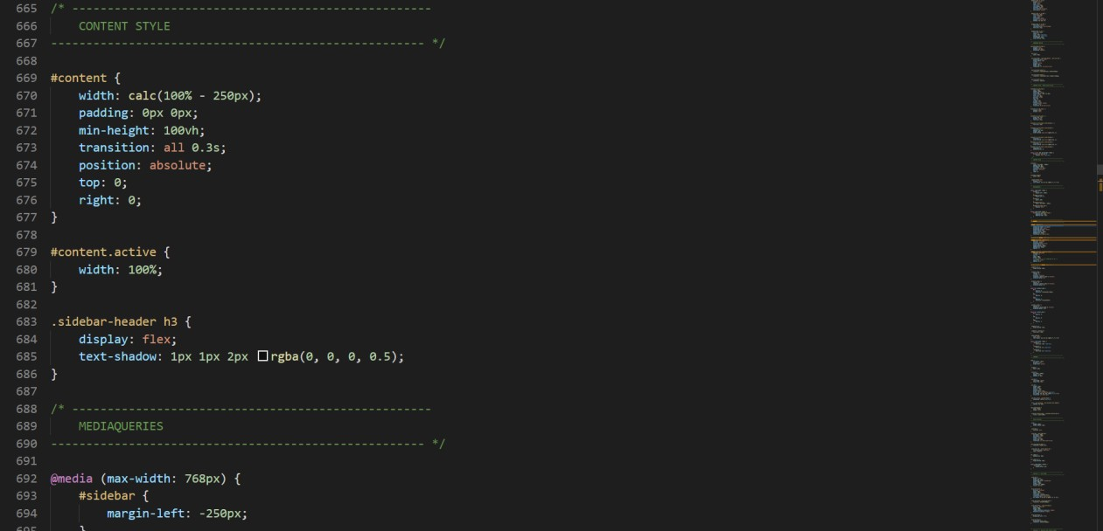

div.wrapper is the parent flex box. Sidebar and Content section are flex-items.

### Logo Animation

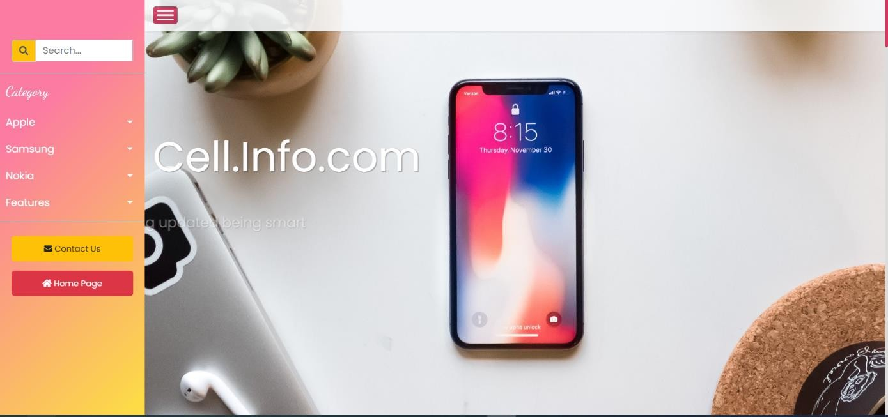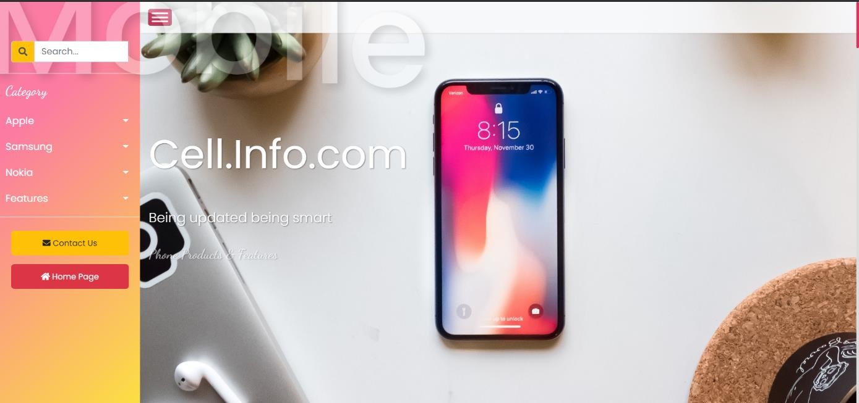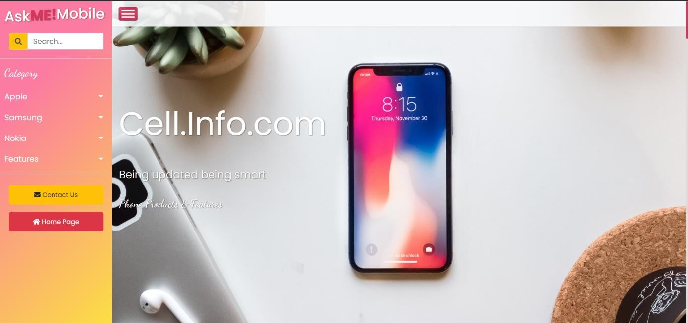

Logo will have a Zoom in animation and A text dancing animation when the page first loaded.

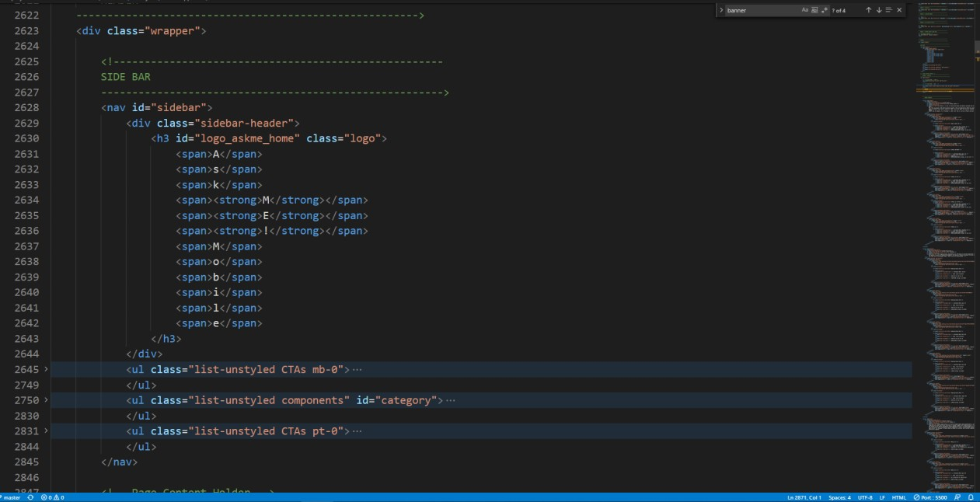HTML code:

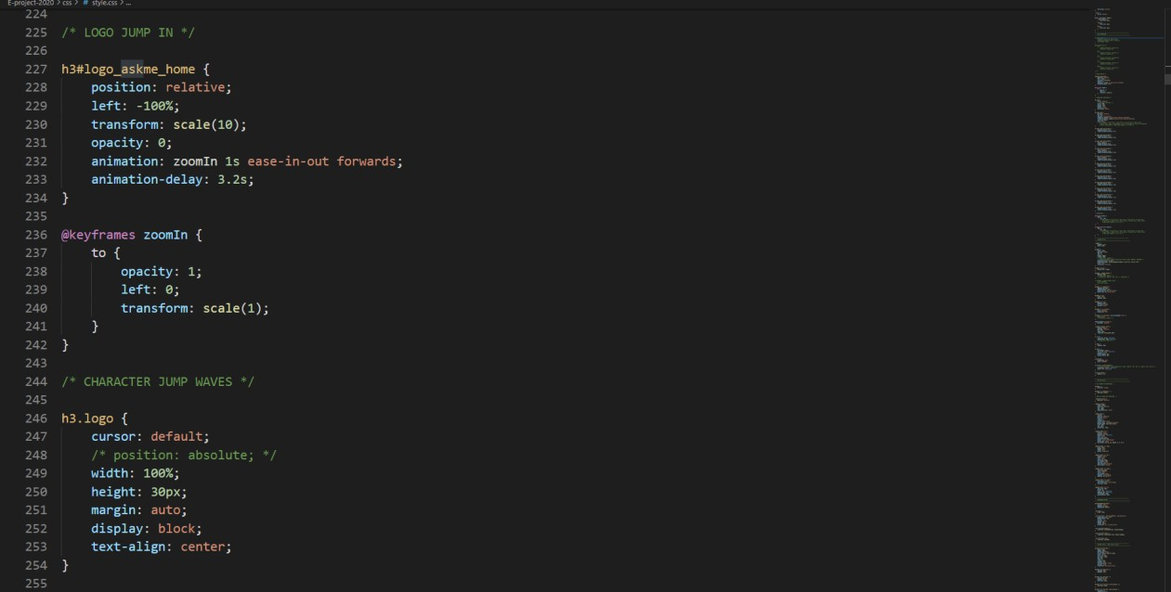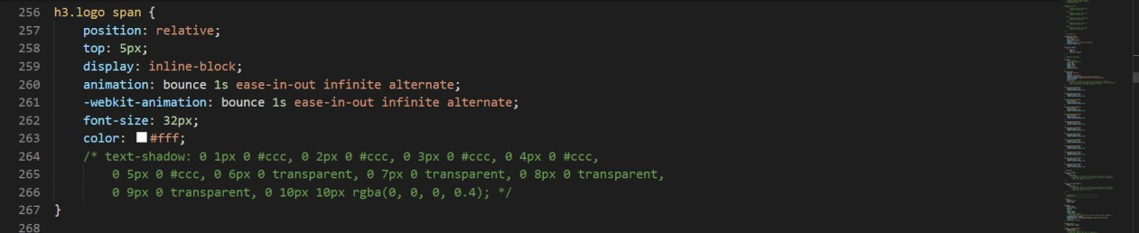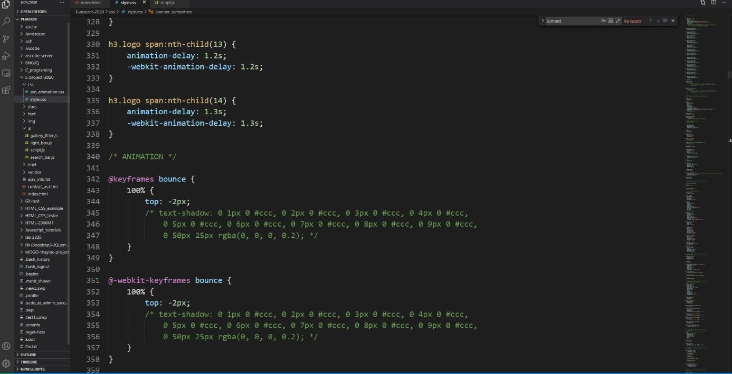CSS Code:

## Top Nav Bar

### Hamburger Menu

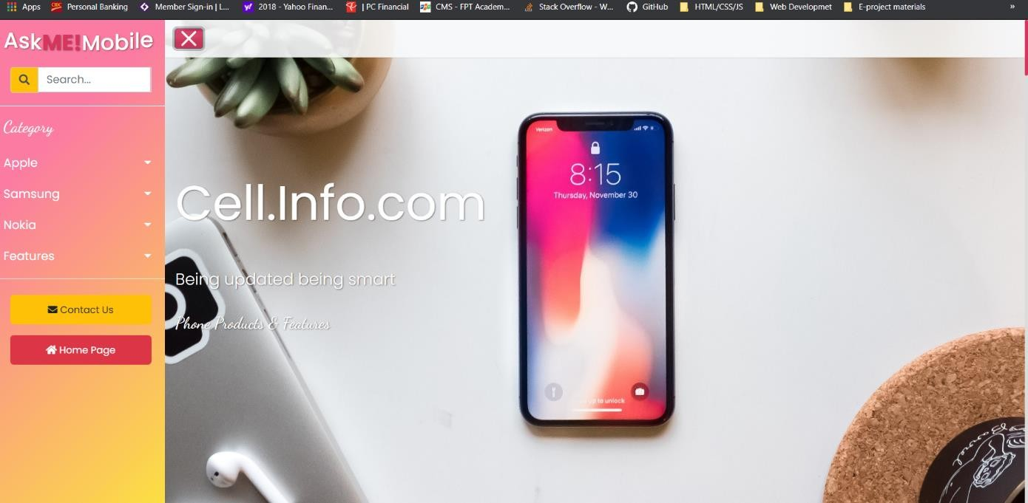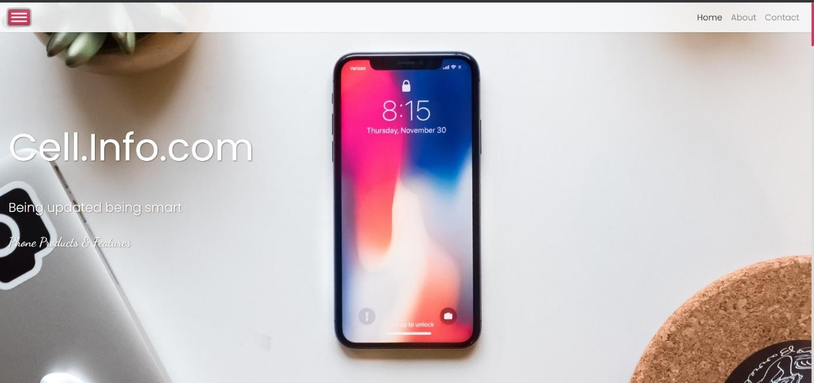

When hover the hamburger menu will change to an “X”, clicking it will toggle side panel off.

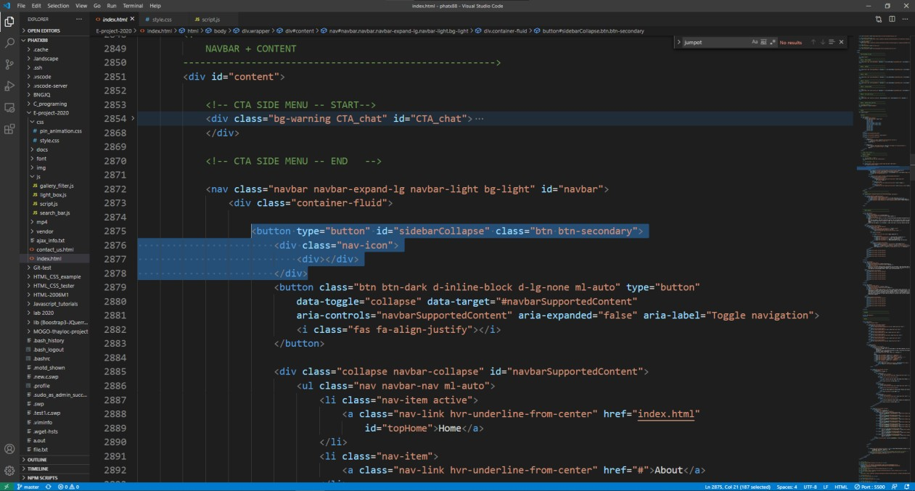HTML code:

CSS code:

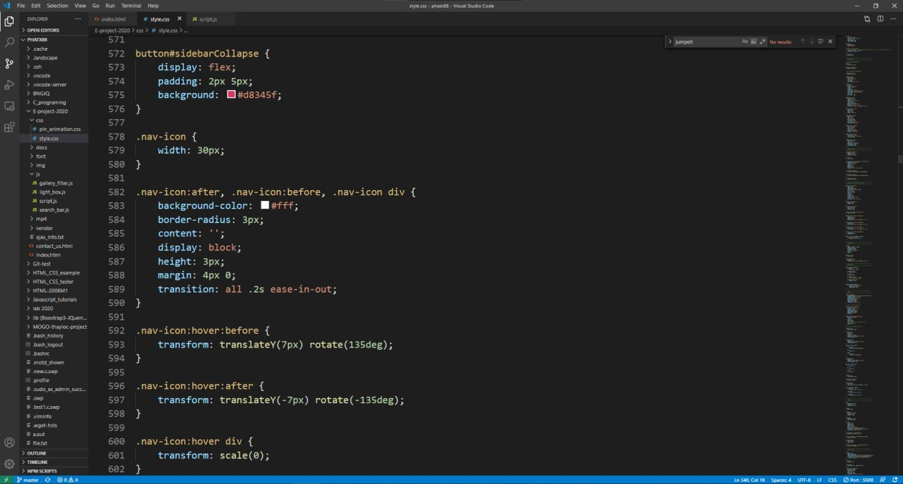

jQuery to toggle class “in” which will move side panel to the left by 250px

JS code:

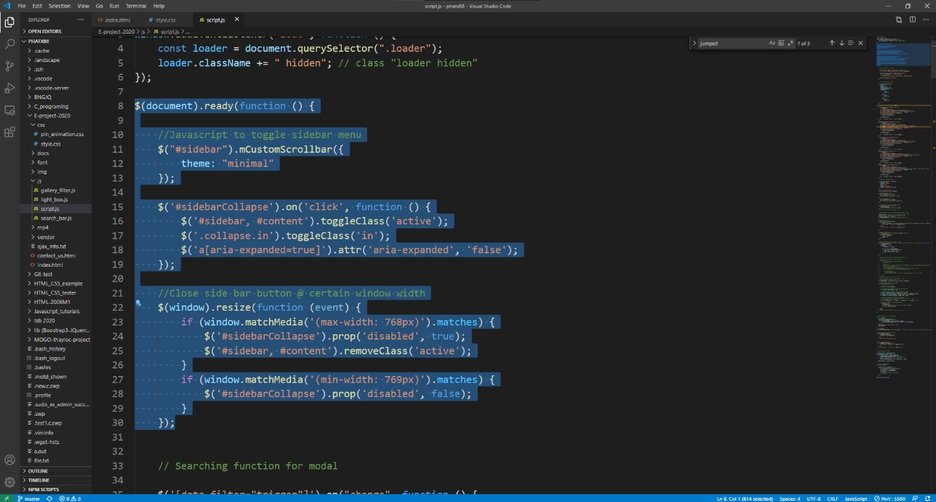

The side panel will automatically turn off and replaced by top navigation bar when the window view is less than 992px, this function is to help with responsiveness when browsing on mobile devices and tablets.

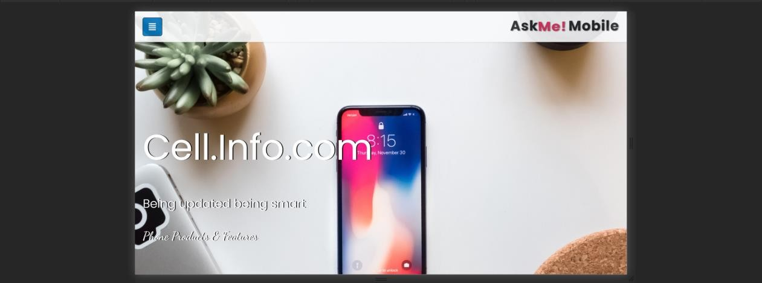

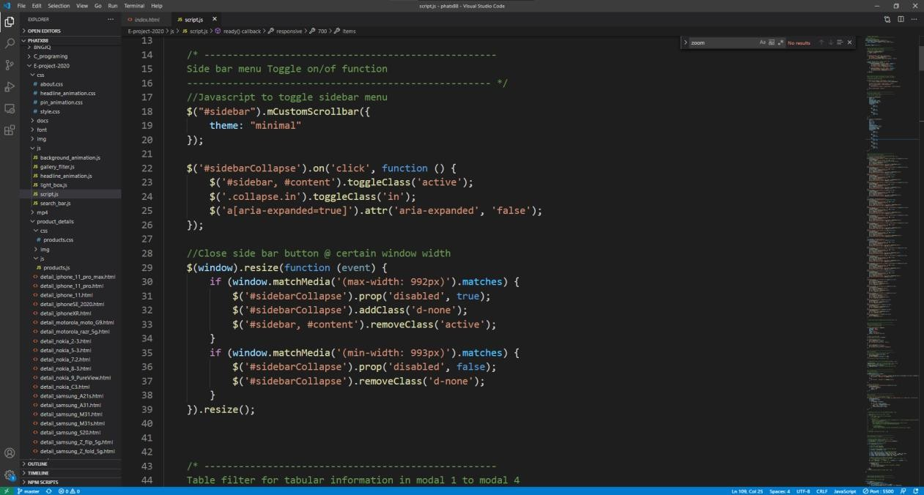

jQuery selector to add ‘disable’ property to the hamburger button. Note that we already used @media queries to handle screen responsive in CSS. For more information about the CSS, refer to 8.4.3

### Navbar Auto hide on scroll

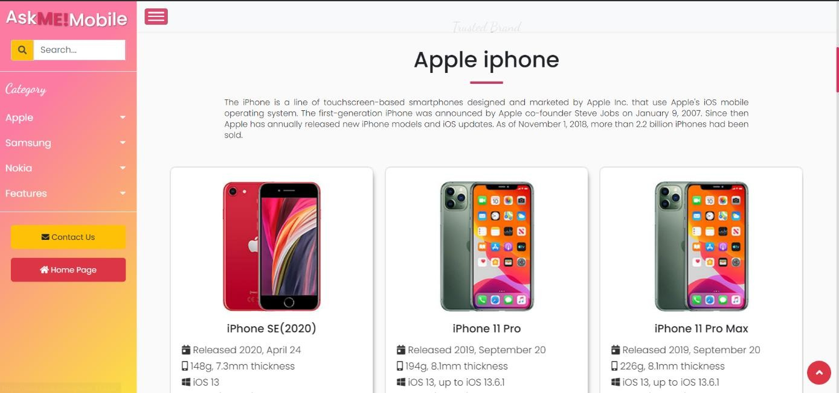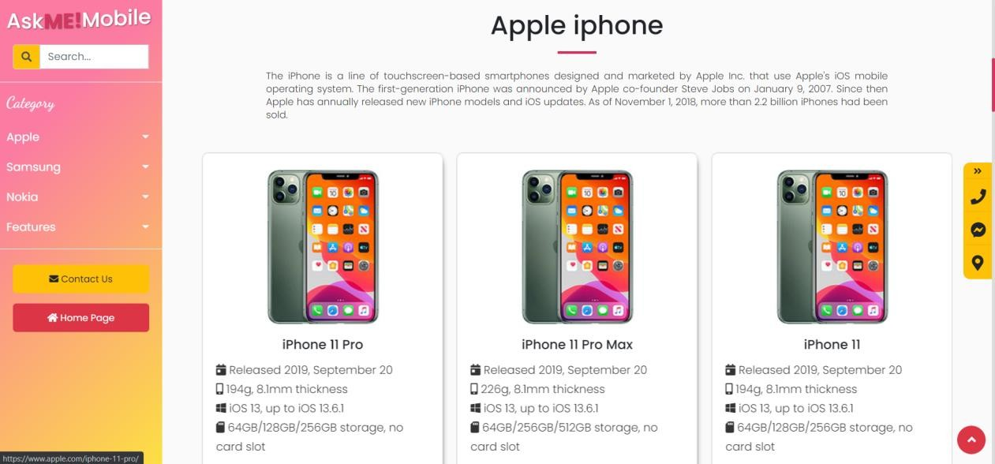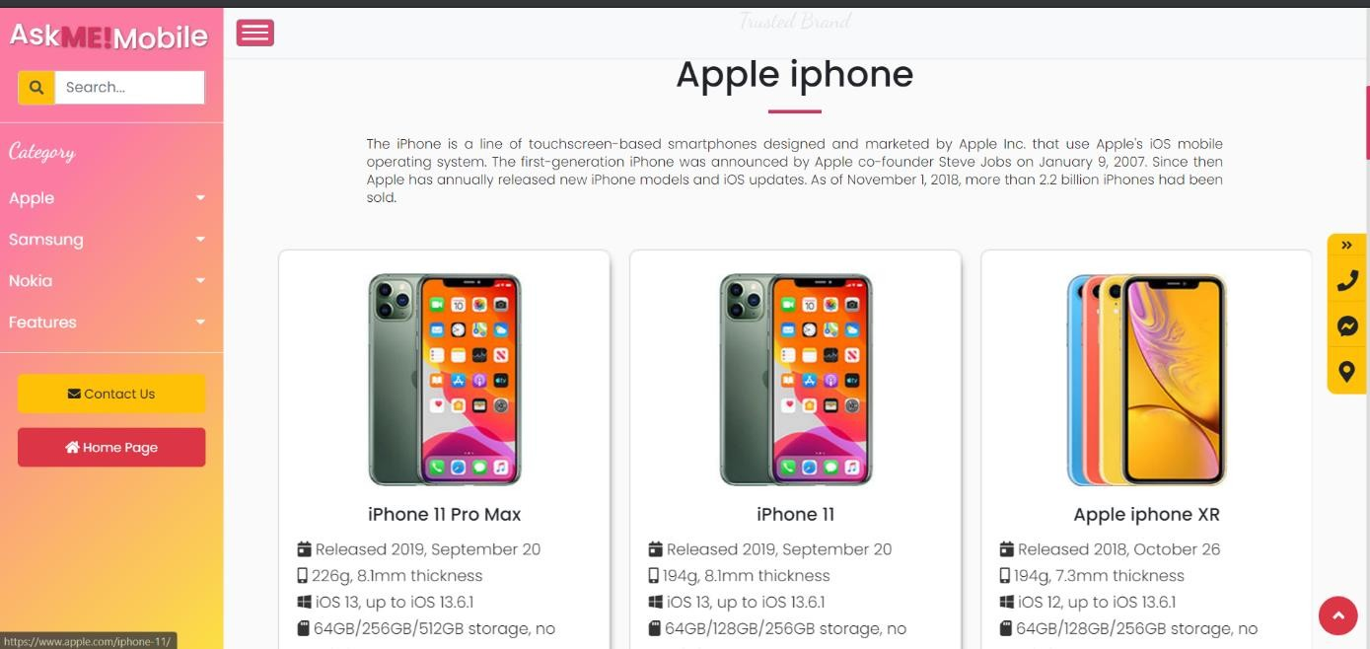

Navbar when

down,

will hide

scrolling

and

will

return as soon as users start scrolling

up again.

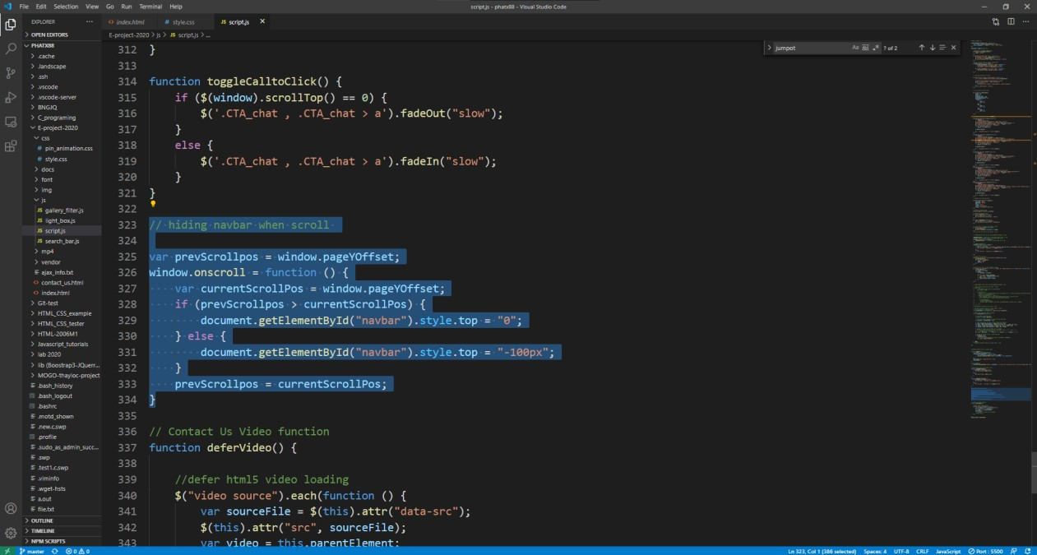JS code:

## Side Panel / Side navbar



### Search Bar & Searching Algorithm

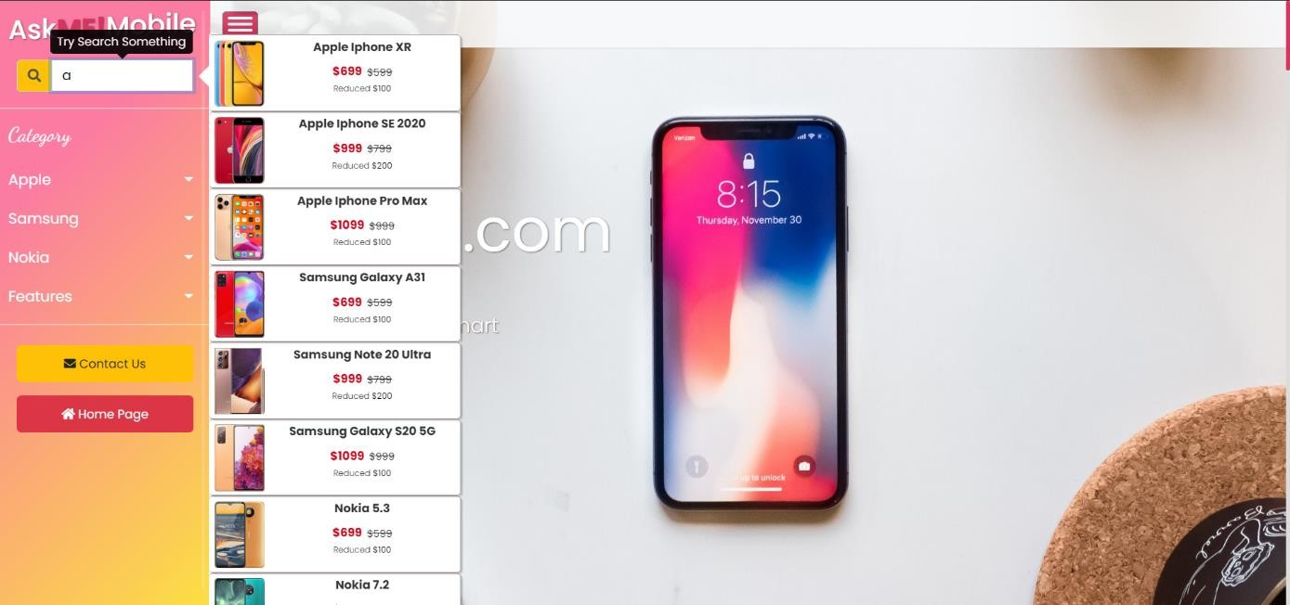

Then after filling a few keywords, a JS algorithm will start to filter out any list items that is not a match and hide it.

Similar to a Popover in Bootstrap. We created a custom Div to contain a list of product items. The custom “popup” is hidden and will show only when users start typing. User can use enter/exit key or clicking outside over body to “hide” the “popup” window.

HTML code:

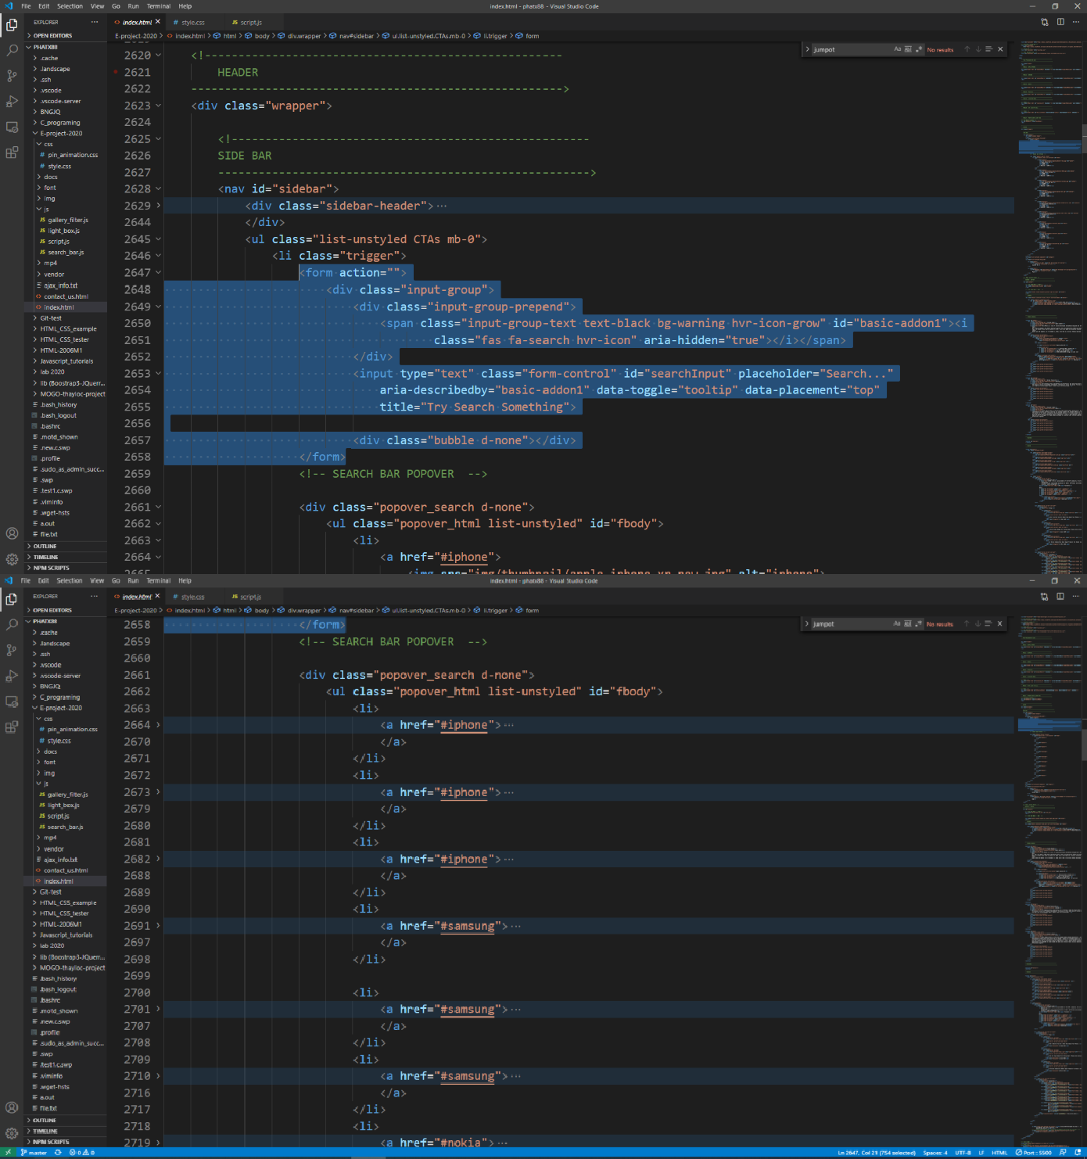

CSS code:

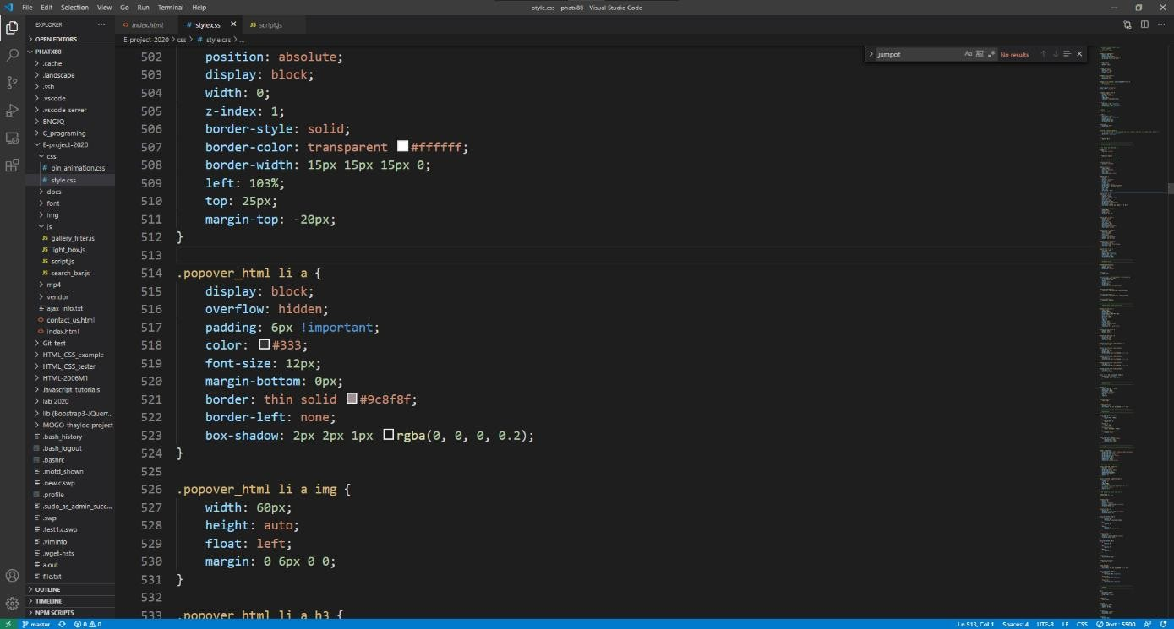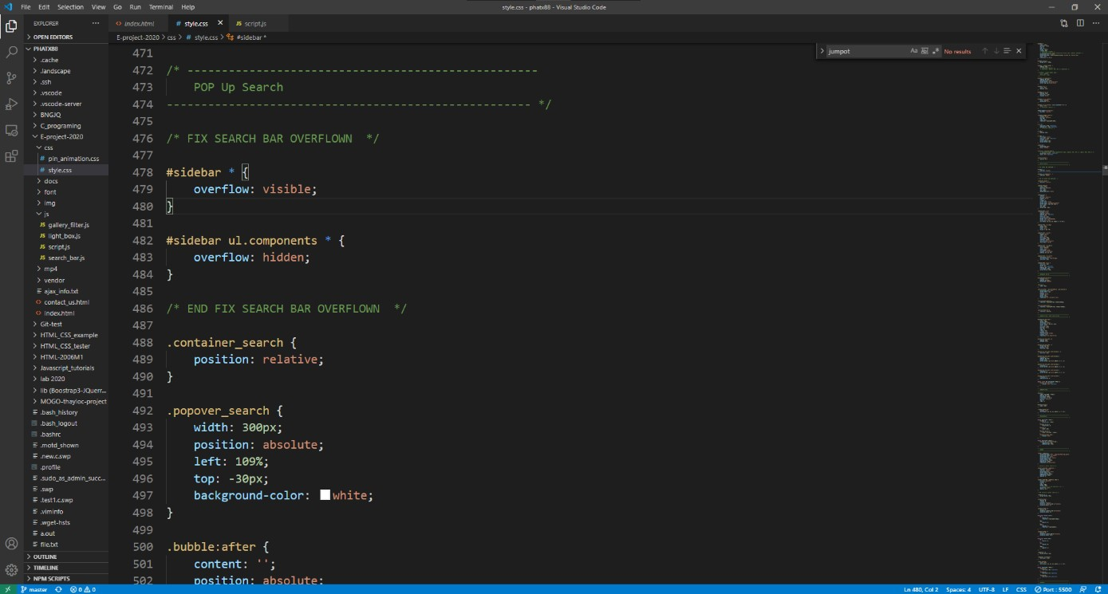

“popup” window is in position absolute to the left of parent “search” div. We encounter “overflown” problem because the main root element side panel prevent all child elements to be wider than parent’s element. The following code is to address this problem

JS code:

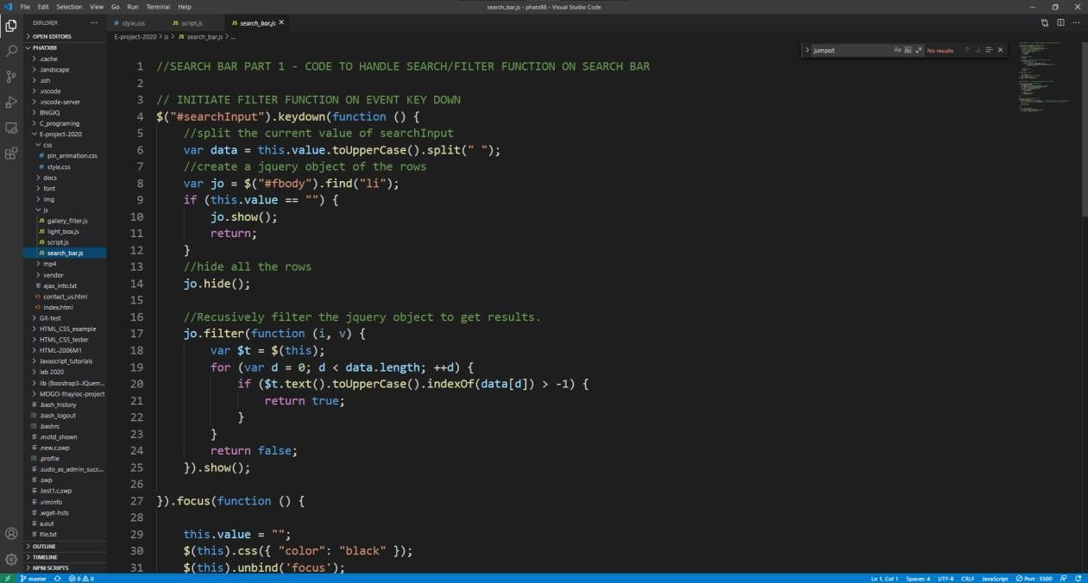

Part 1:

Algorithm to take input key, transfer to Uppercase value and start matching with value in “li”.

It will hide all li, only show those that match keywords.

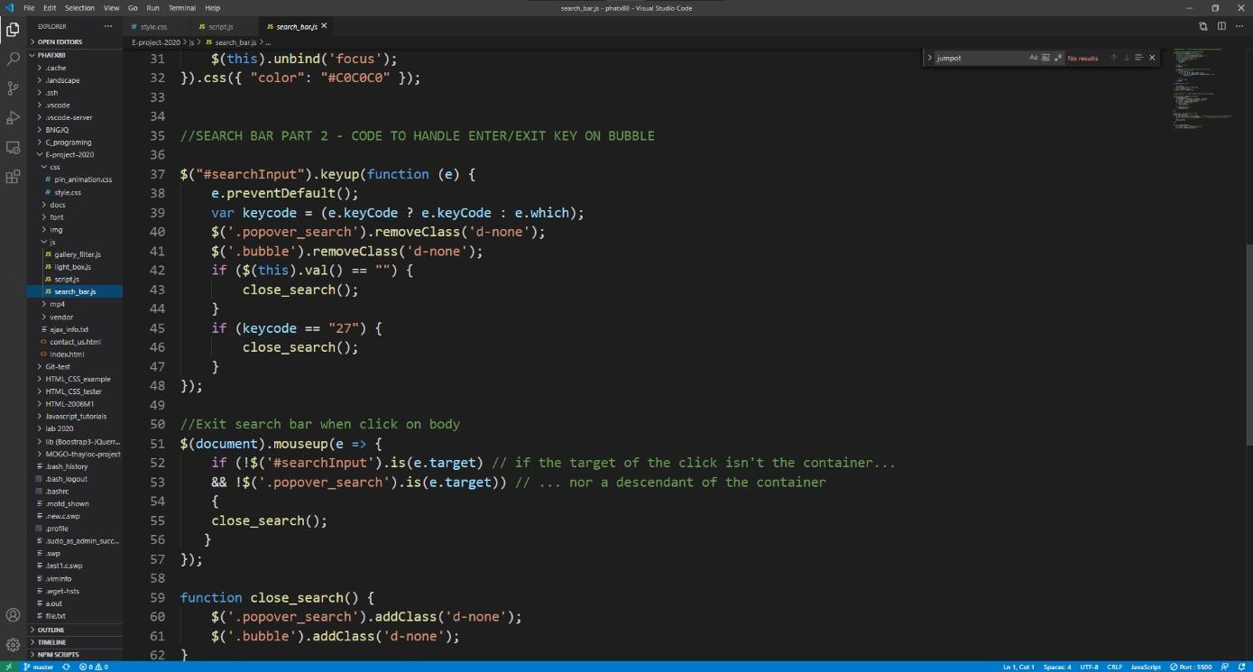

Part 2:

Is to handle enter and exit keys, it determines which input on keyboard and mouse to toggle the “popup” window.

### Drop Down Menus

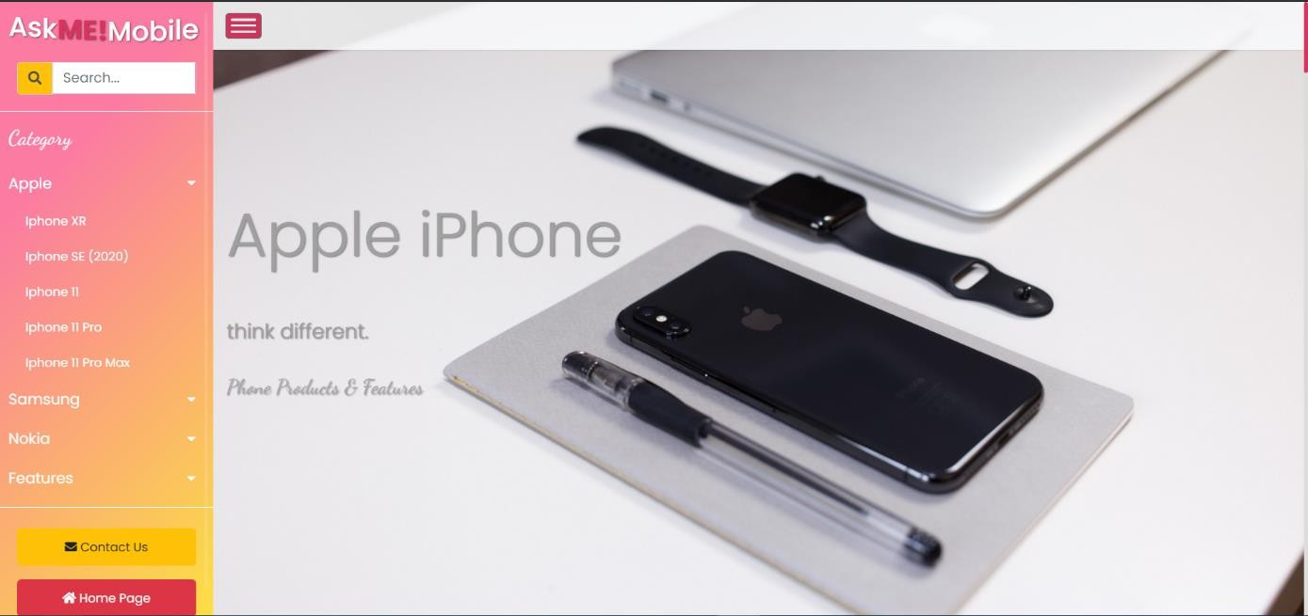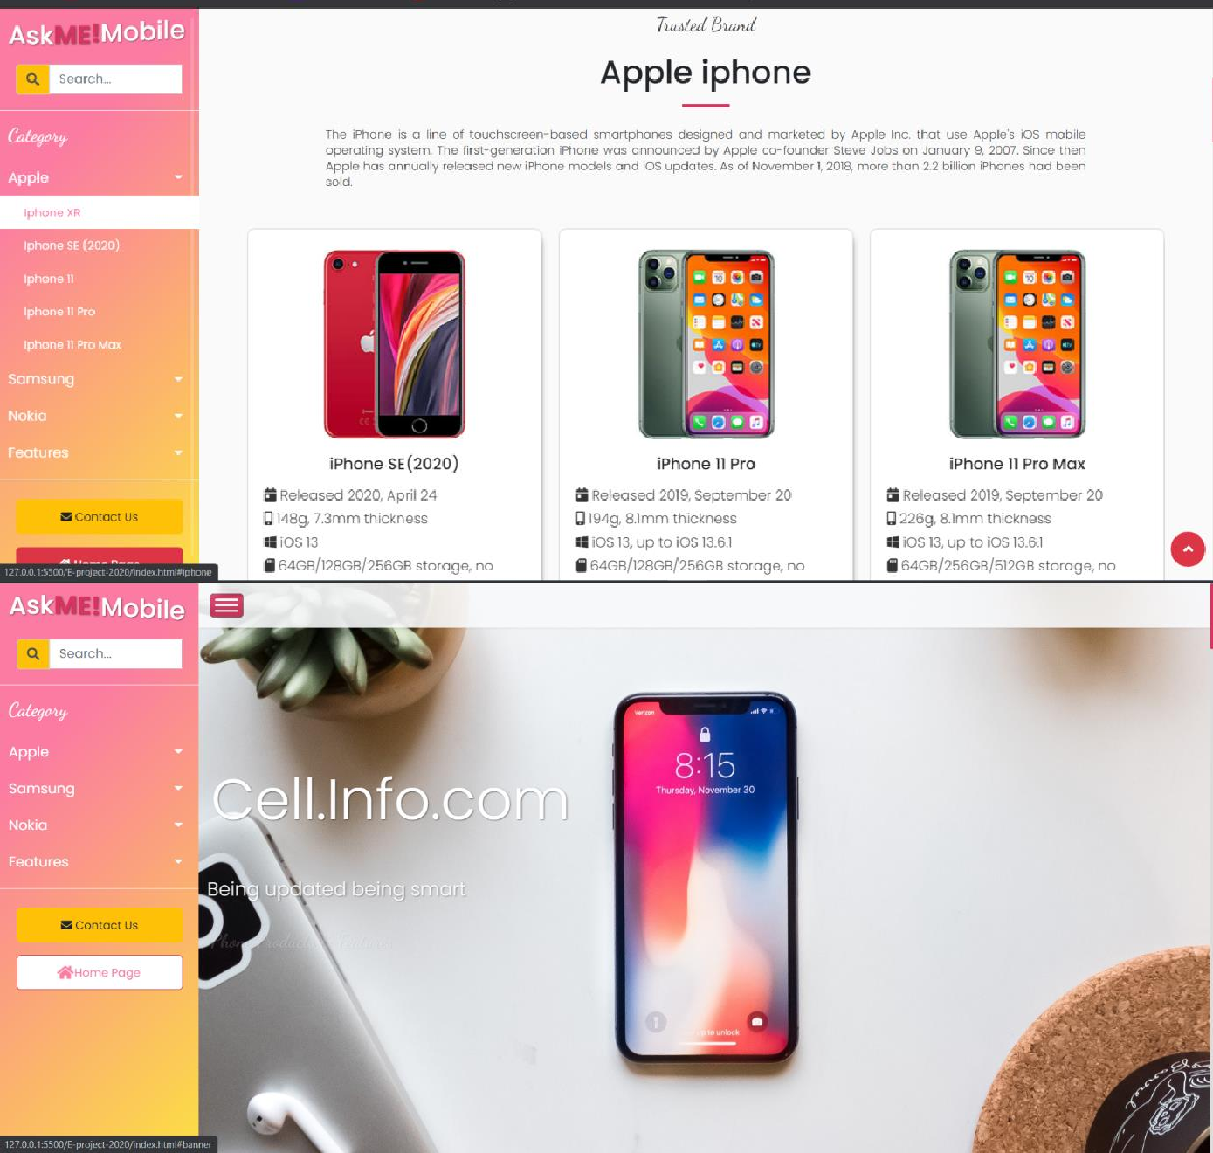

Drop down menu is built upon Bootstrap framework, it will have similar structure as standard Bootstrap navigation bar. Clicking the Nav-link item will trigger scrolling animation toward the desired anchor link.

CTA buttons to navigate between the pages.

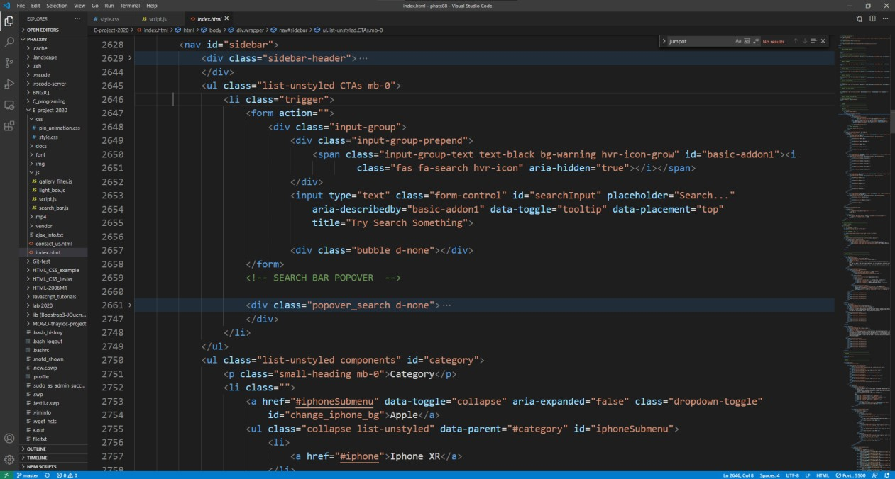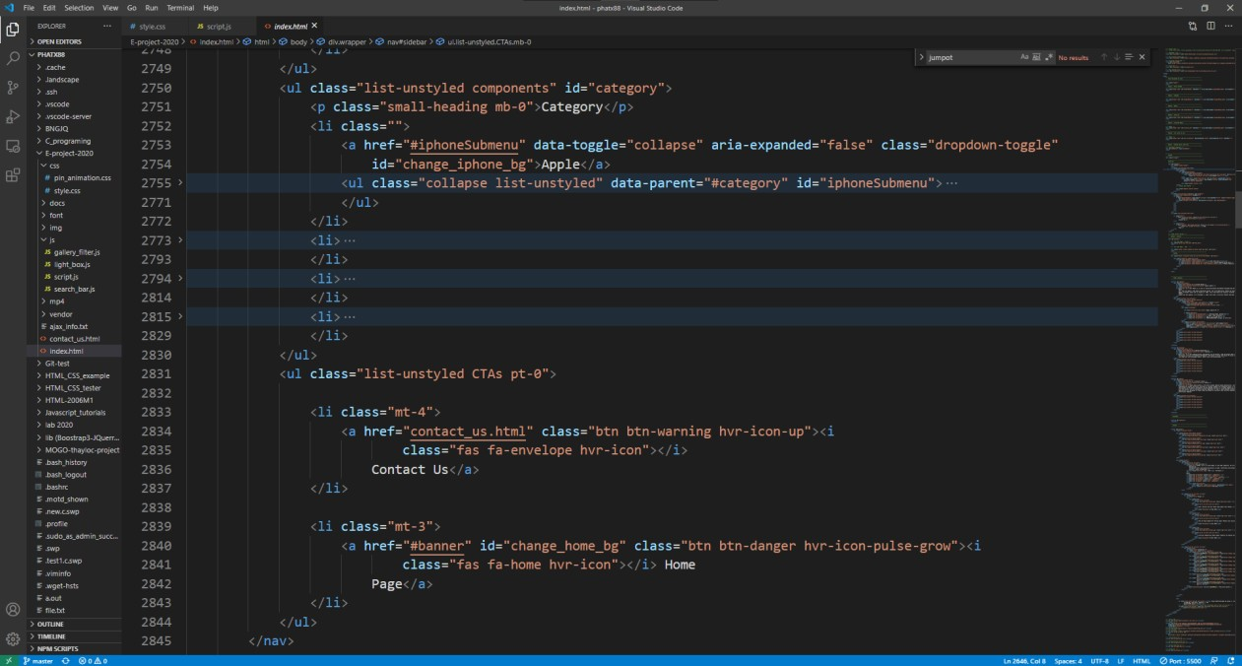HTML code:

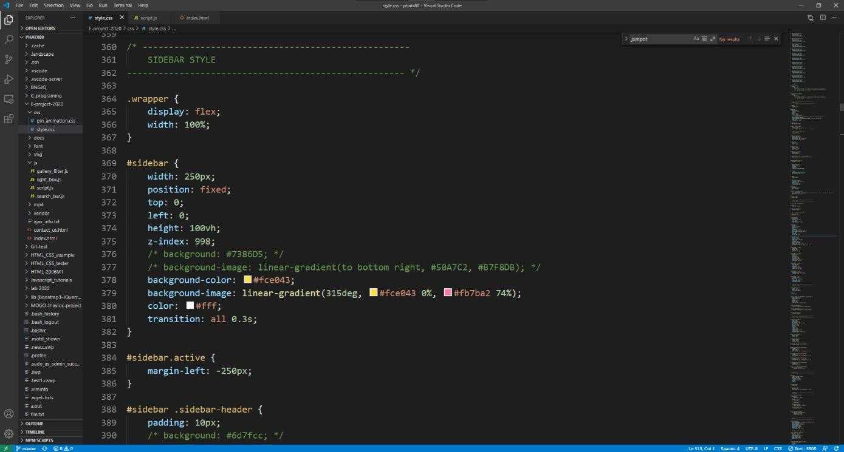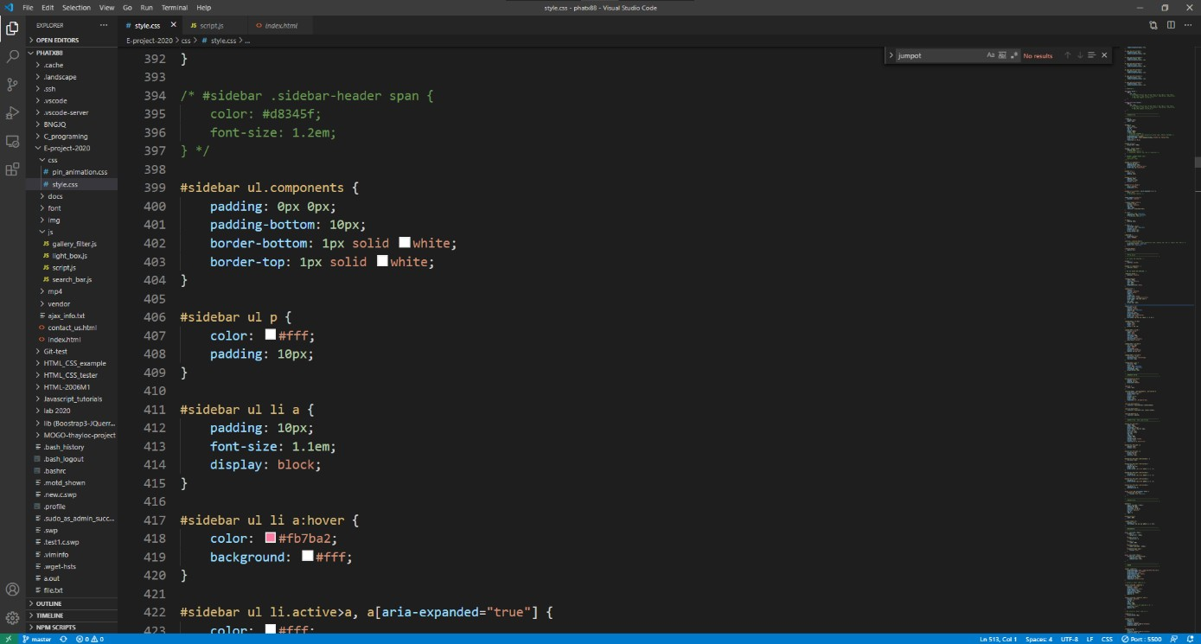CSS code:

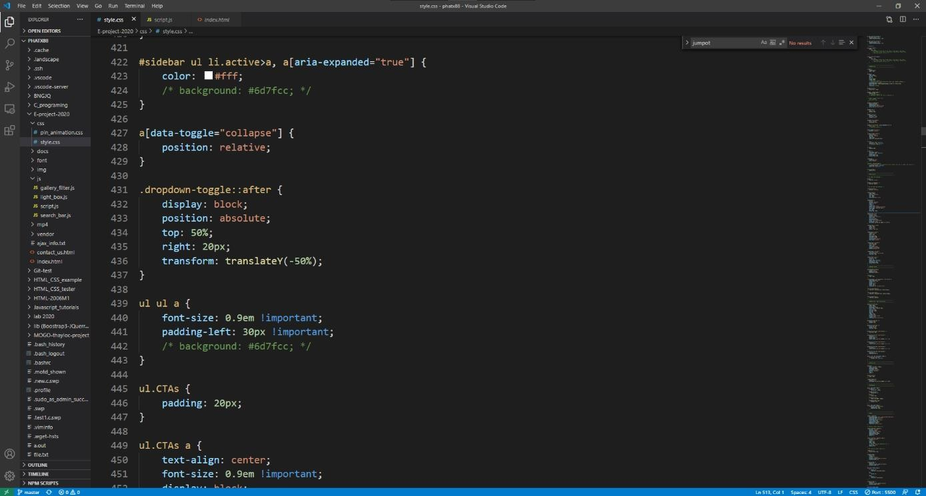

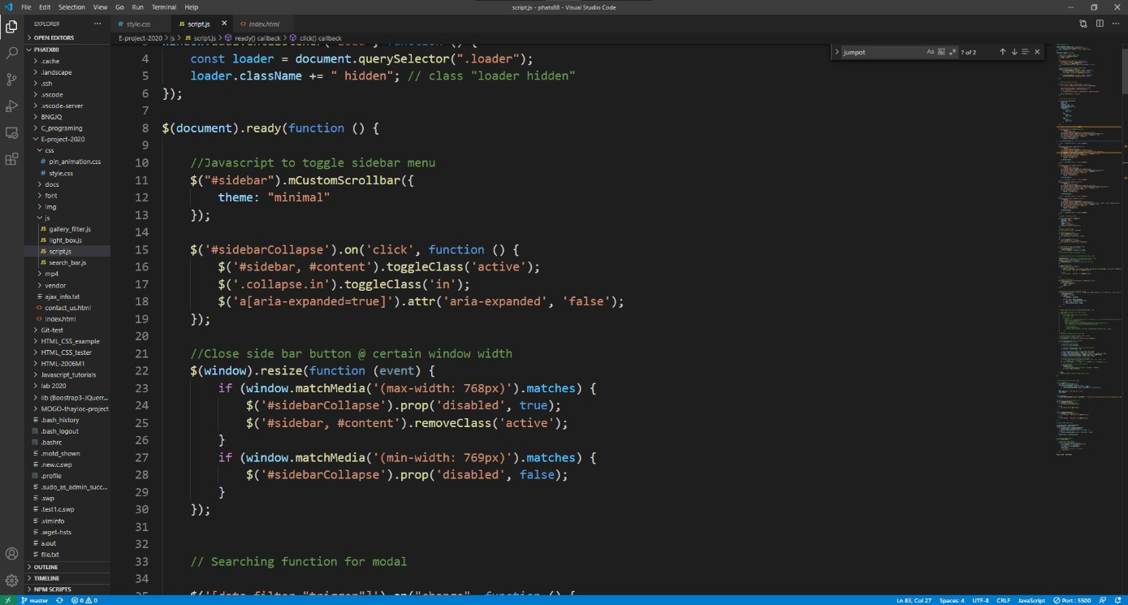

JS code:

Dropdown menu use the standard code template from Bootstrap 4 to open/close dropdown items.

### Side Panel Responsiveness on smaller screen

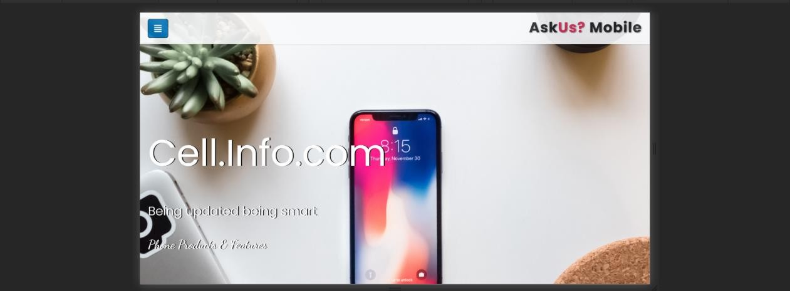The side panel will close automatically when on medium screen or smaller (width < 992px)

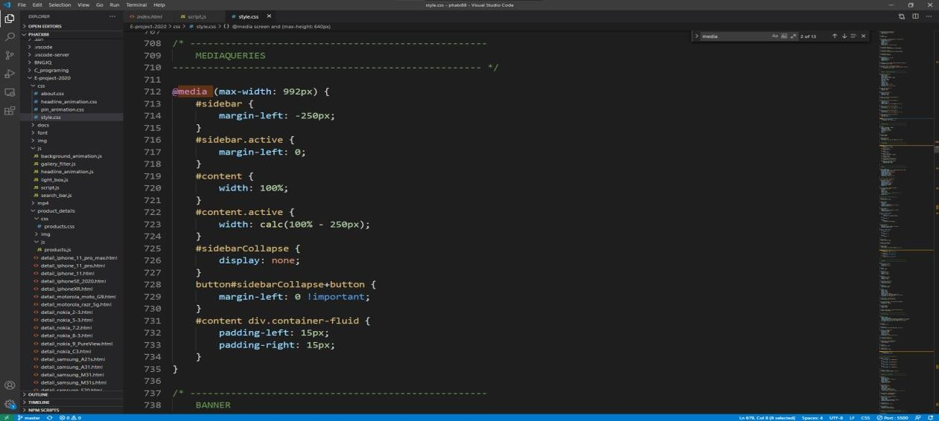

CSS and jQuery code triggered on resizing of browser window.

CSS code:

JS code:

1

pg. 5

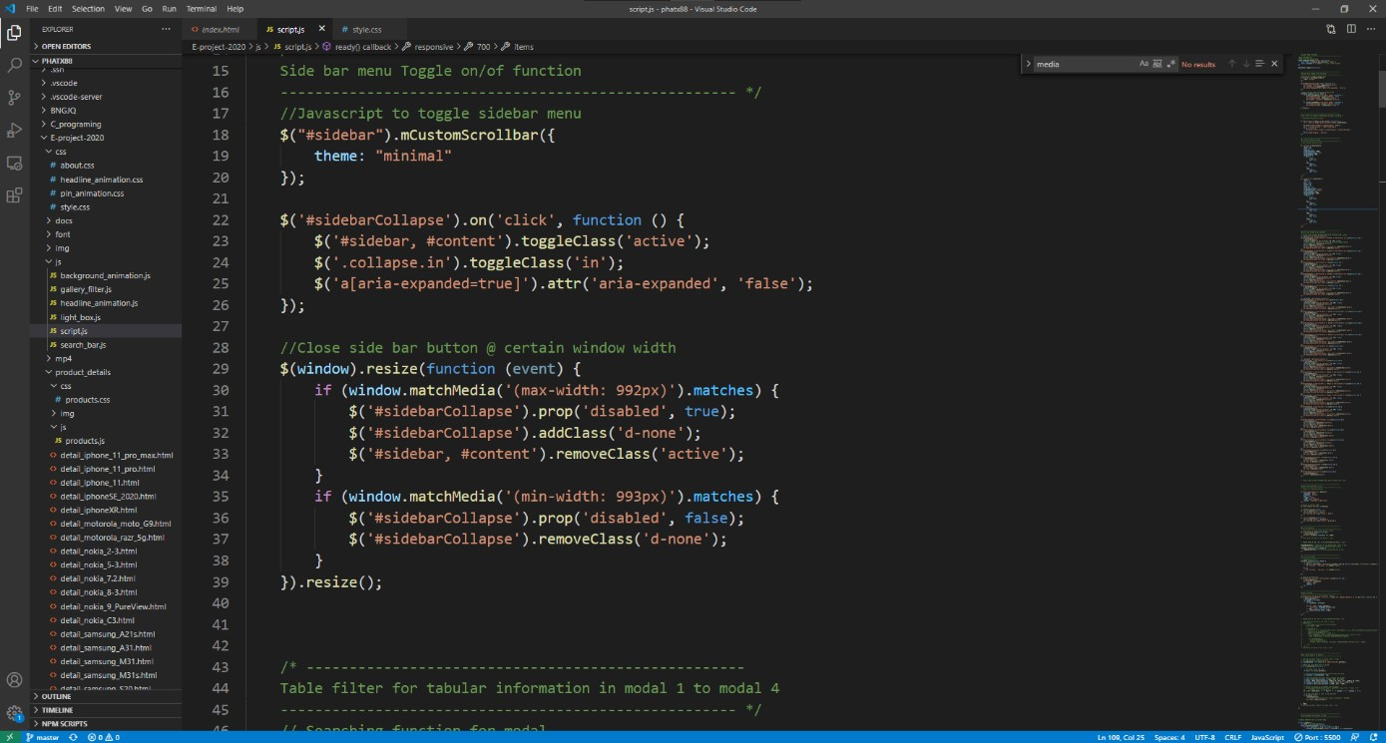

## Home Page - Hero Banner –

### Header Text Animation

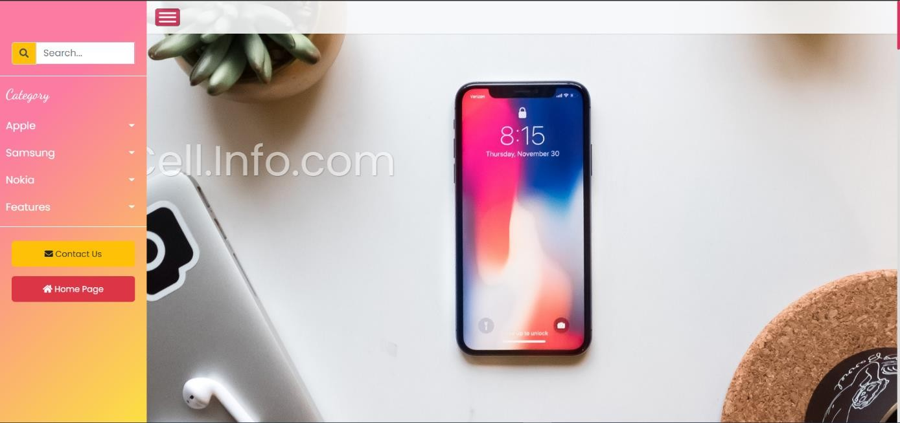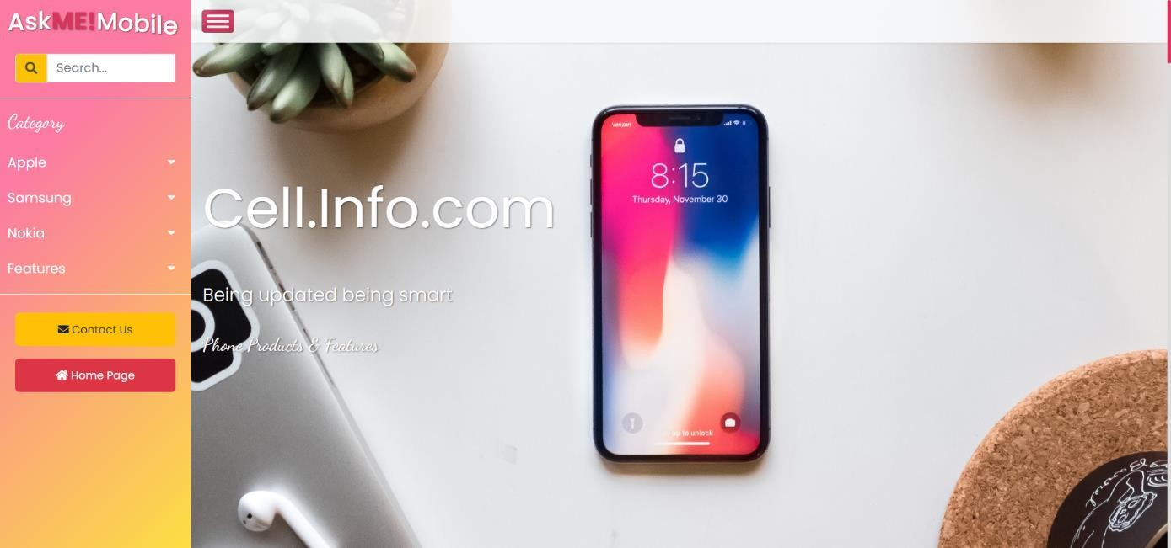

HTML code:

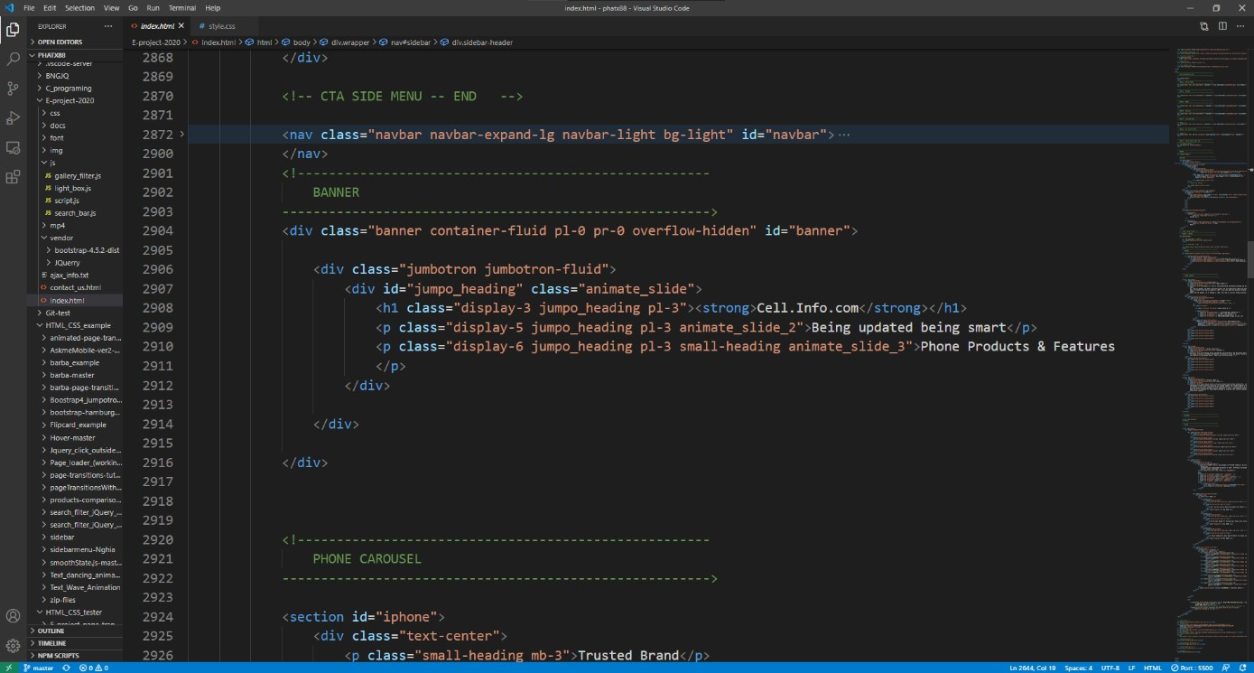

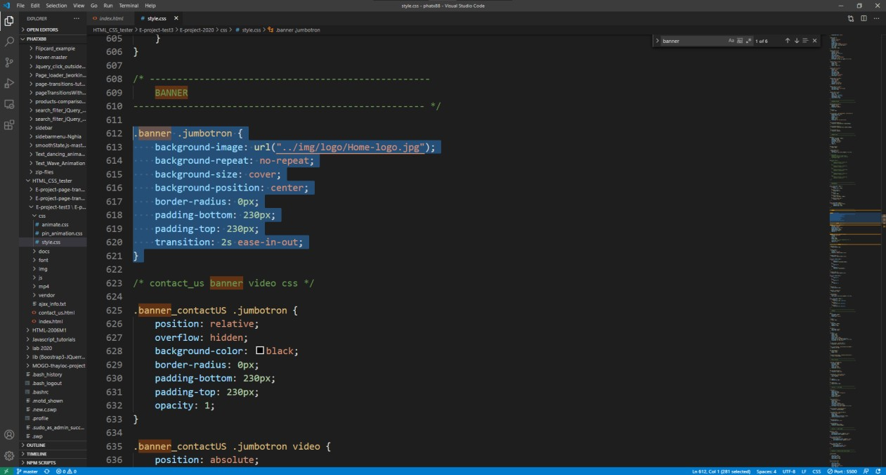CSS code:

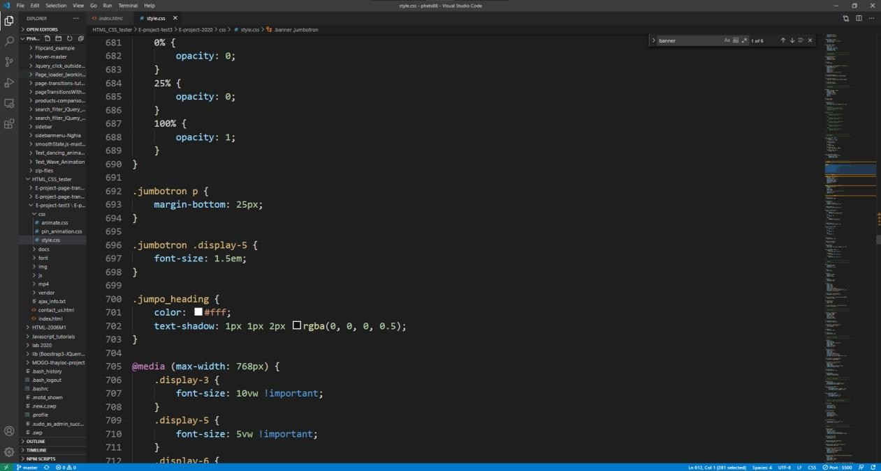

Media queries for

responsiveness

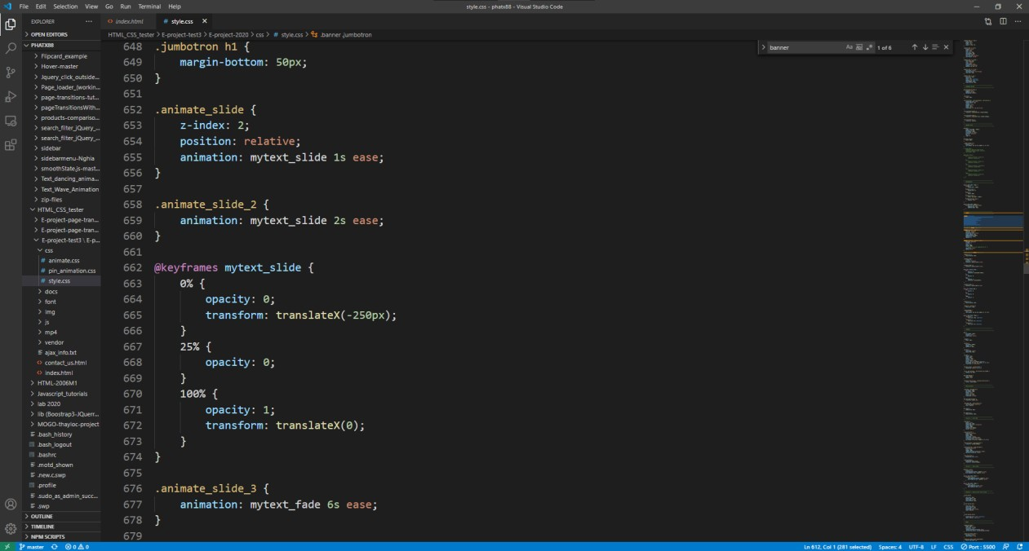

CSS animation to handle sliding in animation

### Changing Background Image Animation

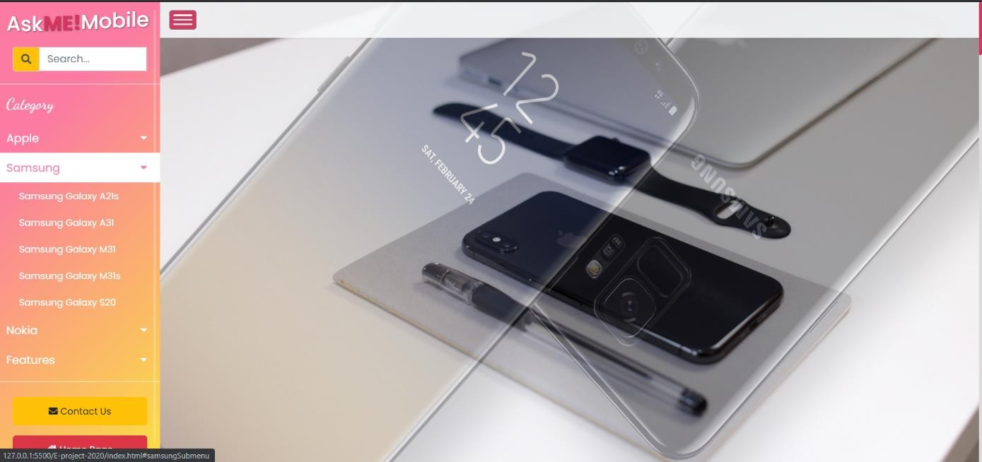

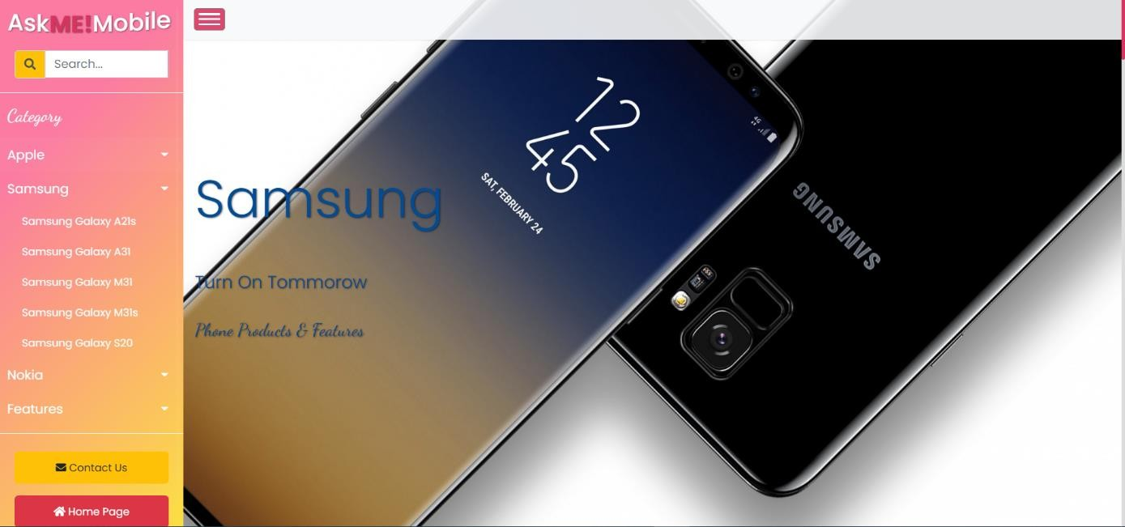

JS code:

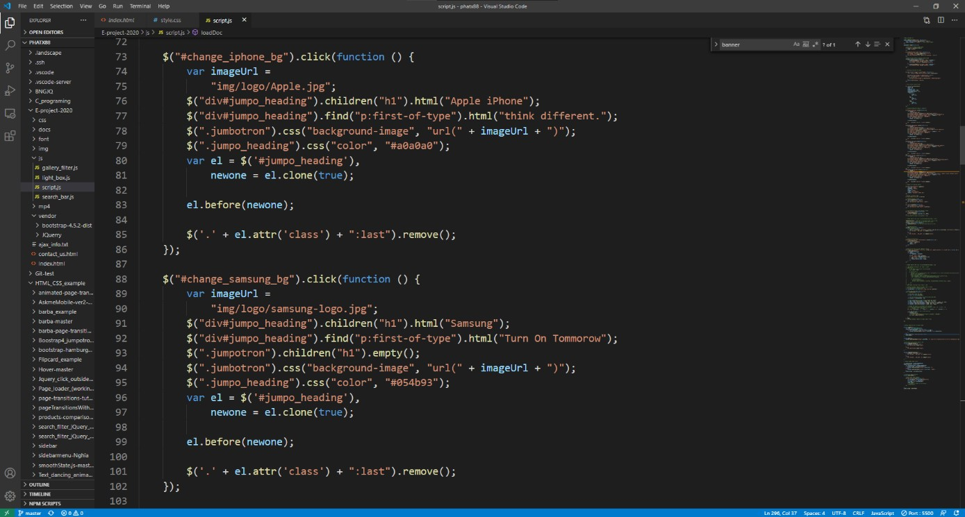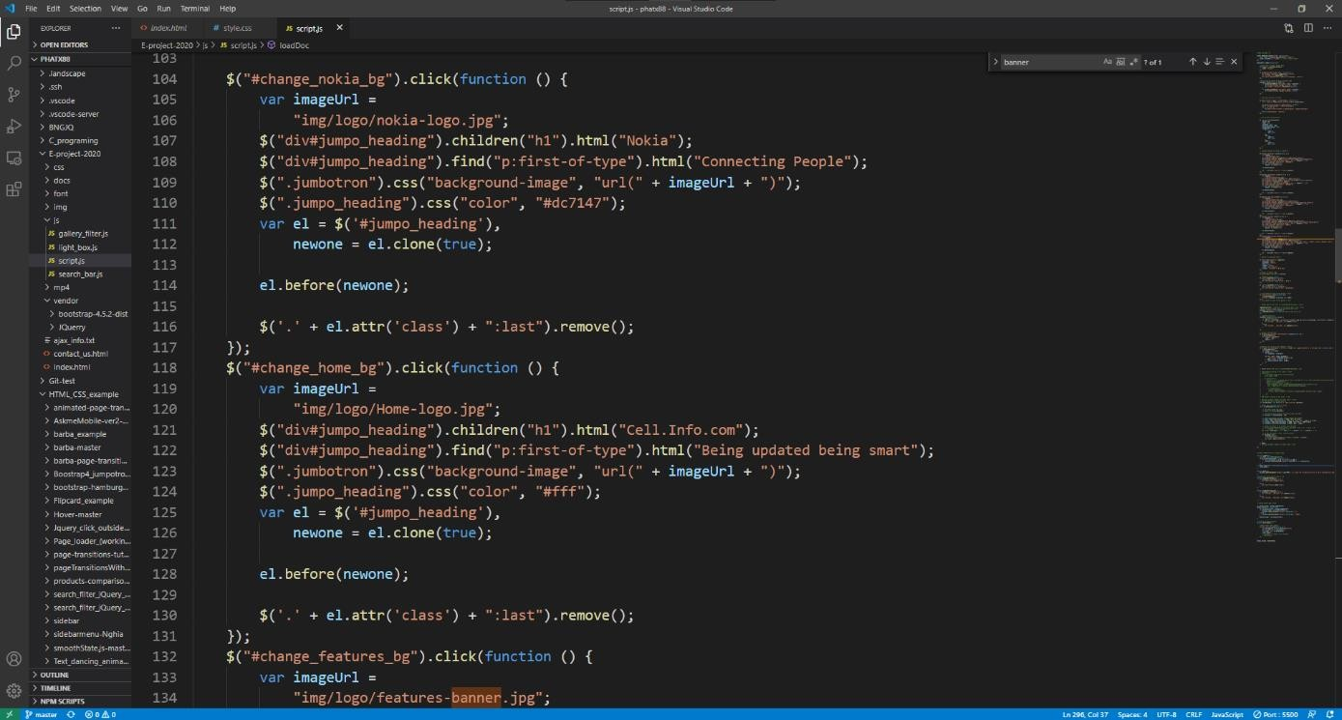

JS code to change image url, and text display

* 1. **Home Page - Main Section**
     1. **Main Section – Owl Carousel**

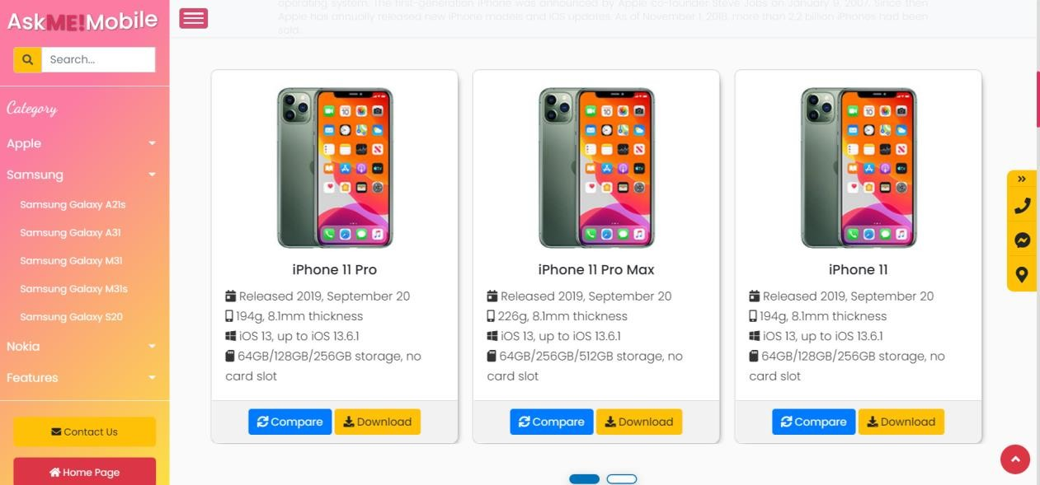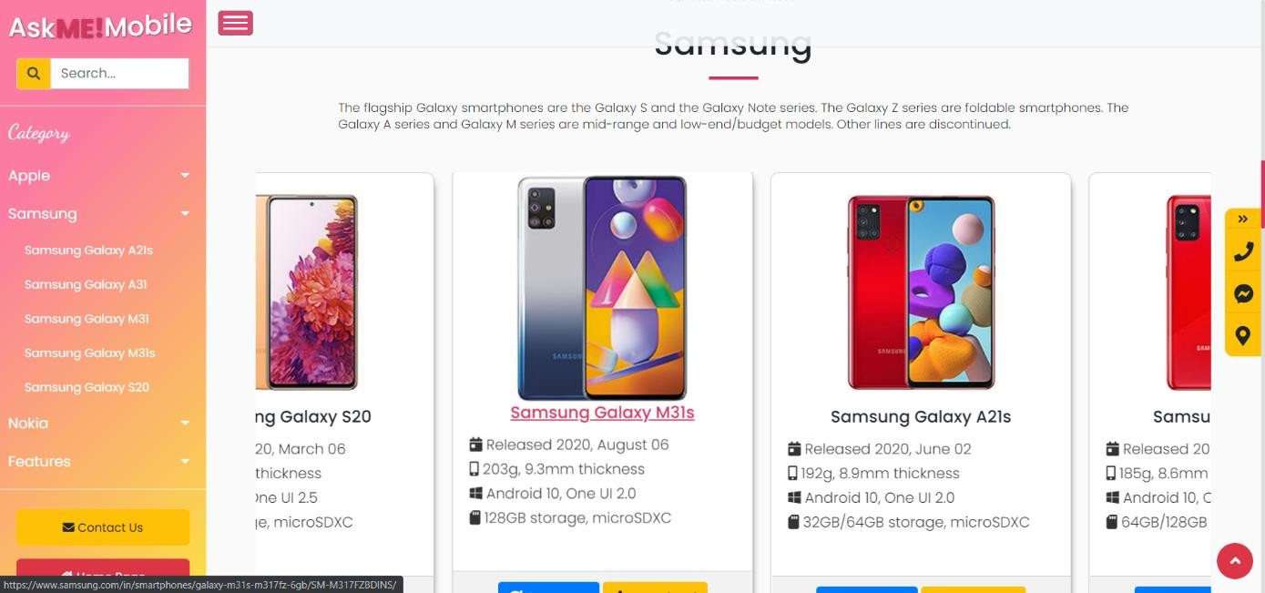

Carousel will move left/right by dragging mouse button. We use owl carousel plugin for our project

There are 3 items of total of 5 items, the owl carousel will remove last item at the end of the loop and append it at the beginning. This will create an endless loop pictures slide show.

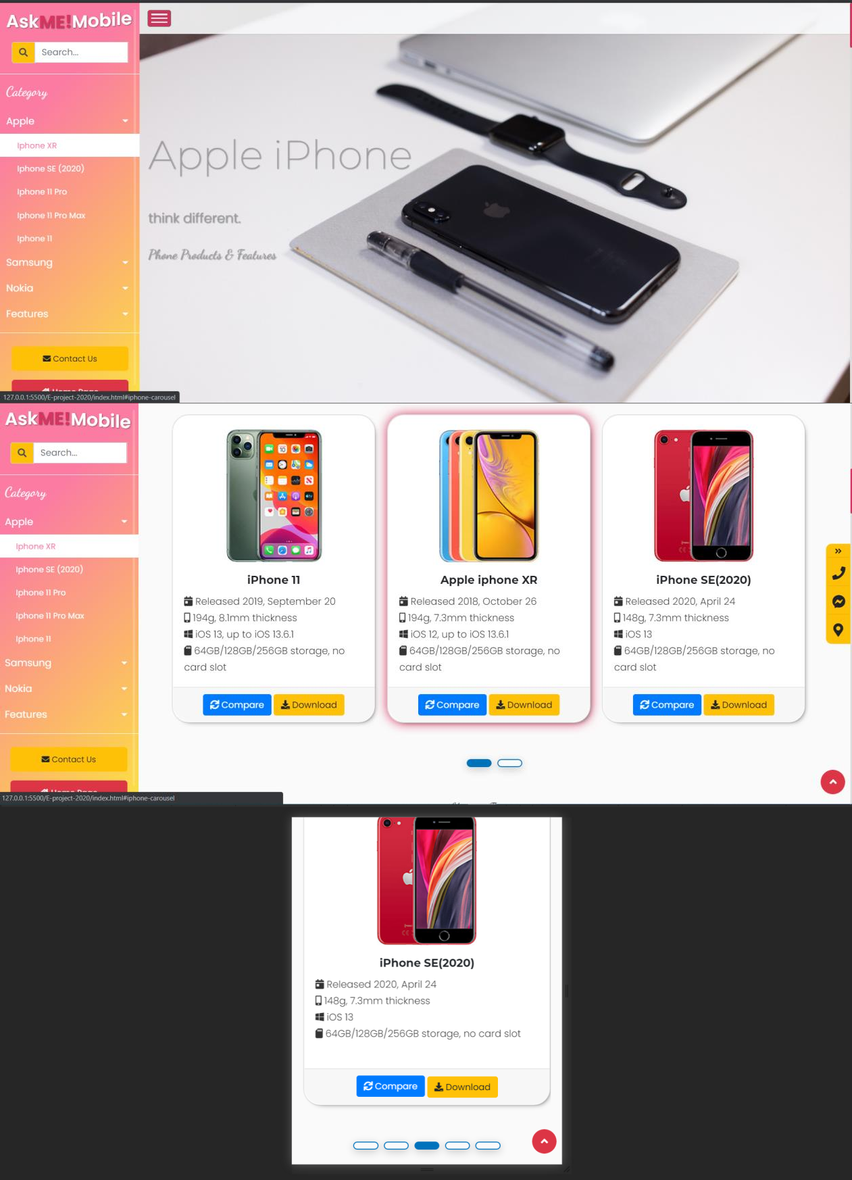

The code in owl carousel can also allow us to greatly customize it. Here is an example:

Click on this link will move the view window to the item located within owl carousel

It also have many options to handle responsiveness. Such as ‘dots’, ‘nav’,

‘repsonsive’ options

HTML code:

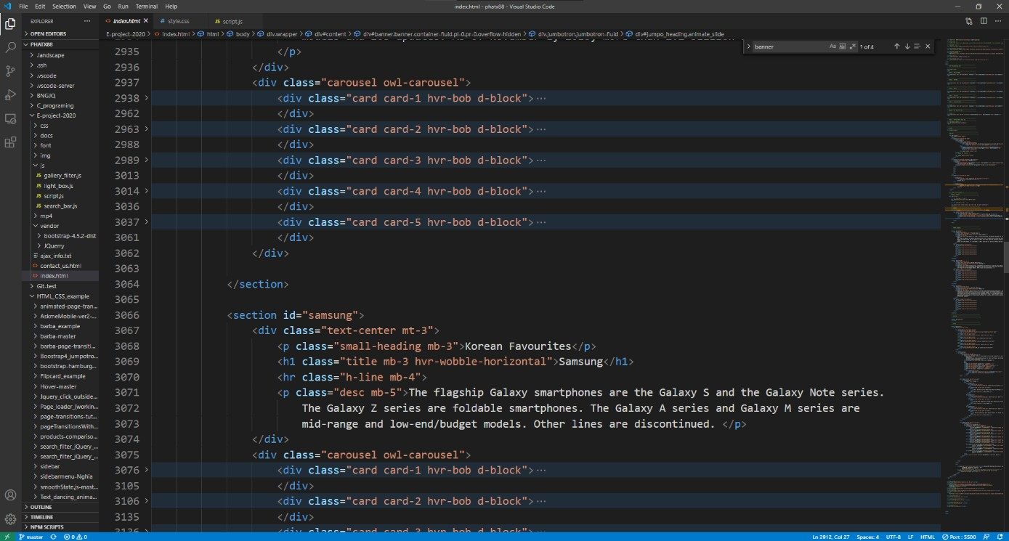

CSS code:

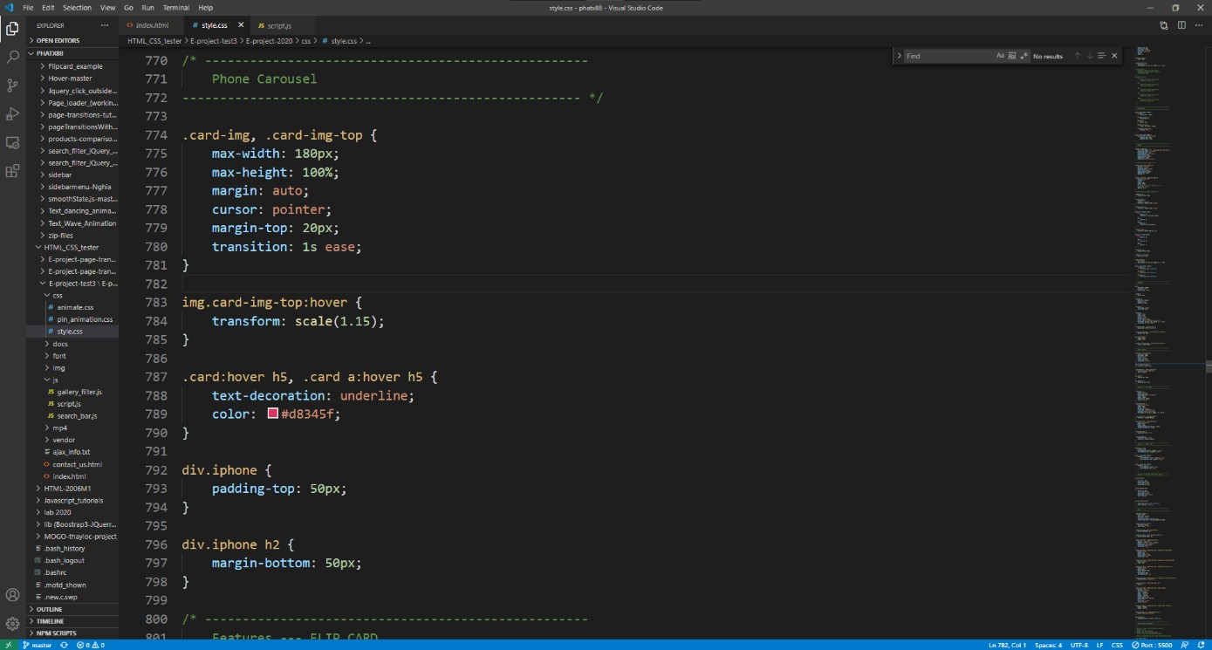

JS code:

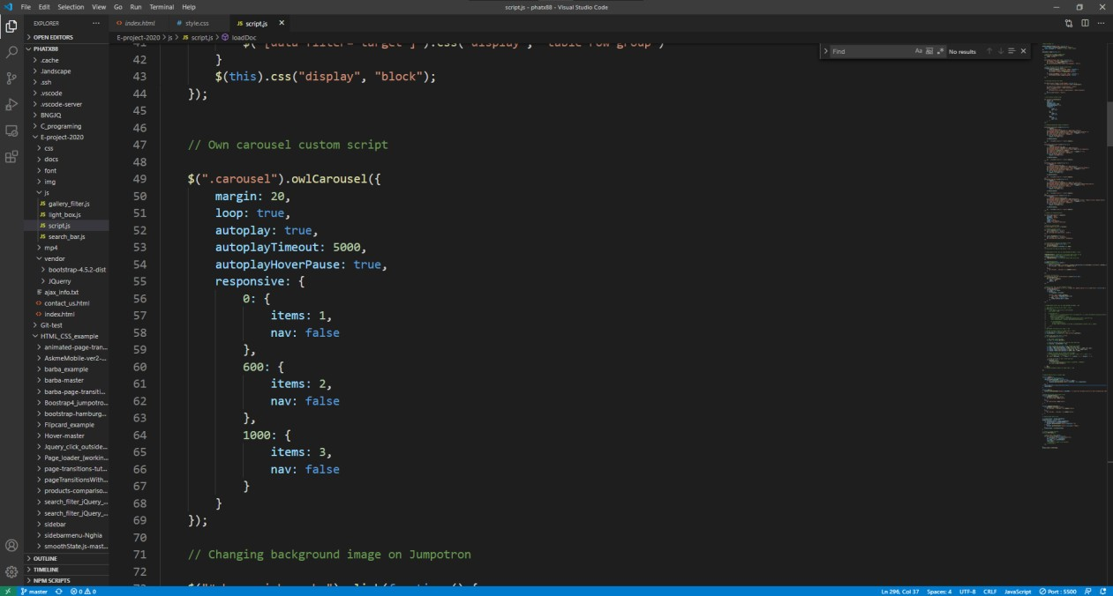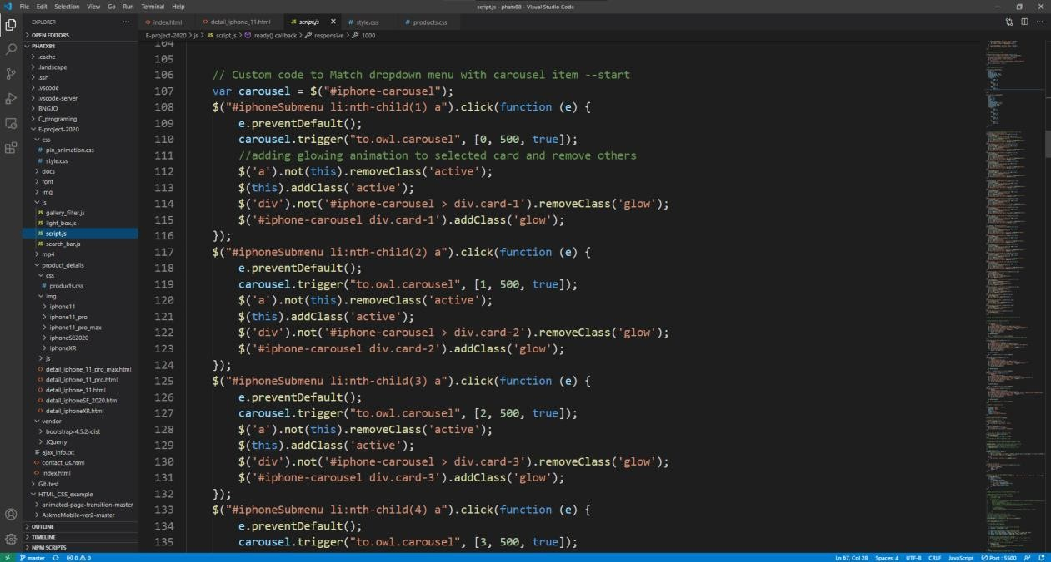

We use “to.owl.carousel” to move slide to certain position, it creates an effect of linking item from viewing window.

Owl Carousel to set custom sliding time

* + 1. **Main Section – Gallery with filter buttons–**

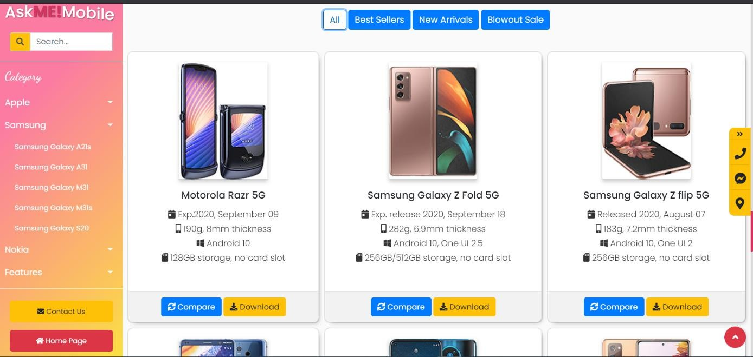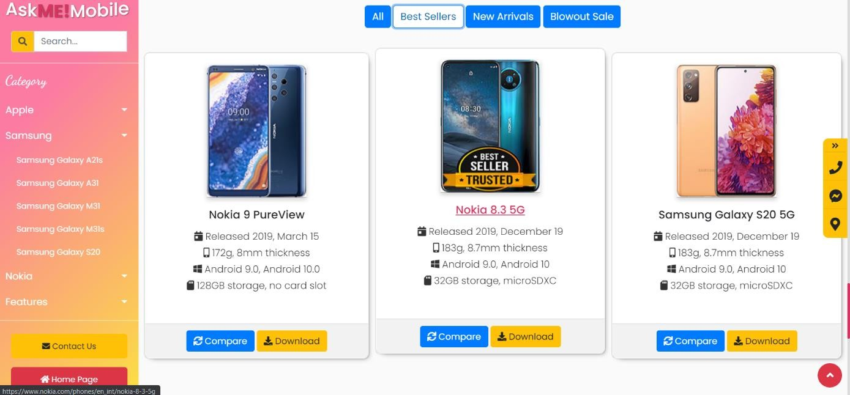

Clicking filter will show only desired products

HTML code:

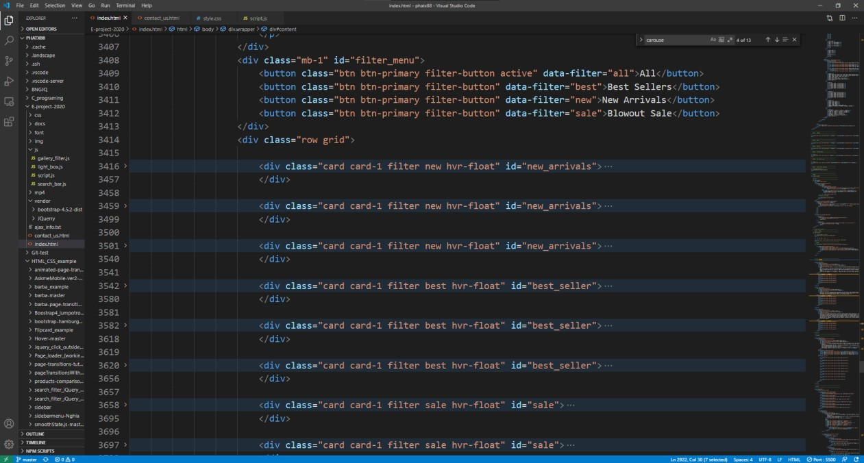

Use CSS grid to organize individual phone items.

CSS code:

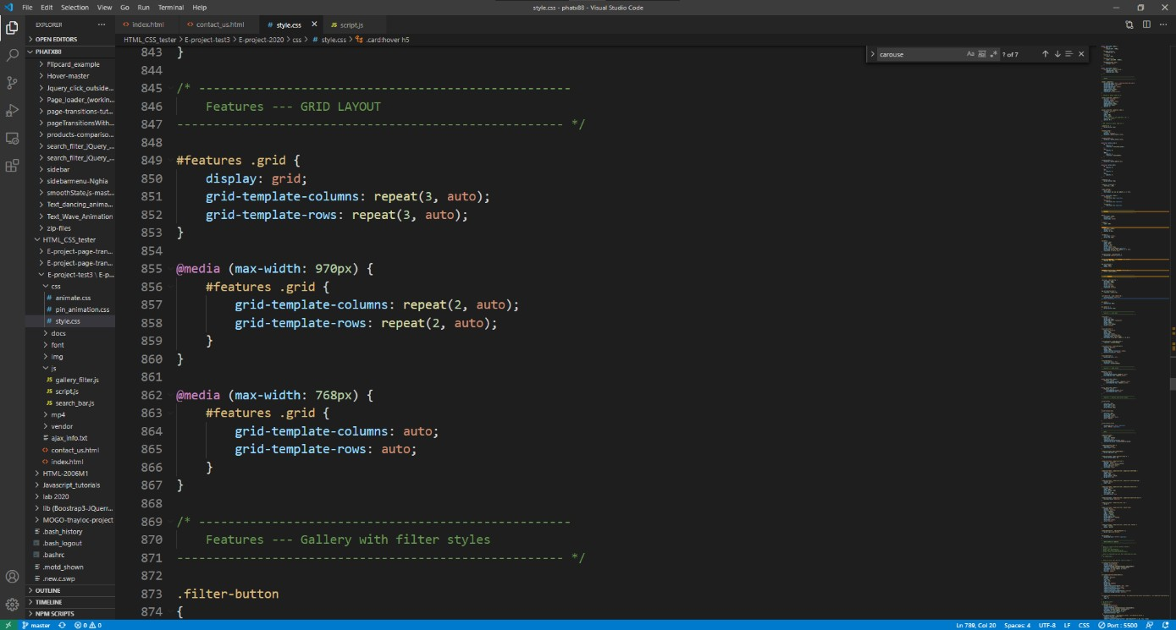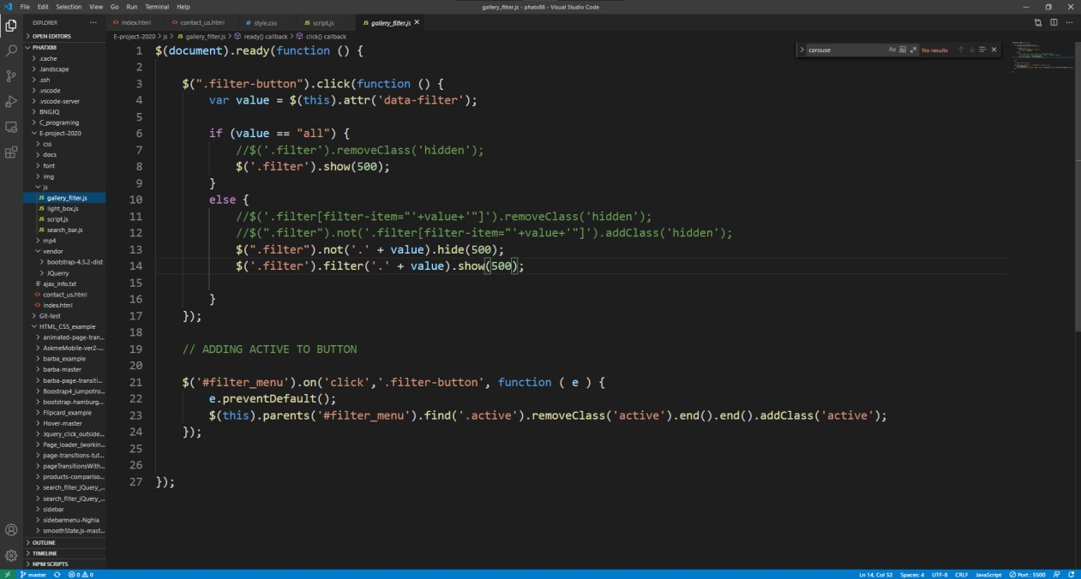

JS code:

Algorithm to insert attr[‘data-filter’] when clicking to certain button. Using JQuery selector (.’filter’) to decide to show if attr[‘data-filter’] is a match and to hide if attr not match.

* + 1. **Main Section - Compare & Download Modals –**

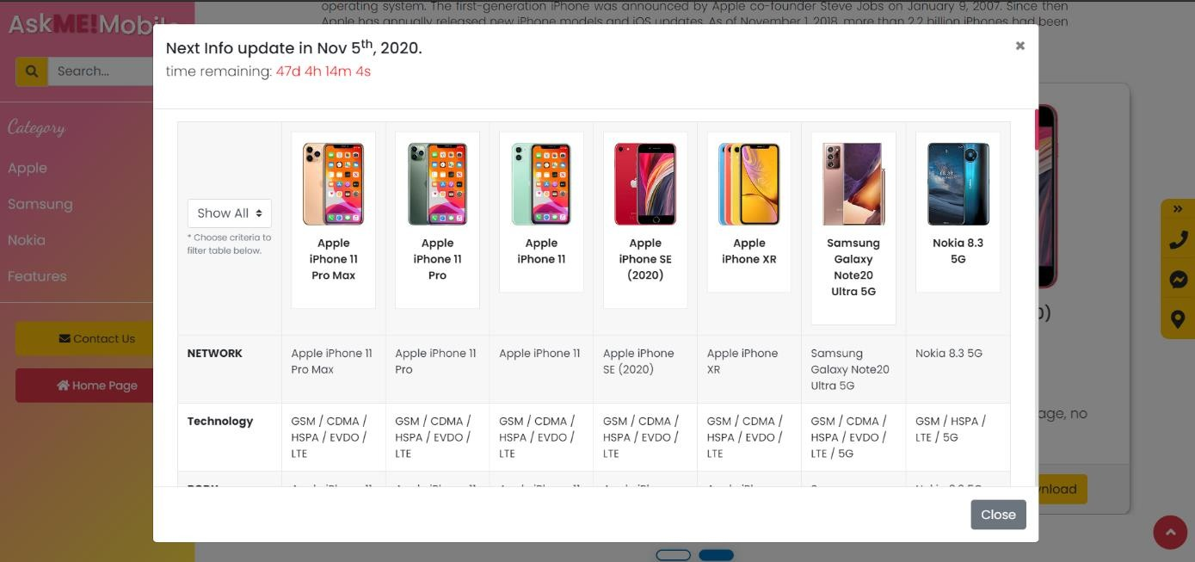

Clicking compare will open a modal. A tabular info table is inserted within the modal

A countdown timer reminder set to expired in 1 month

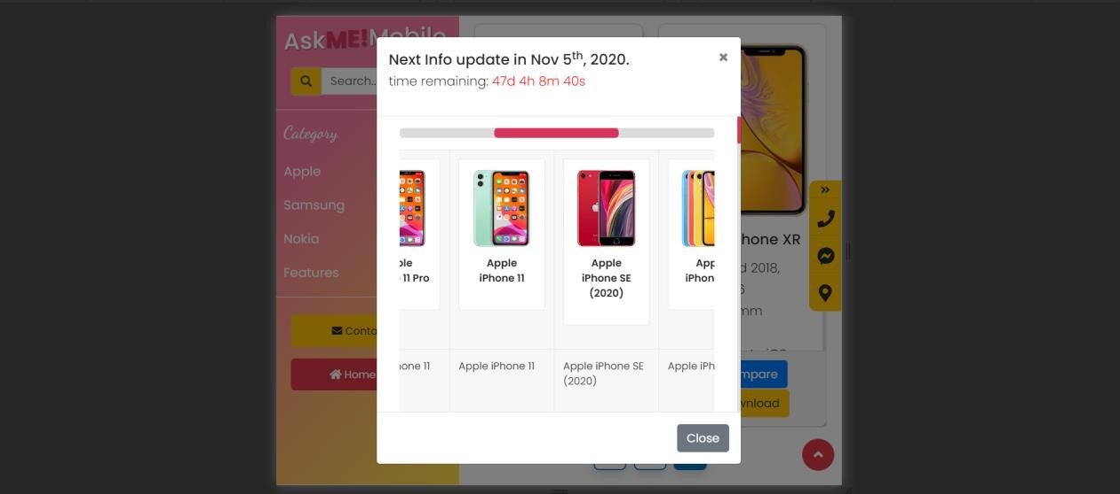

Clicking “Download”

We flipped the bottom scroll bar to the top for user accessibility when screen is less than 768px.

HTML code:

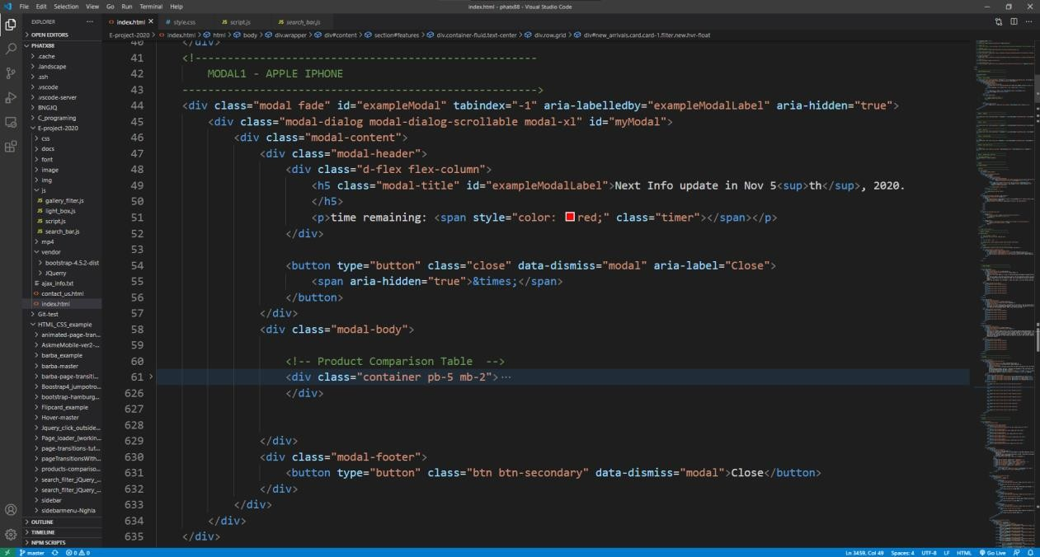

The modal html is copied from Bootstrap 4 documentation. Our project used the standard scrollable modal template.

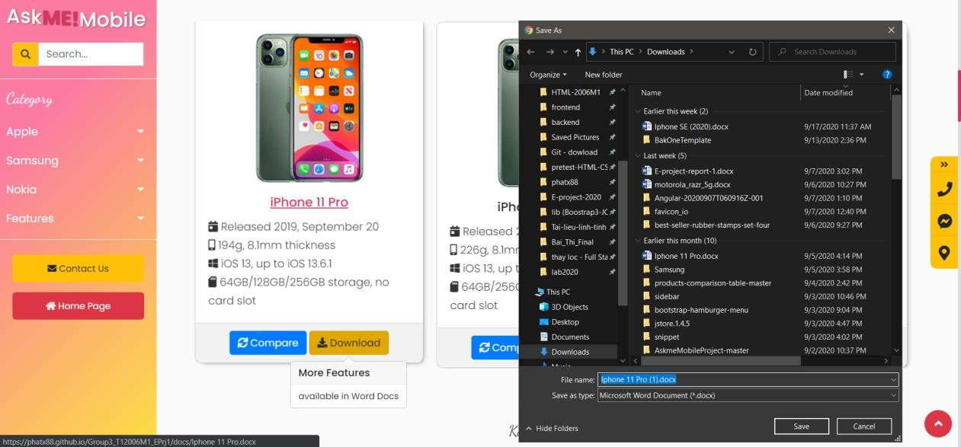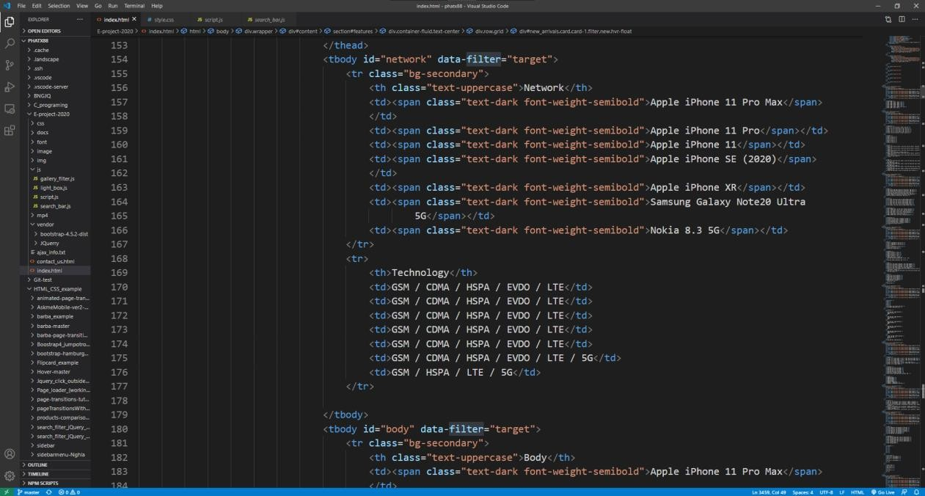

We fill table with information, table layout is standard thead, tbody, and

tfooter

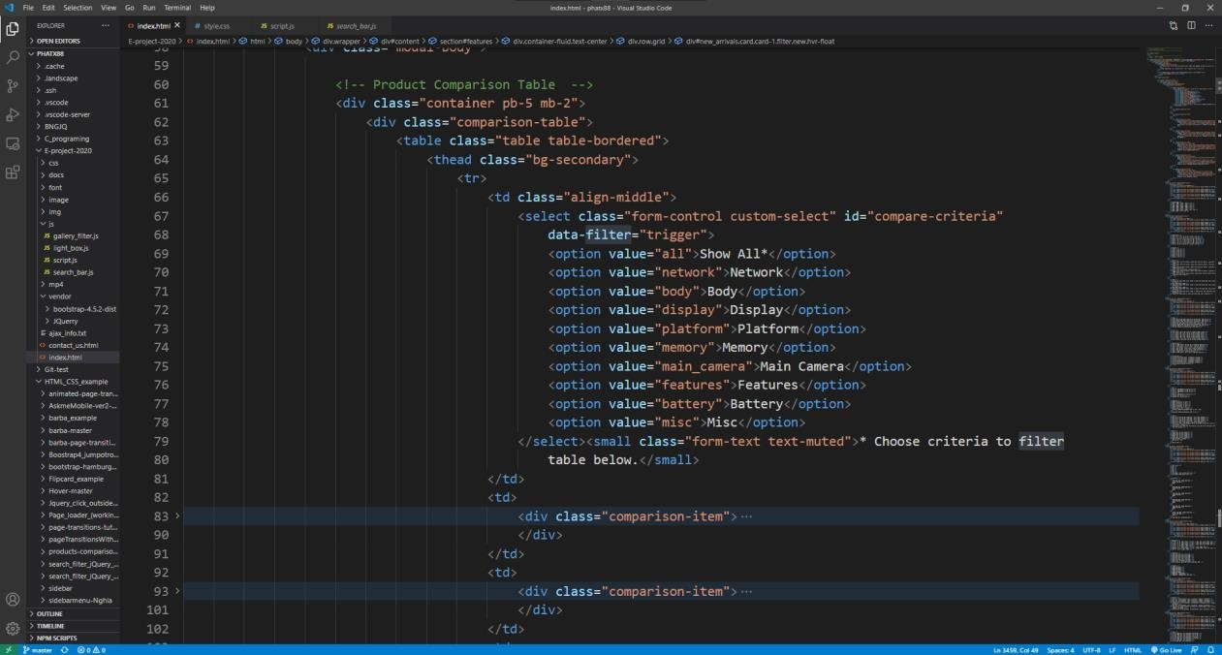

Select option to choose and categorize tabular info

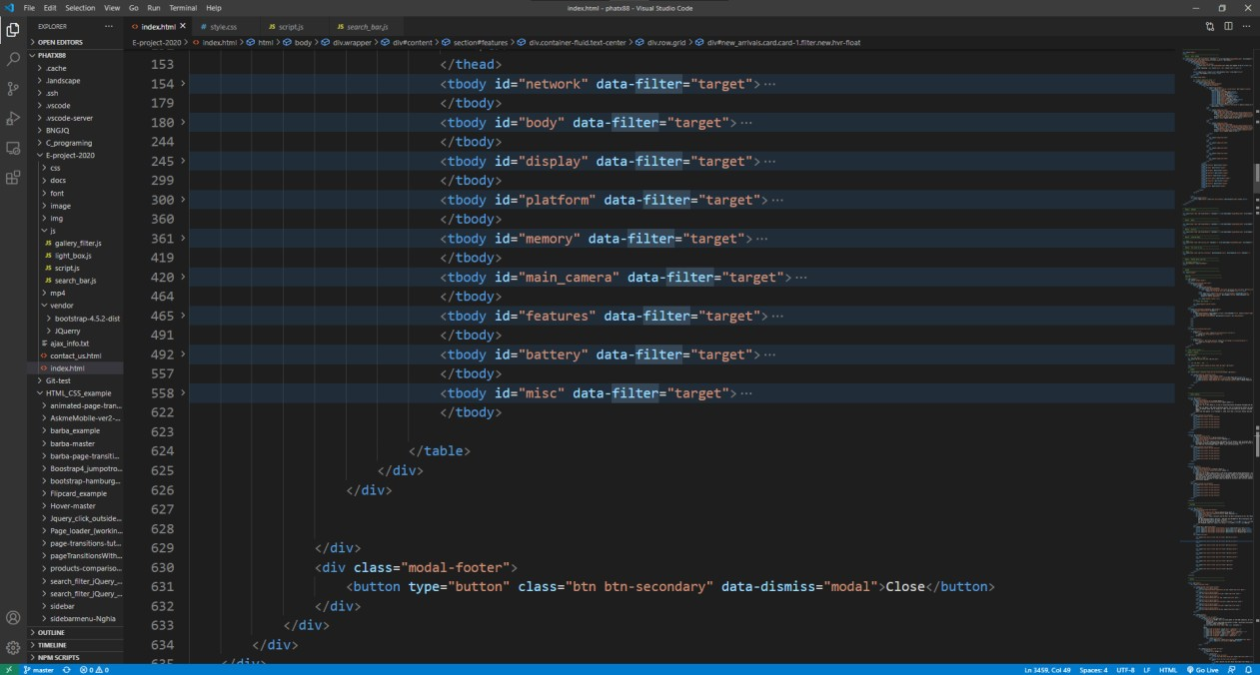

CSS code:

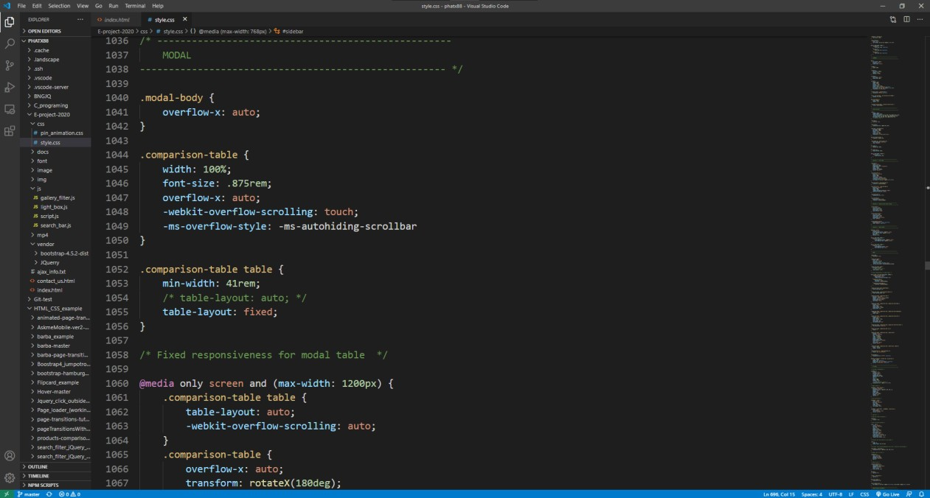

We designed the table to be able to handle small mobile screen. Users is able to scroll horizontally when overflown. This design decision is to enhance user accessibility without causing

frustration when reading on small screen.

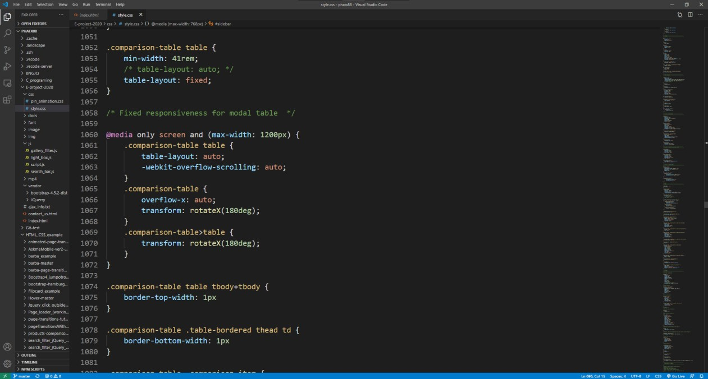

Then we flipped the scroll bar from bottom to top.

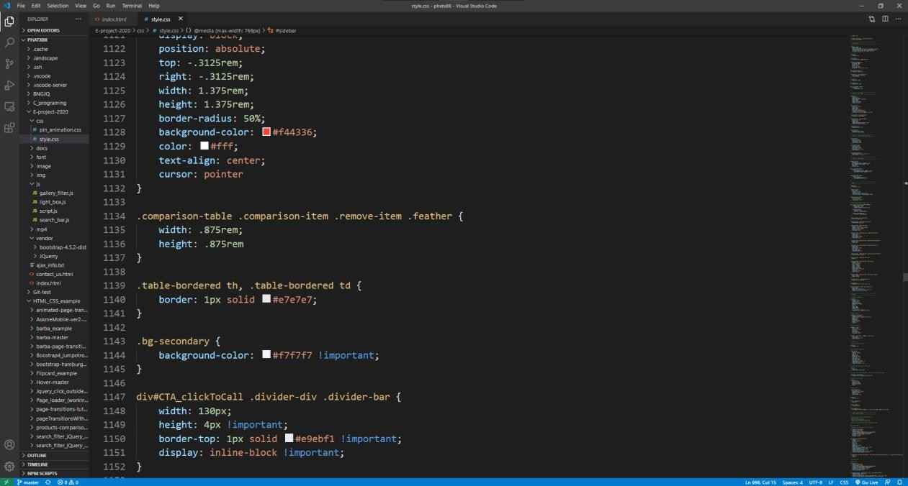

JS code:

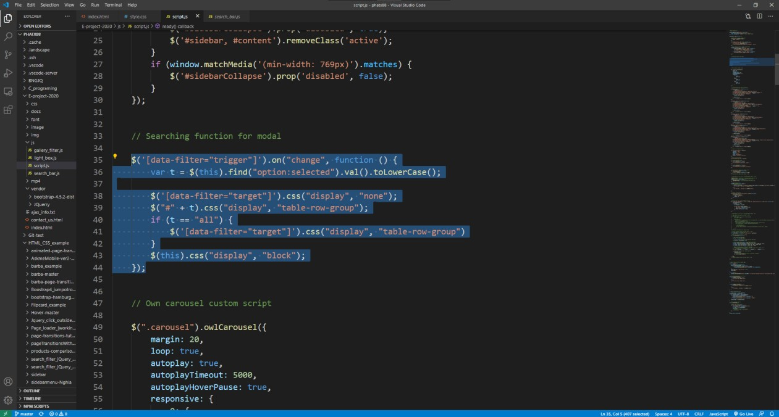

Sorting Algorithm for the table.

* 1. **Side Panel Call To Action Modals**

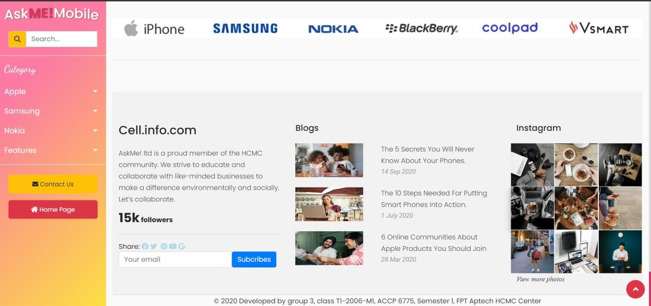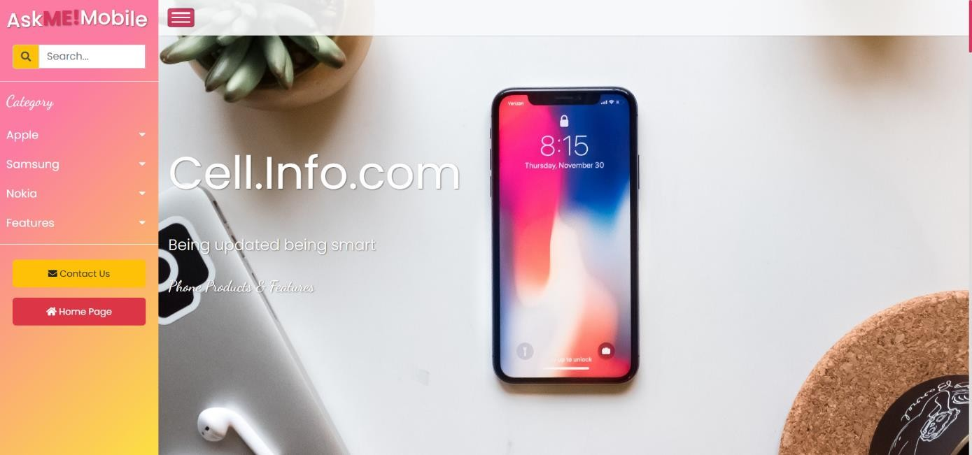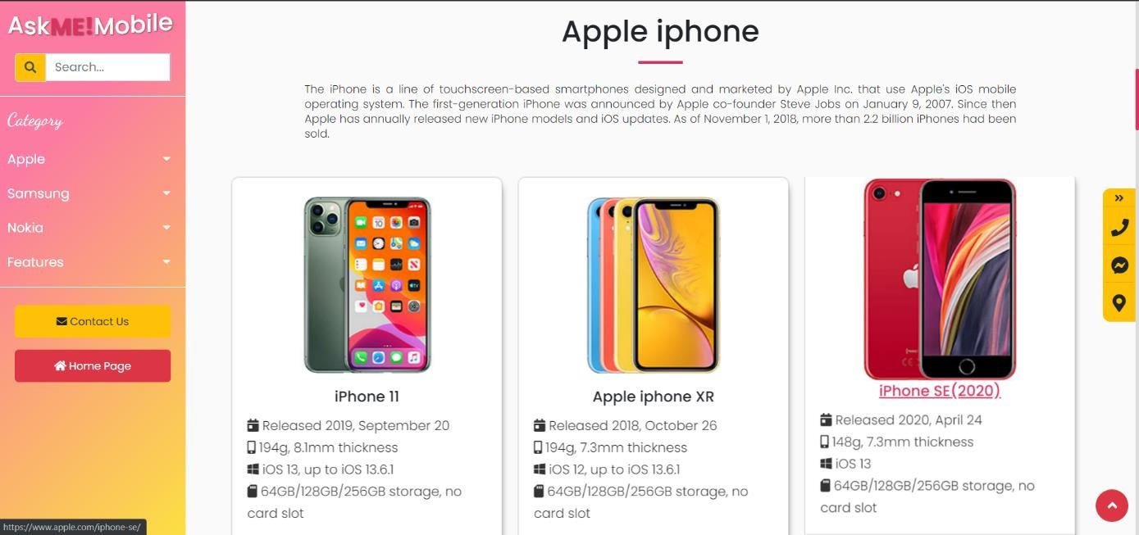

CTA panel to only appear when scrolling down below the Hero Banner but on top of footer.

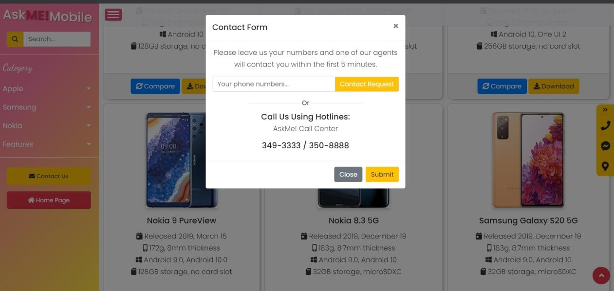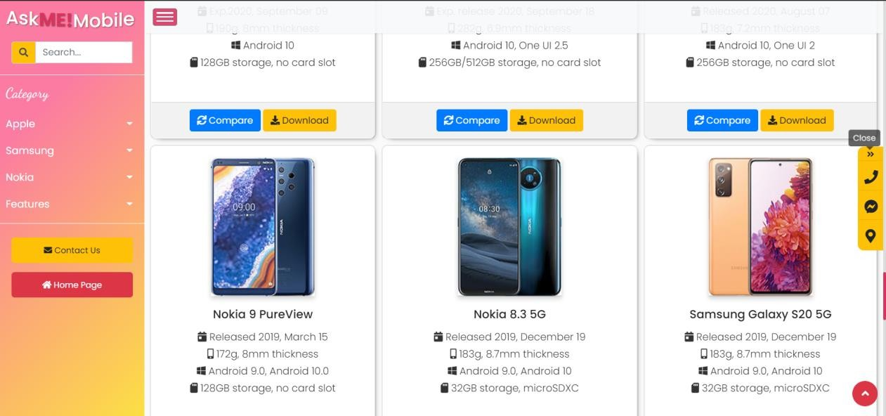

Clicking the side button will open modals. The top button will remove the CTA panel.

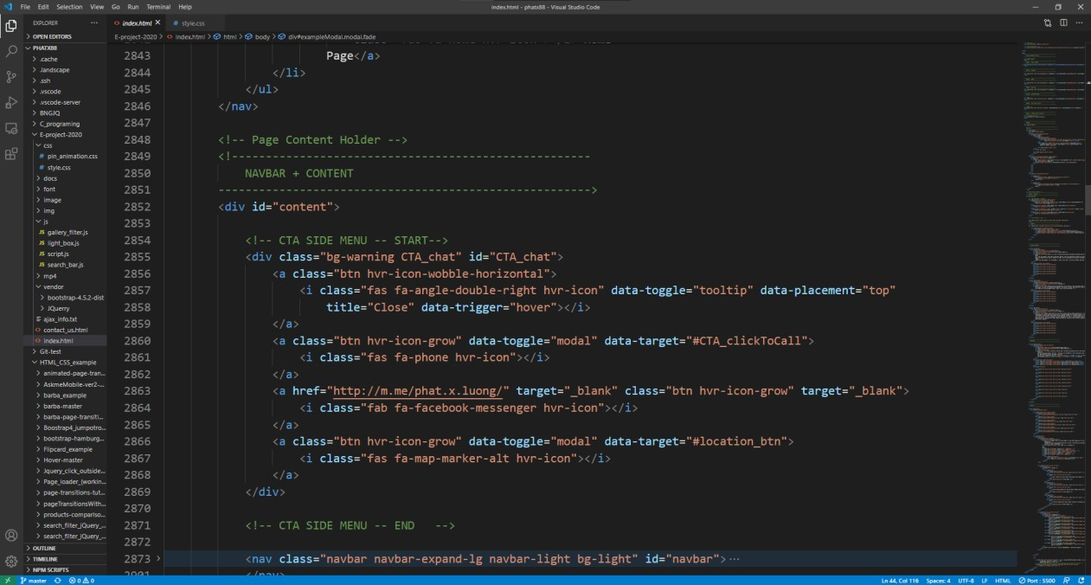HTML code:

CSS code:

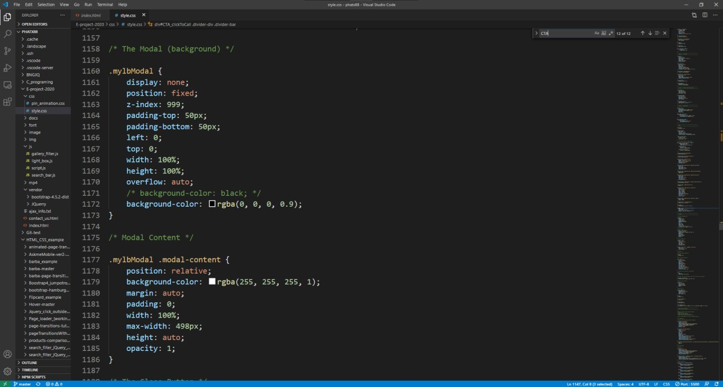

* 1. **Product Details Page**

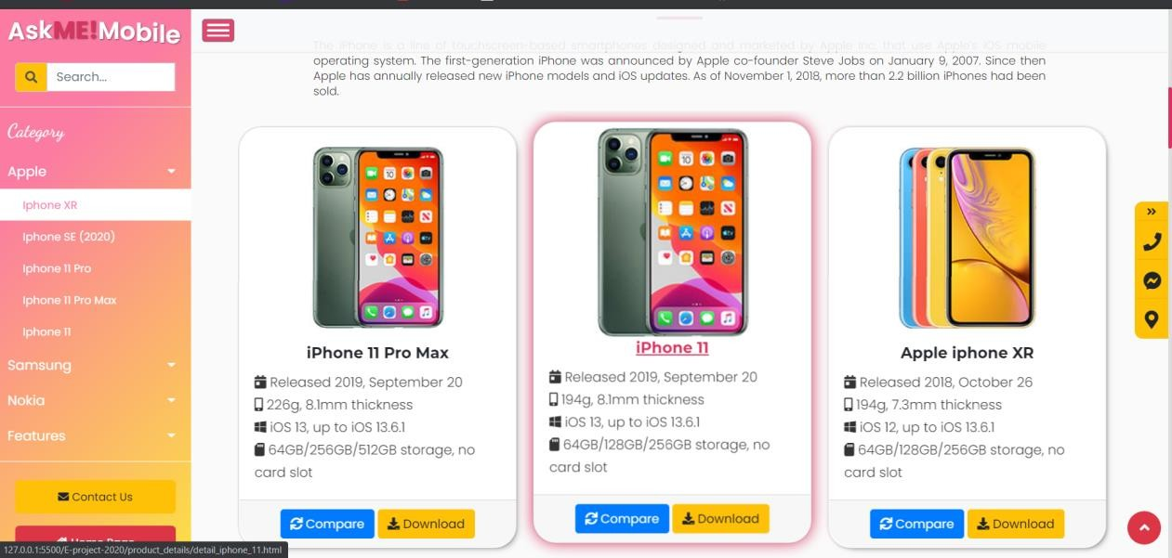We created a html page detailing product’s features for each of the phone models on our website.

* + 1. **Youtube embedded promotional videos.**

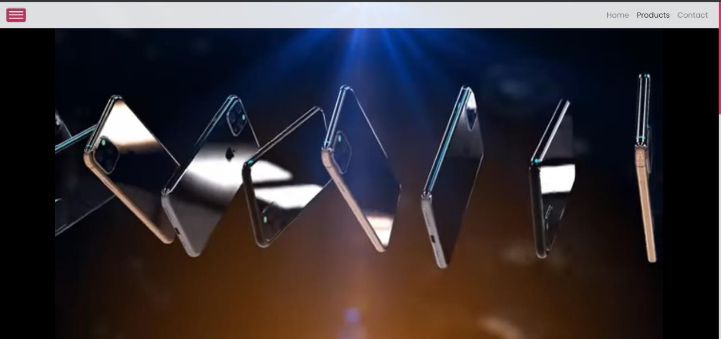

This is an embedded YouTube video showing a trailer of this

phone modal

HTML code:

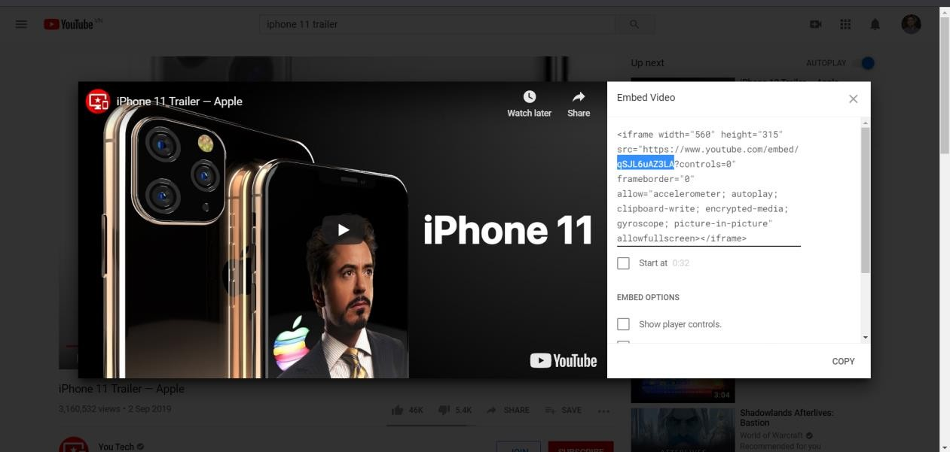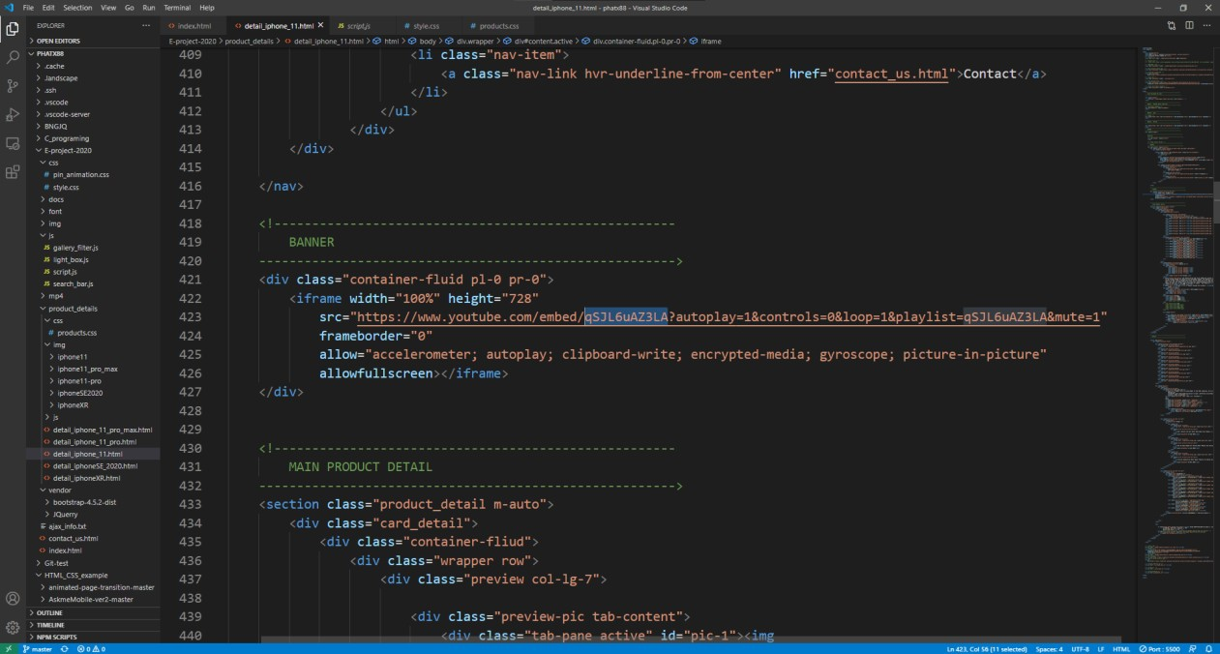

Applying video id to our HTML code

* + 1. **Product detail section**

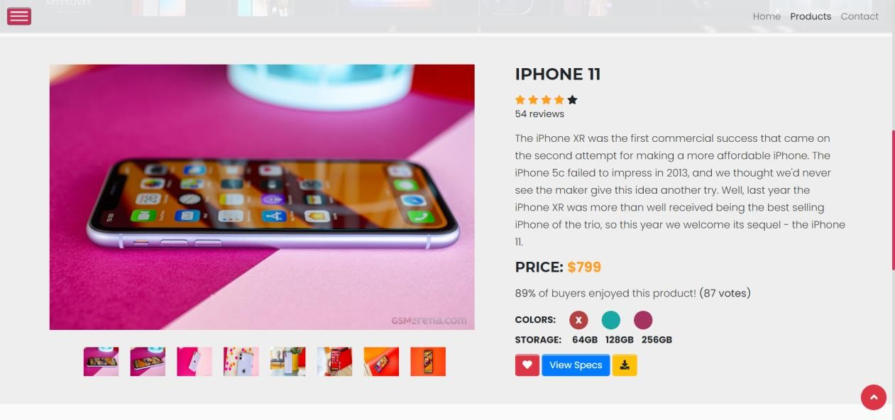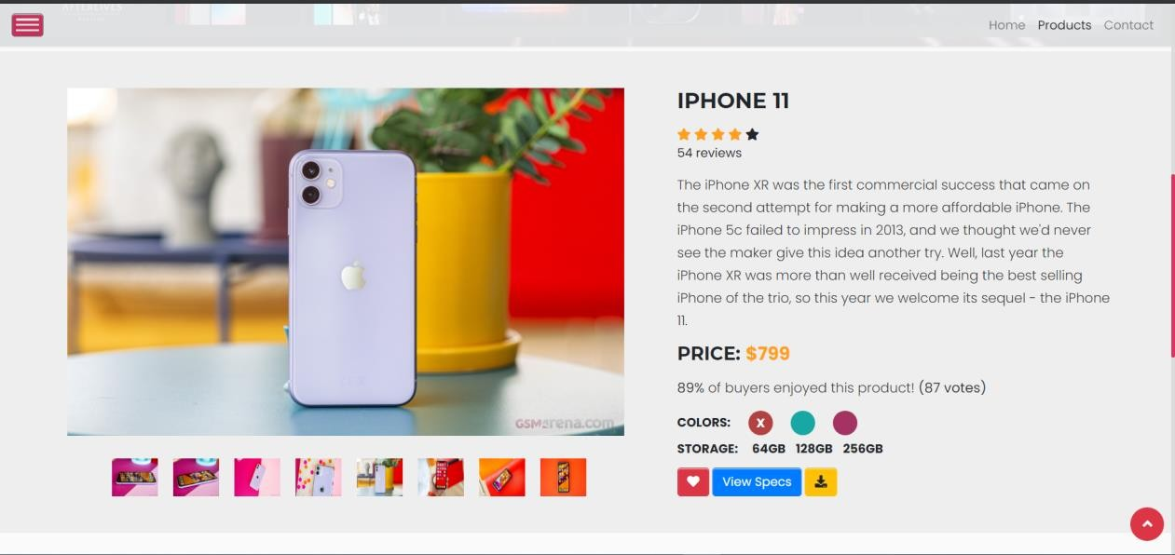

We used Bootstrap 4 “tab”, ‘data target’ attributes to build a bootstrap carousel, to show case the products screen shots

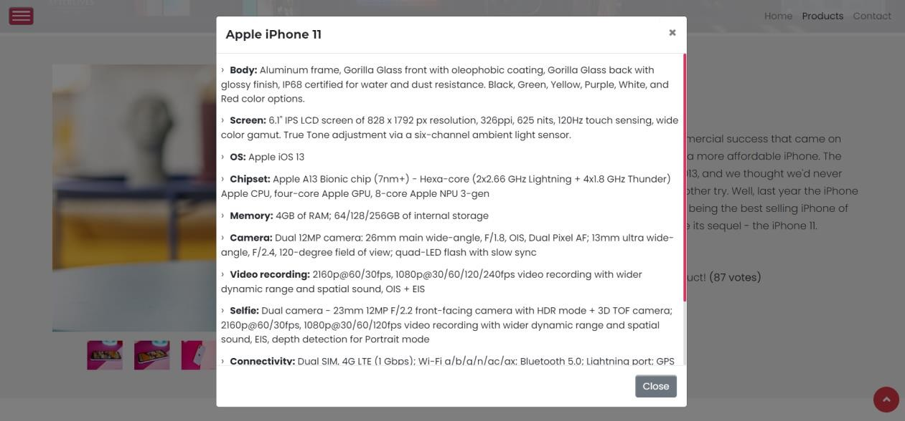

Clicking on ‘view specs’ will open more info about the phone model

HTML code:

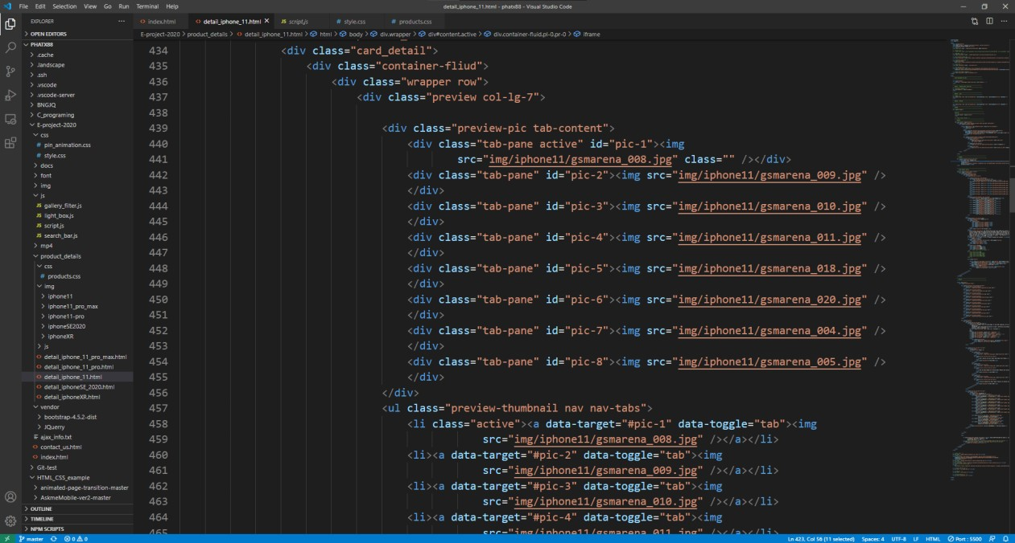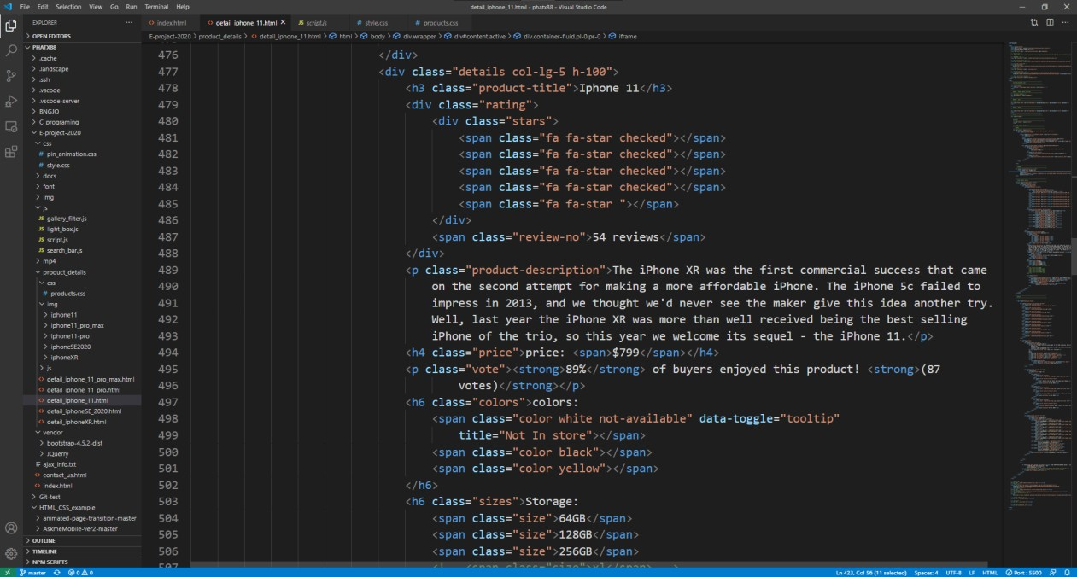

Adding Bootstrap “tab” data attributes to a toggleable/dynamic tabs for our carousel

* + 1. **Rating page**

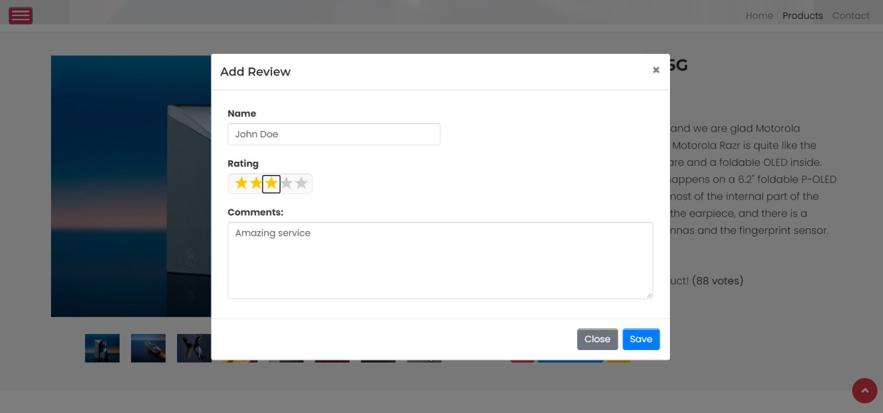

We created an “Add Review” section in boostrap modal container.

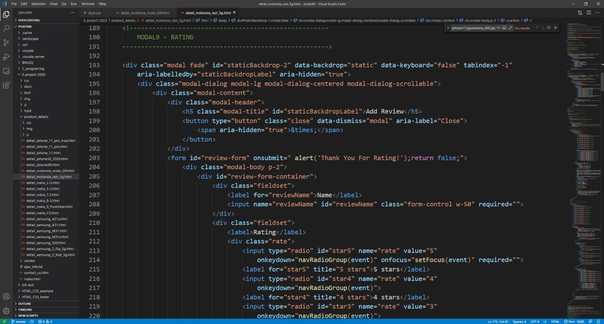HTML code:

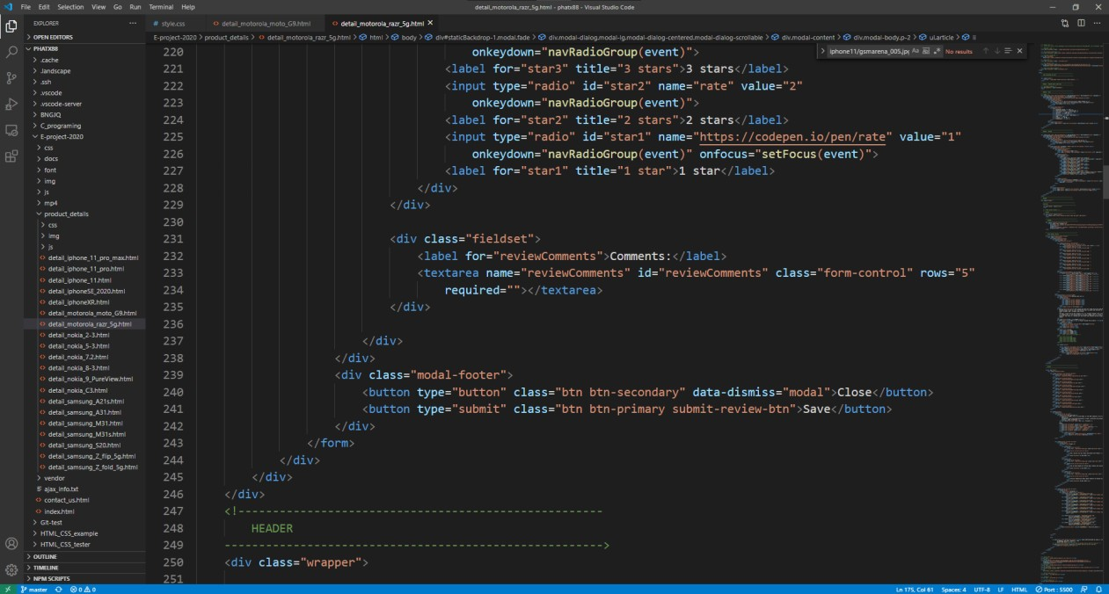

We use some a code on code.pen as a reference for creating the rating page.

CSS code:

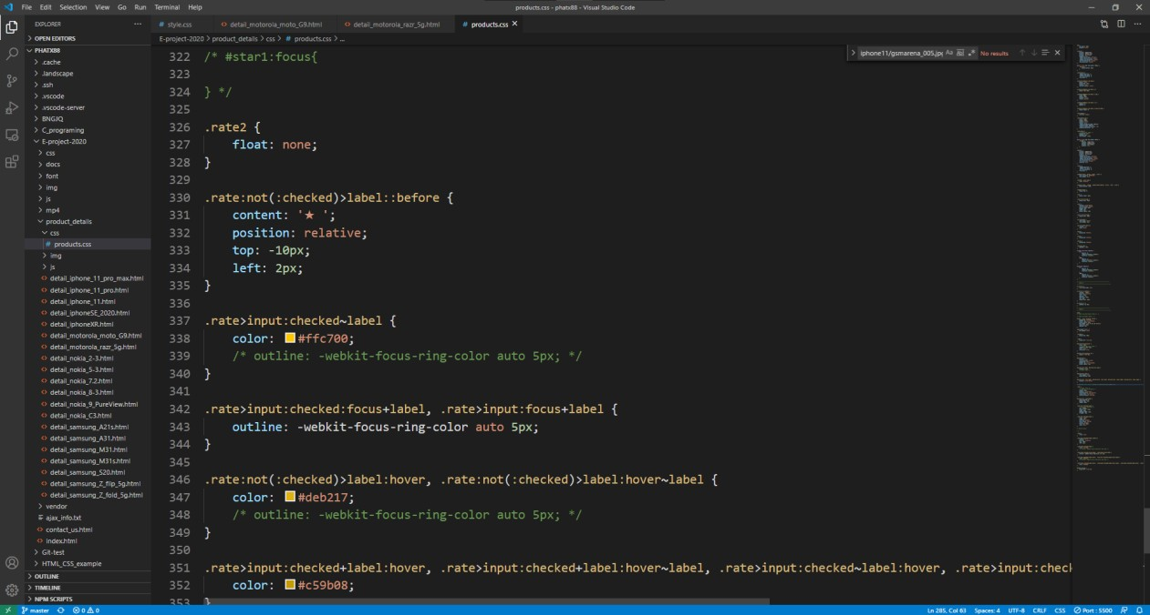

CSS code to add “star” when checking on input radio for rating.

JS code:

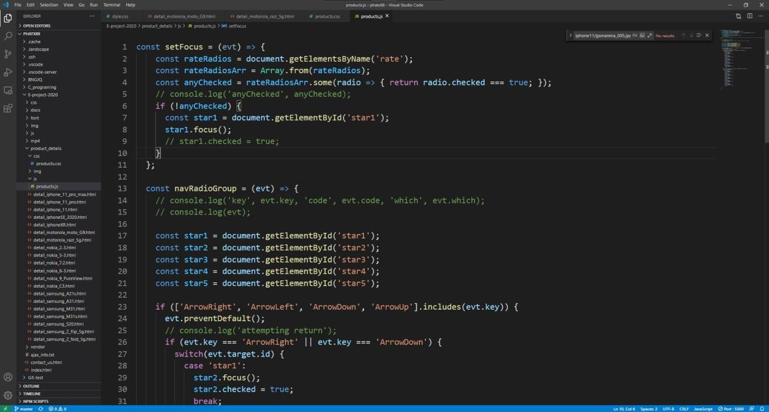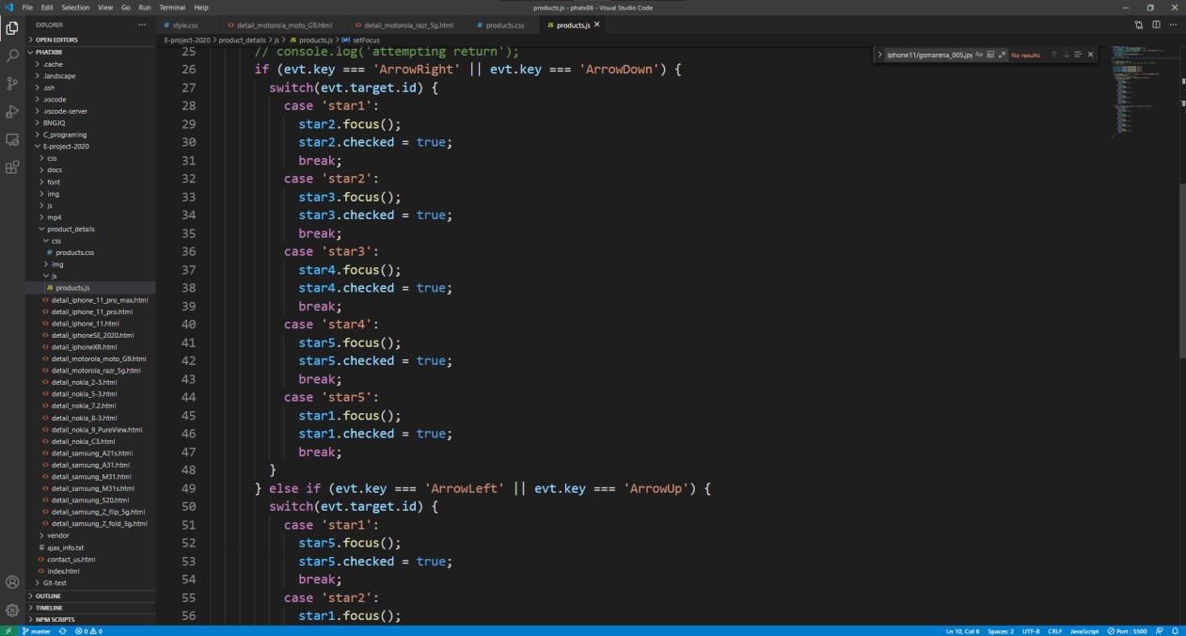

Code to handle focus and input keys for star rating using “left, right, up, down” arrows

* 1. **Contact Us Page**
     1. **Contact Us - Hero Banner –**

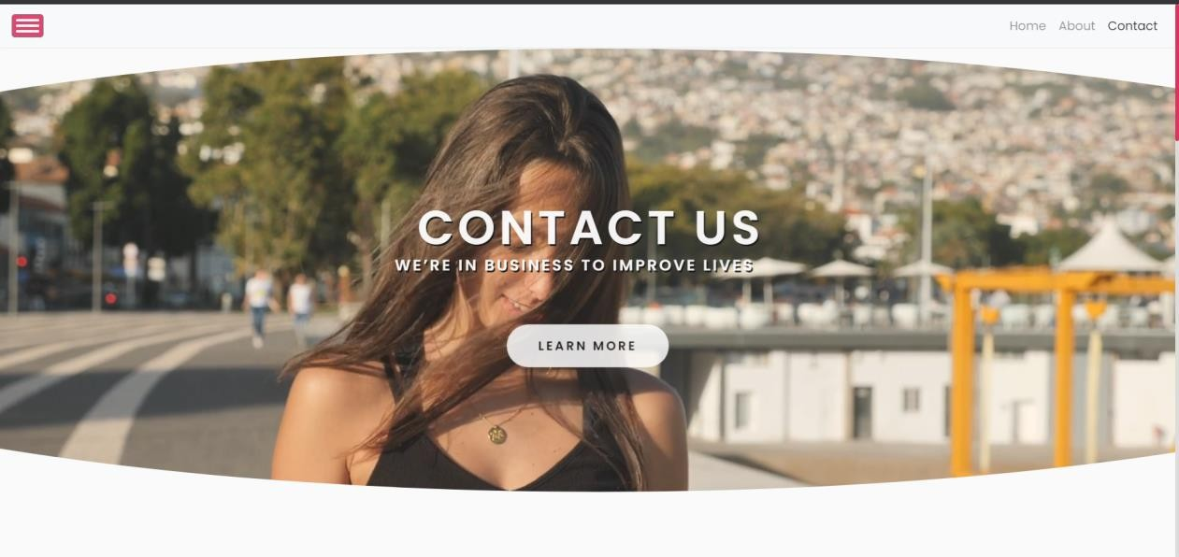

HTML code:

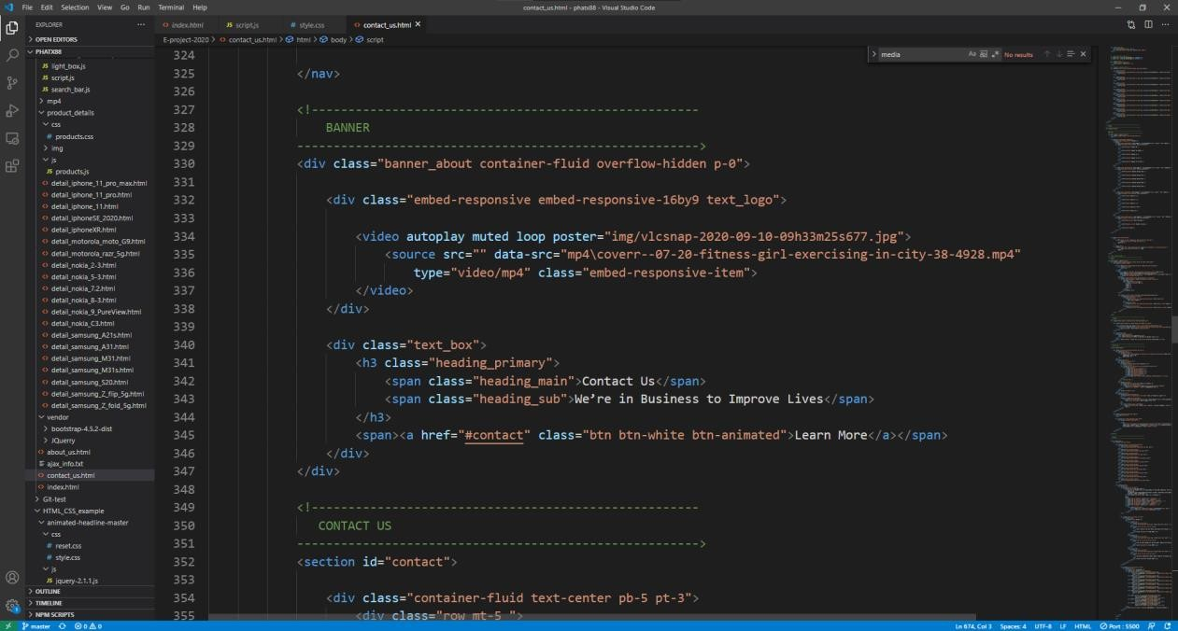

CSS code:

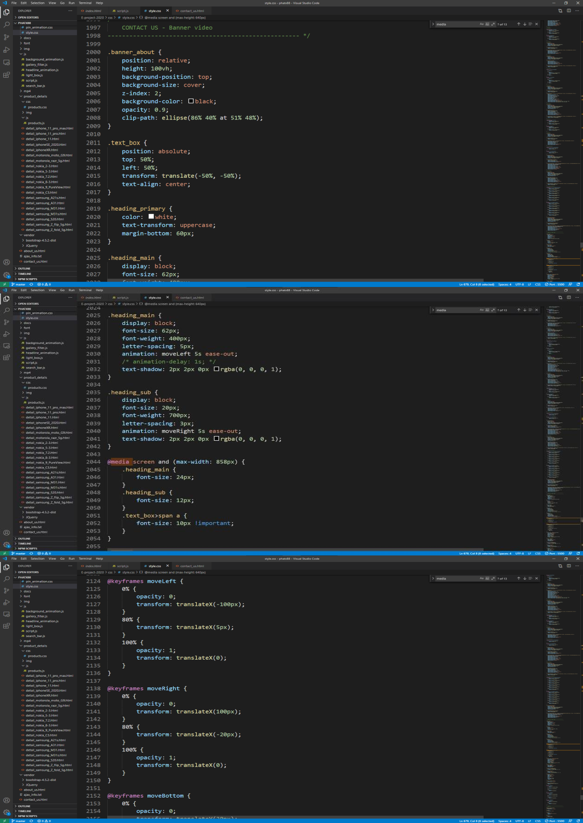

JS code:

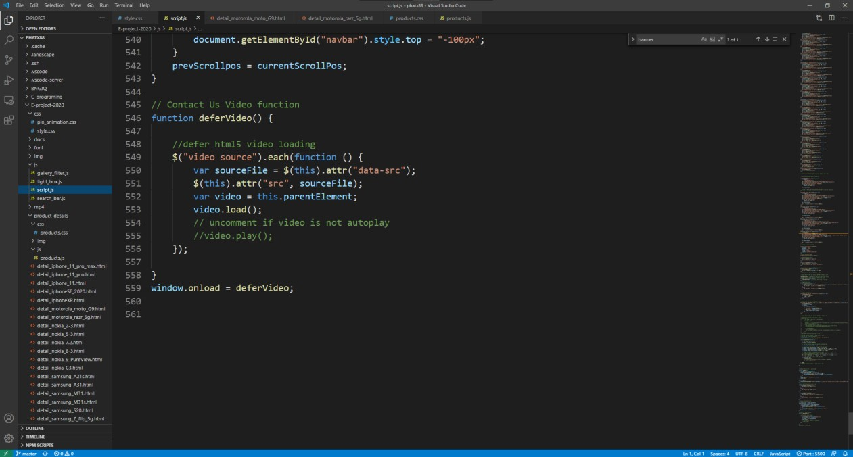

* + 1. **Contact Us – Feedback & Inquiries –**

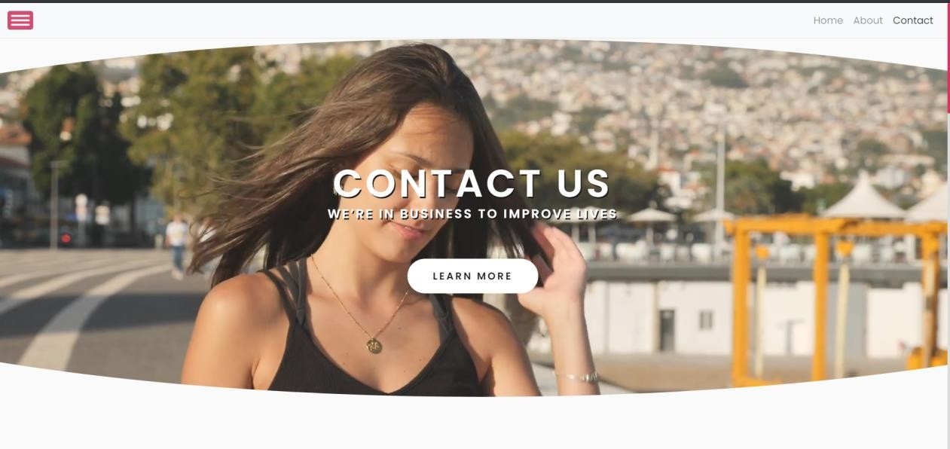

Clicking “learn more” button will scroll down view window to main content

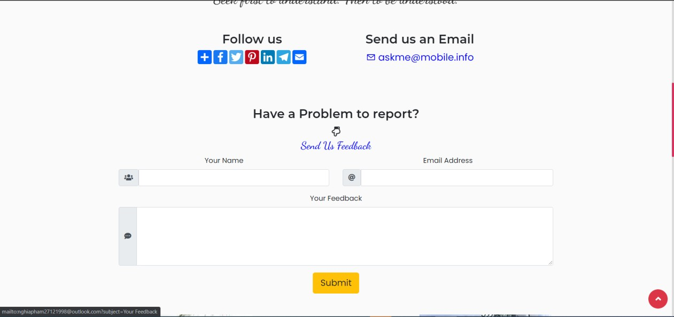

We use Ajax “XMLHTTP request ” command to create the feedback session in this page

HTML code:

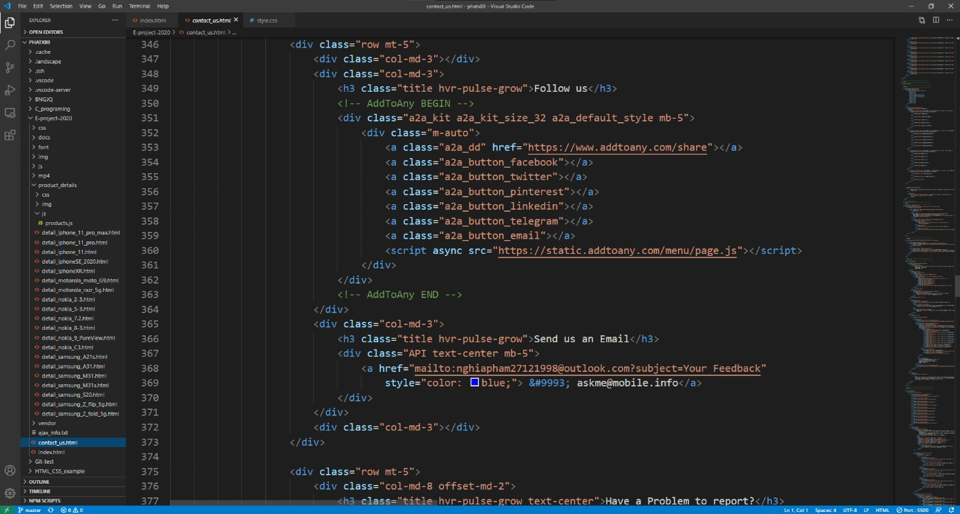

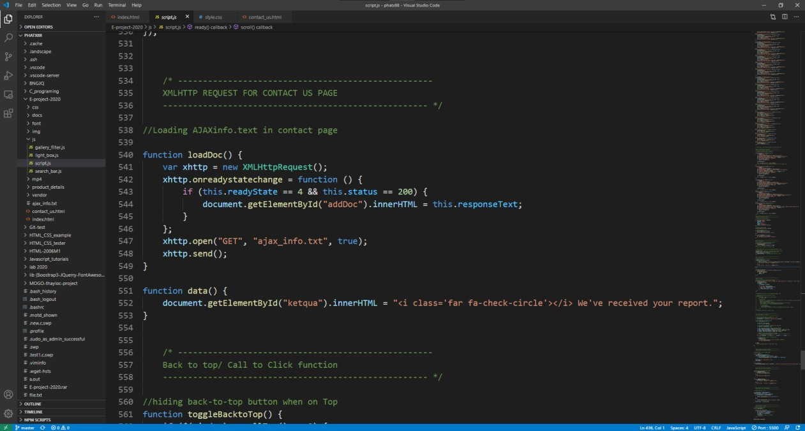JS code:

Ajax text file:

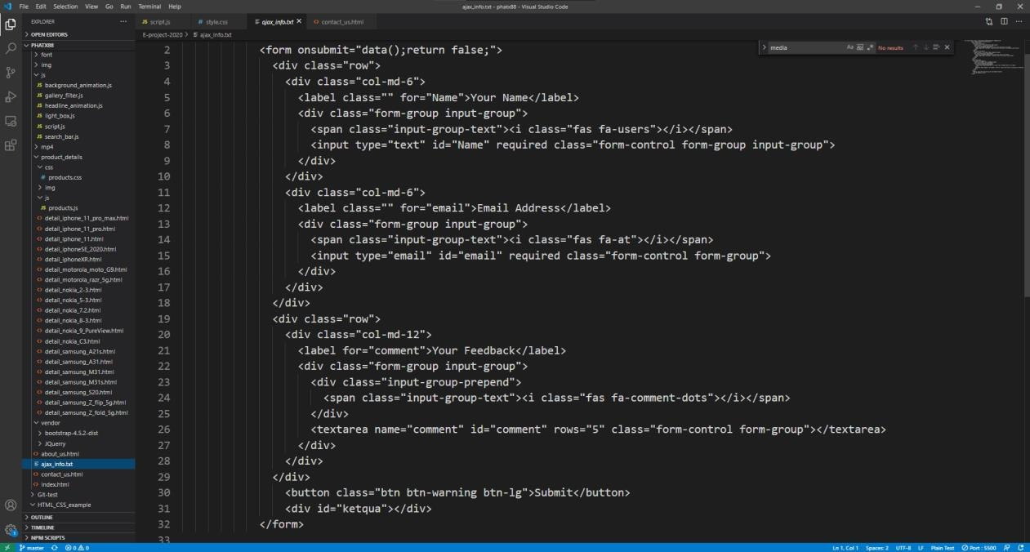

* + 1. **Contact Us – Geolocation/Google Map**

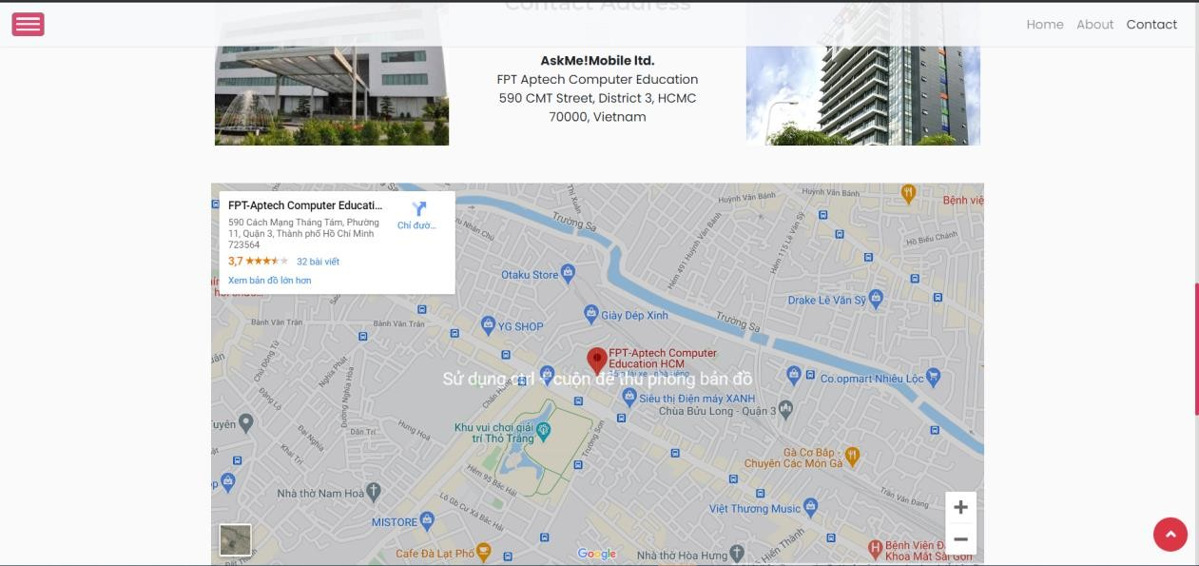

HTML code:

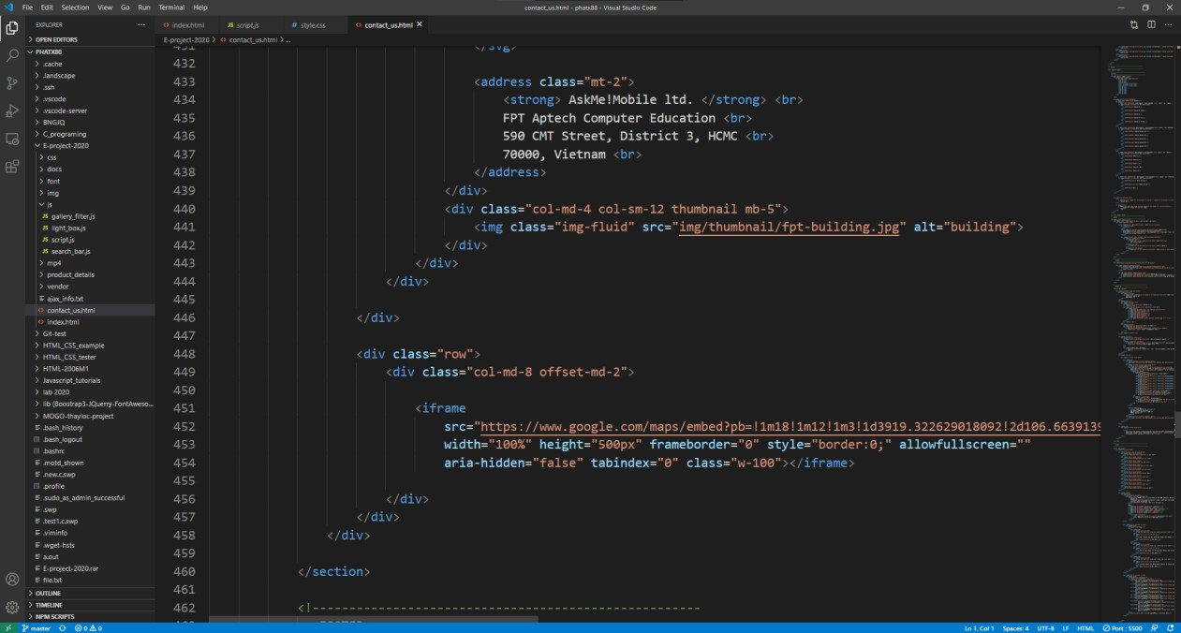

We embedded the code from Google map to use to show our office location

* 1. **Footer**

Using Bootstrap grid system, we created a visually stimulating footer session

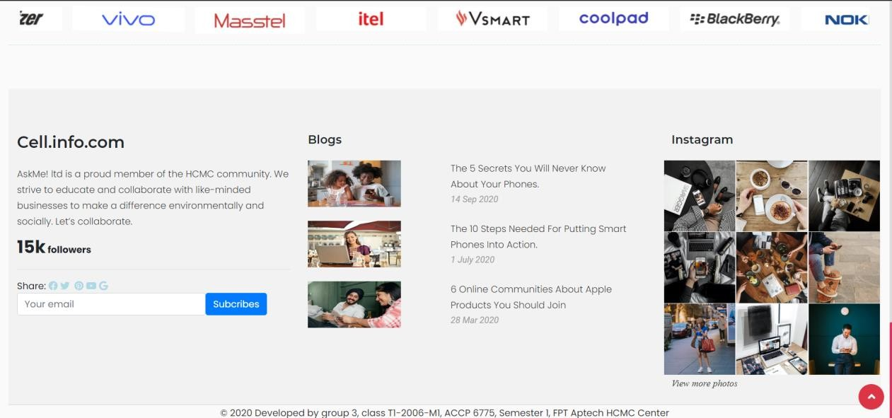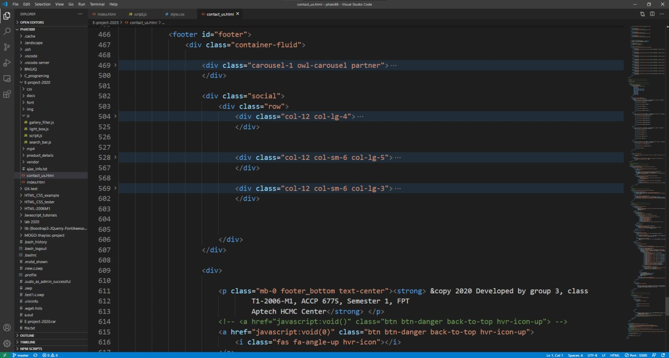

* + 1. **Footer – Bootstrap Layout**

This part use owl carousel

HTML code:

Built-in light box gallery & Back_to_top button

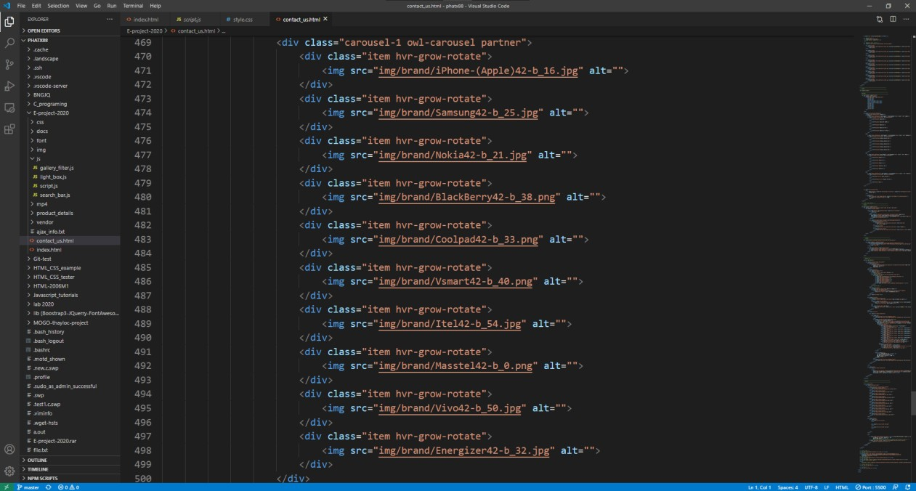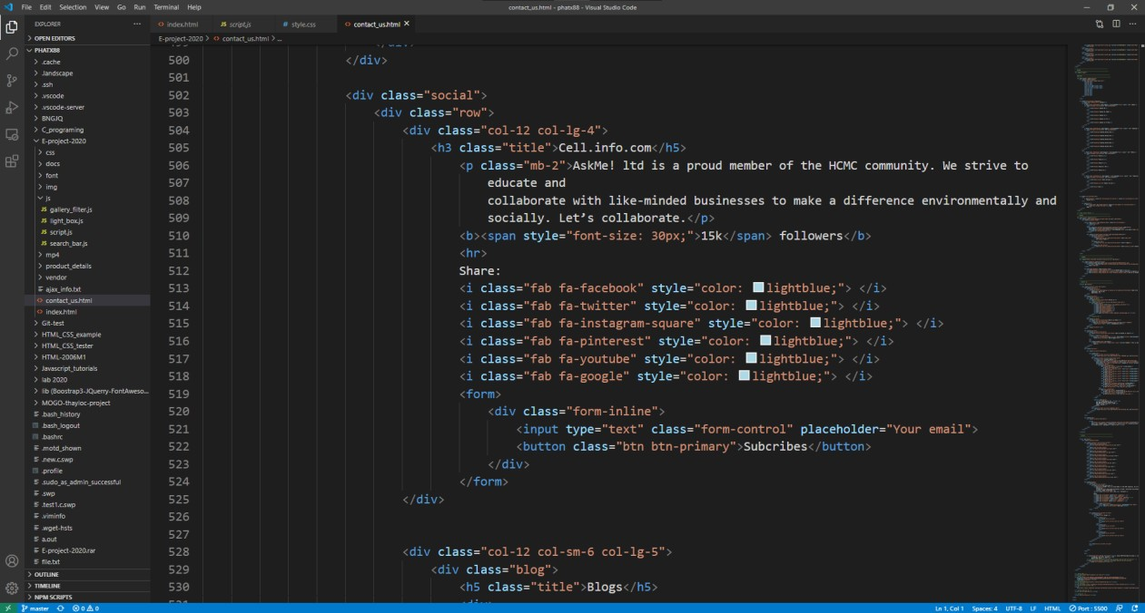

Owl carousel session.

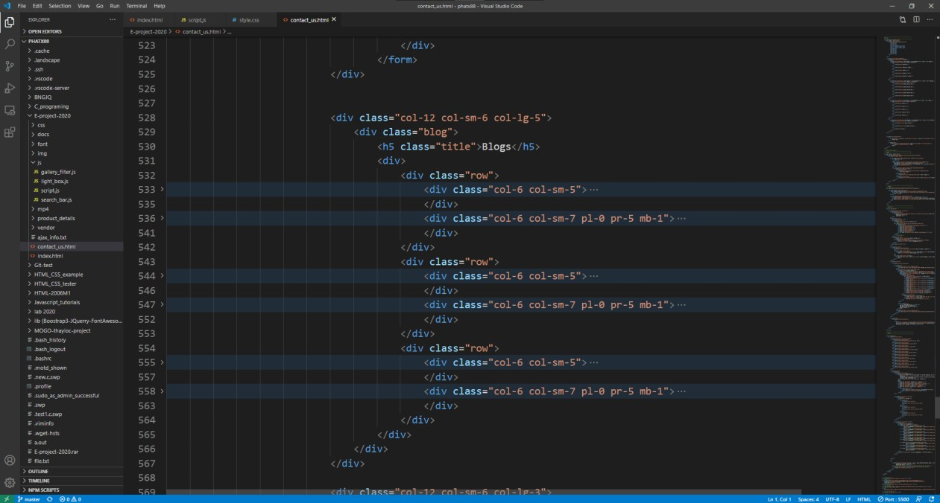

JS code:

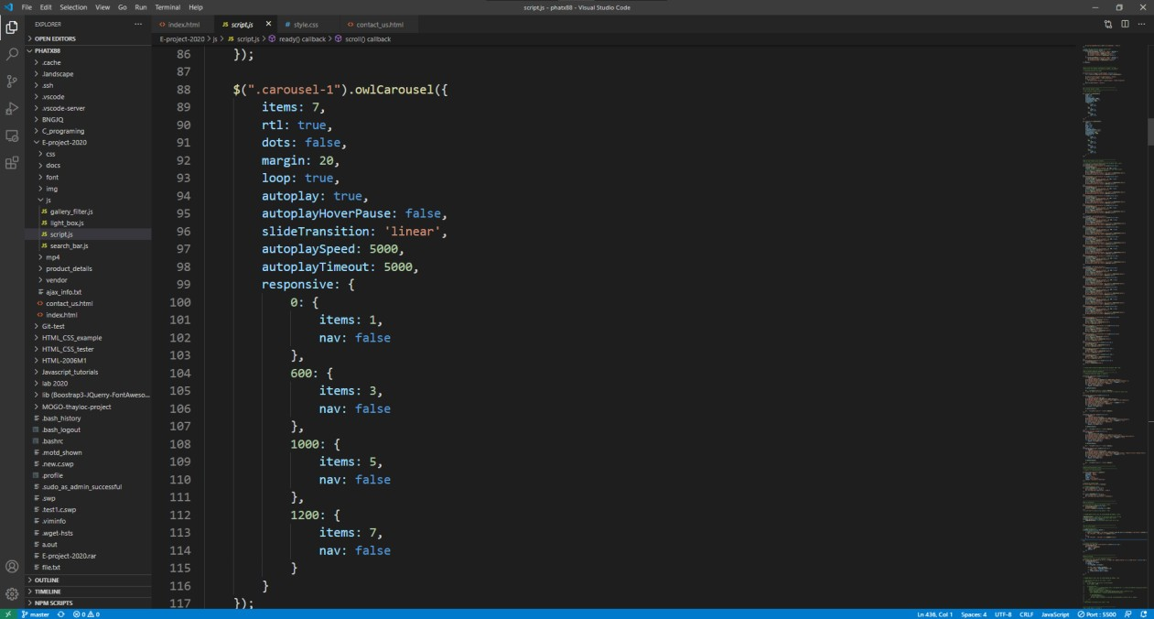

Custom owl carousel jQuery for footer

* + 1. **Footer – Lightbox Gallery**

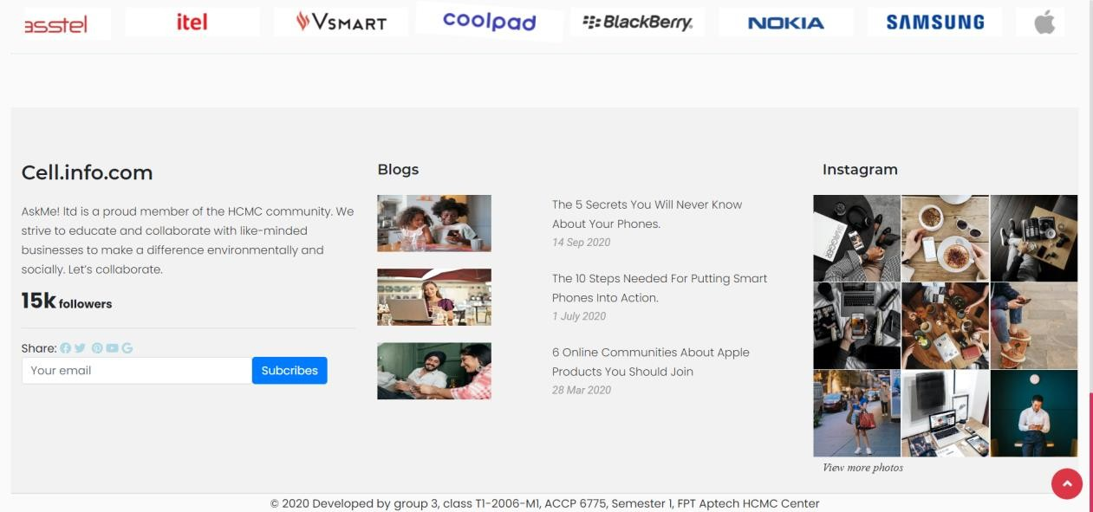

Clicking here will open a lightbox gallery. We used W3C sample code to built

the modal.

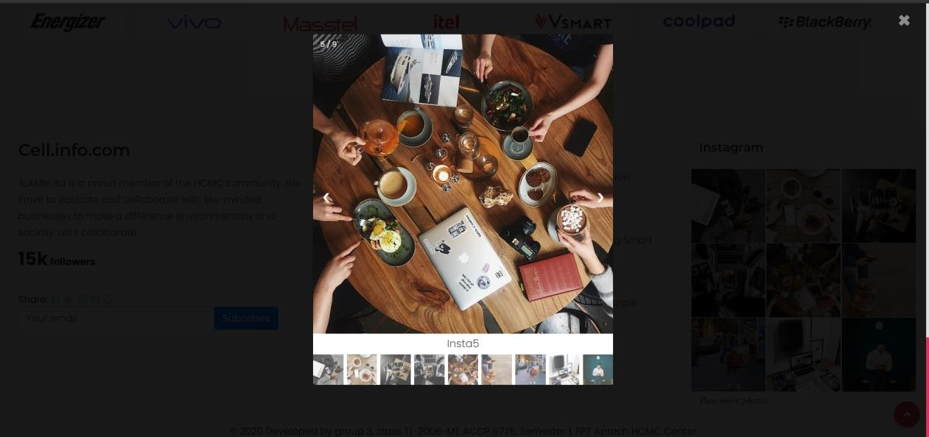

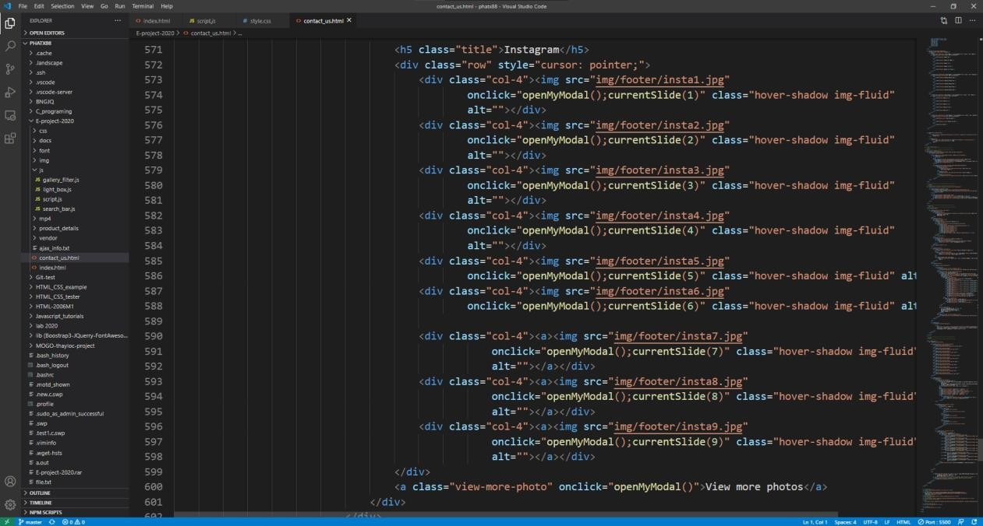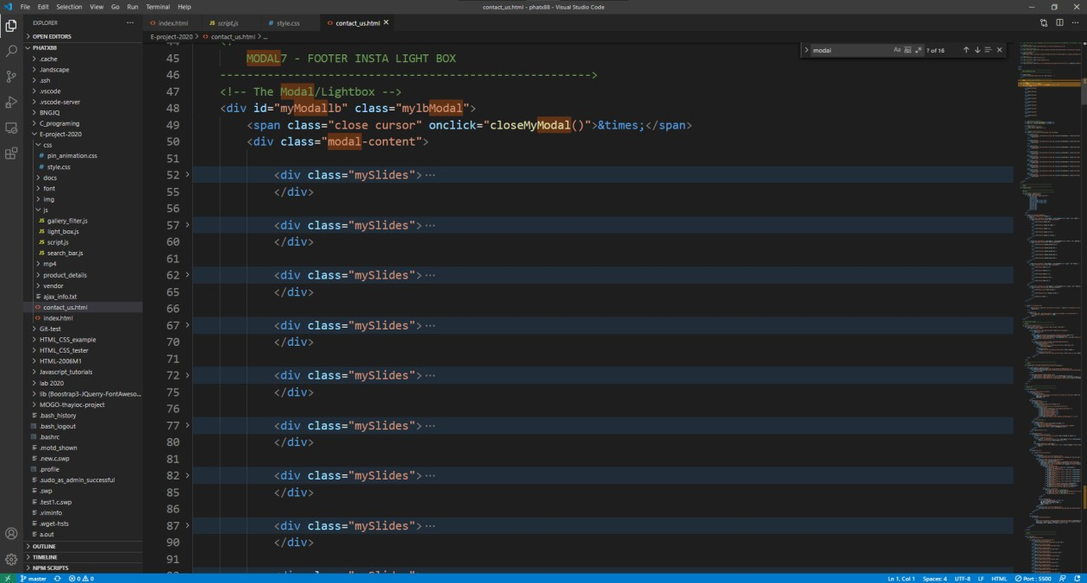HTML code:

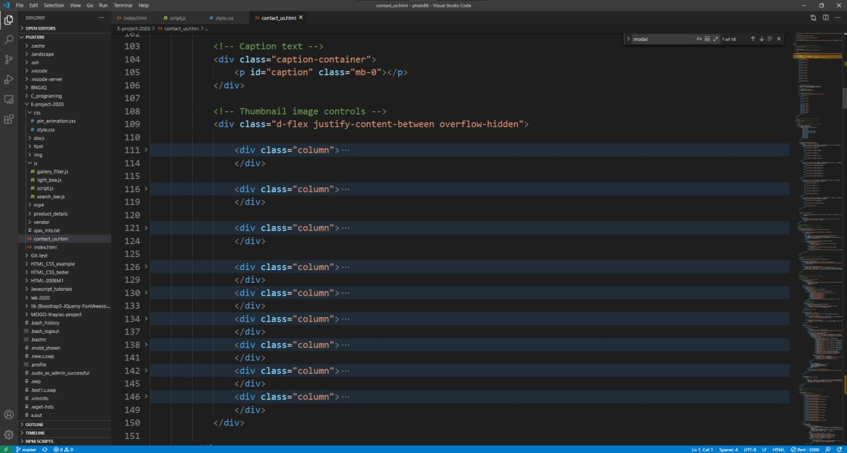

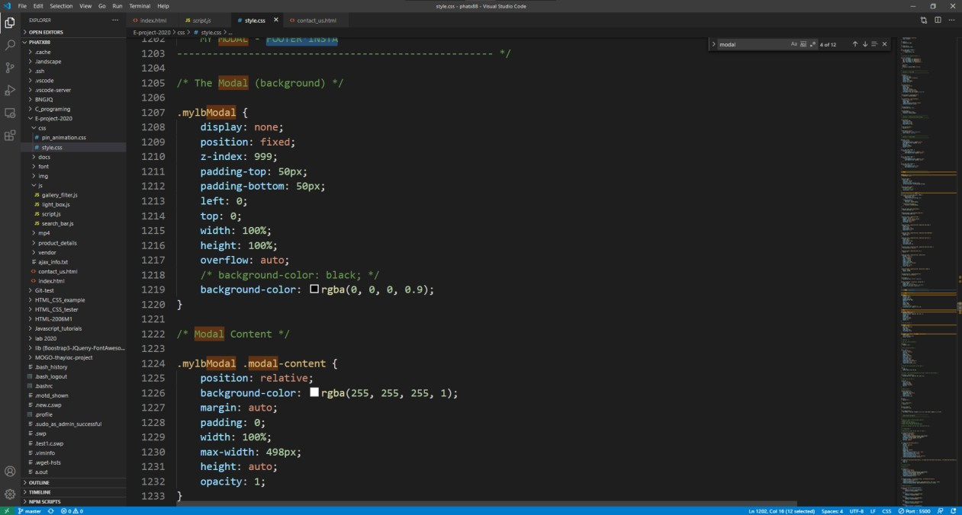CSS code:

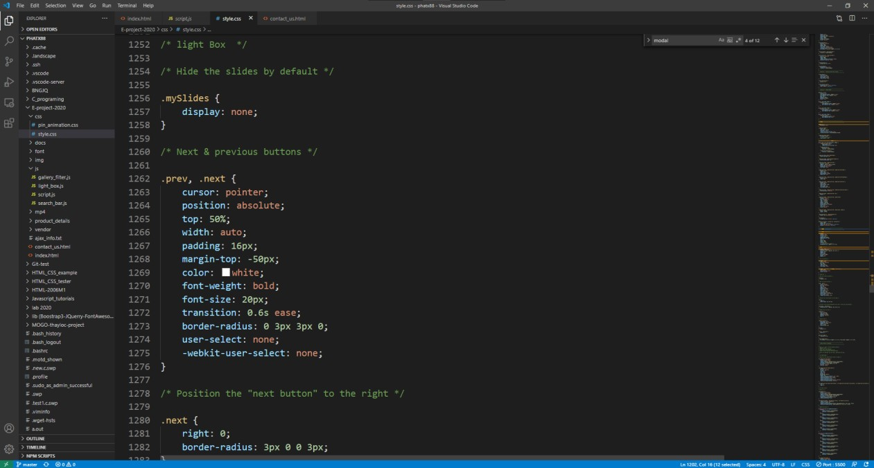

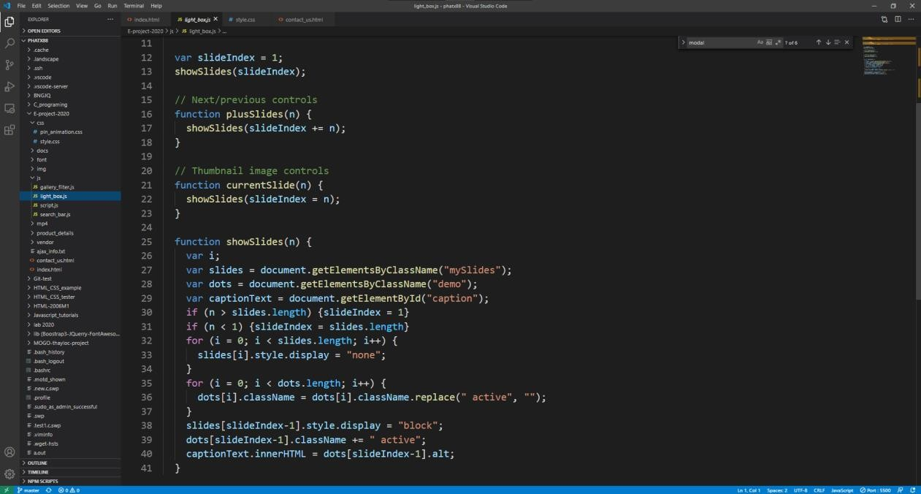JS code:

* 1. **Miscellaneous CSS/Animation Modules**
     1. **Hover.css by Ian Lunn**

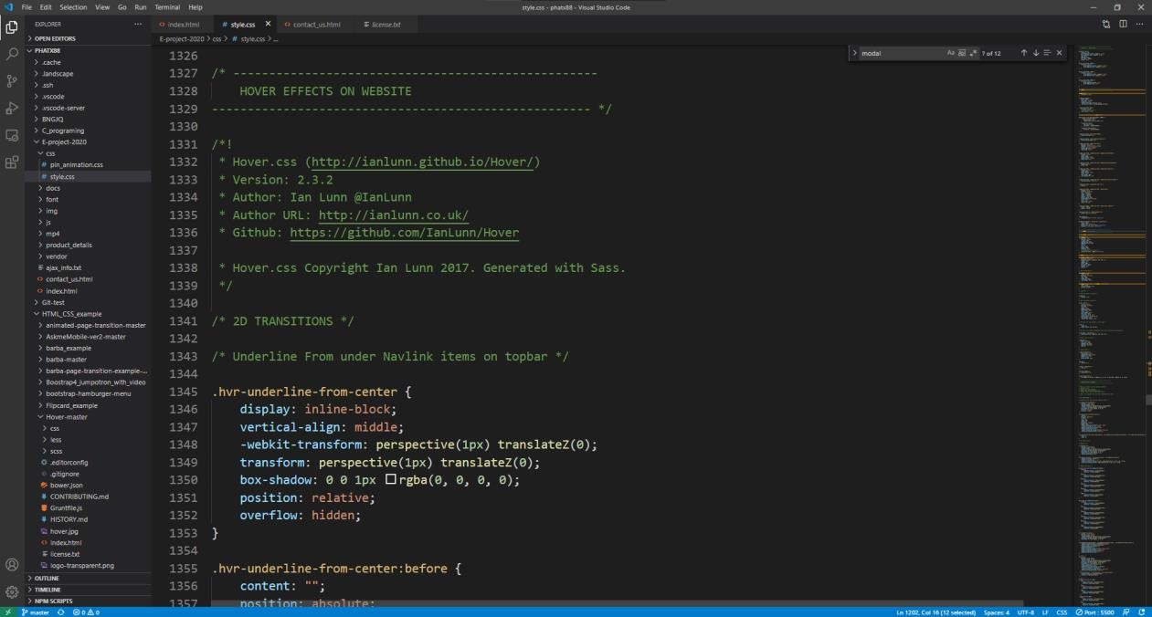CSS code:

* + 1. **Pin Construction Animation by Nikolay Talanov**

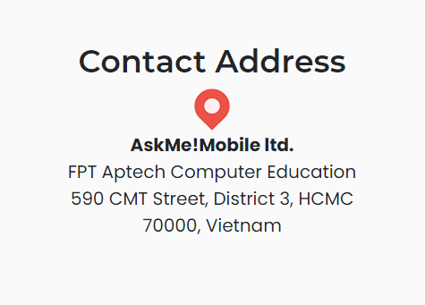

HTML code:

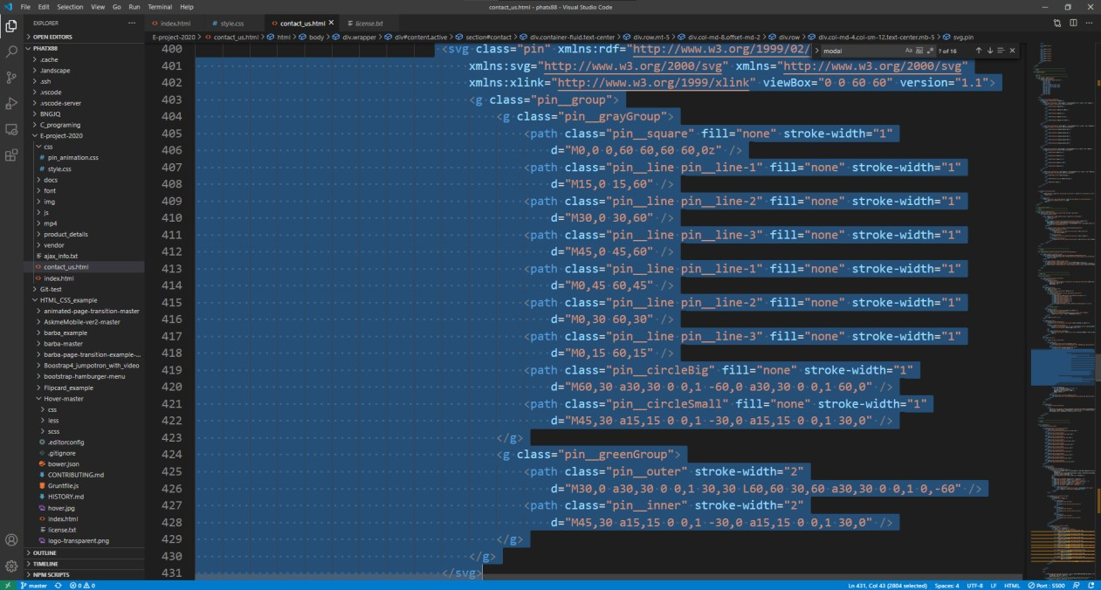

# TASK SHEET 2

|  |  |  |  |  |  |  |
| --- | --- | --- | --- | --- | --- | --- |
| **Project Ref No.** | **Project Title – Ask Me Mobile** | **Activity Plan Prepared**  **by** | **Date of preparation of Activity Plan** | | | |
| **Task** | **Actual Start Date** | **Actual Days** | **Teammate Names** | **Status** |
| Brainstorming ideas for layouts and Project  Objectives. | | Phát, Triều, Nghĩa | 05/09/2020 | 1 day | Phát, Triều, Nghĩa | Completed |
| Draw site maps and  architecture design. | | Phát | 03/09/2020 | 1 days | Phát | Completed |
| Wire framing general page  layout. | | Phát, Triều | 05/09/2020 | 4 days | Phát, Triều | Completed |
| Collect static assets (pictures,  mp4, documentation) | | Phát, Triều,  Nghĩa | 05/09/2020 | 3 days | Phát, Triều,  Nghĩa | Completed |
| Design & Build Home Page. | | Phát | 03/09/2020 | 12 days | Phát | Completed |
| Design & Build Contact Us  Page. | | Triều,  Nghĩa | 05/09/2020 | 4 days | Nghĩa | Completed |
| Design & Build About Us  Page. | | Nghĩa | 08/09/2020 | 4 days | Triều,  Nghĩa | Completed |
| Design & Build Footer  Session. | | Triều | 12/09/2020 | 5 days | Triều | Completed |
| Design & Build Product Detail Pages. | | Phát, Nghĩa,  Triều | 19/09/2020 | 7 days | Phát, Nghĩa,  Triều | Completed |
| Write project report Review 1 | | Phát | 09/09/2020 | 3 days | Phát | Completed |
| Testing UI. | | Triều,  Nghĩa | 15/09/2020 | 3 days | Triều | Completed |
| Testing Responsiveness. | | Phát, Triều,  Nghĩa | 15/09/2020 | 10 days | Triều,  Nghĩa | Completed |
| Final Testing. | | Triều,  Nghĩa | 26/09/2020 | 3 days | Triều,  Nghĩa | Completed |
| Write project report Review 2 | | Phát | 17/09/2020 | 8 days | Phát | Completed |

# CHECKLIST VALIDATION

|  |  |  |
| --- | --- | --- |
| **Task**  **No.** | **Requirement** | **Validation** |
| 1 | The Home Page should be neatly created with proper logo, menu and images. | Yes |
| 2 | A Menu should be created which would categorize all the information about the features provided in the Site For e.g. a Menu for Various Cell phones, a Menu for Features of Cell phones etc.  etc. something like that. | Yes |
| 3 | The information should be categorized according to the Brand names of Mobiles like if a User wants to see only Nokia Phones then  he click on Some Nokia Link/button etc. and he will see only That Brand phones and so on. | Yes |
| 4 | A Brief summary of features of Individual phones should be displayed on the Web Page along with the Cell phone but detailed Features should be stored in Individual Word documents which can be downloaded or viewed by the User who wishes to see the same. | Yes |
| 5 | A Comparison Web Page should also be there where there is Phone comparisons done with various models of same brand or various models of various brands. | Yes |
| 6 | The Comparison information should be provided in Tabular format comparing the features of different phones. | Yes |
| 7 | This information would be for 5 Phones of similar brands and 2 phones of different brands for 1 month and then it will change so for the time being the Page should handle the above requirement. | Yes |
| 8 | The Colour Schemes should be soothing, more of Pastel Colours can be chosen for the same. | Yes |
| 9 | When a particular brand phones are being displayed the background image of the Web page should show the Logo of that brand for e.g. if Nokia Phones are being displayed then that page should have the  Logo of NOKIA as the background image and the same in case of other Brands. | Yes |
| 10 | There should be a “Contact Us” page which will have the Address of the Company and the mail address which when clicked will invoke the local mail client from where they can send an email. Address of the Company should be displayed using GeoLocation API (eg.  GoogleMaps) | Yes |
| 11 | The information on the mobile phones and all can be picked up from the Sites of Nokia, Samsung etc. | Yes |
| 12 | Make use of layers, buttons and modals components of Bootstrap & HTML to avoid creation of html pages. | Yes |
| 13 | Review the appearance and organization of the site. | Yes |
| 14 | Checking Responsive for small and medium screen. | Yes |

# REFERENCES

* + - 1. Bootstrap 4 Tutorial. <https://www.w3schools.com/bootstrap4/default.asp>
      2. Bootstrap 4 documentation. <https://getbootstrap.com/docs/4.5/getting-started/introduction/>
      3. Jquery API documentation. <https://api.jquery.com/>
      4. The Gioi Di Dong websites. <https://www.thegioididong.com/>
      5. Apple iphone websites. <https://www.apple.com/iphone/>
      6. Samsung Galaxy websites. <https://www.samsung.com/vn/smartphones/galaxy-s20/>
      7. Nokia websites. <https://www.nokia.com/phones/en_int/android-phones>
      8. Motorola websites. <https://www.motorola.in/smartphones-razr/p>
      9. GsmArena. <https://www.gsmarena.com/>
      10. W3C Schools code snippets how to. <https://www.w3schools.com/howto/default.asp>
      11. 4k HD desktop wallpaper crafter. <https://wallpapercrafter.com/>
      12. Owl.Carousel.js. <https://owlcarousel2.github.io/OwlCarousel2/>
      13. CSS gradient color generator. Gradient backgrounds. [https://cssgradient.io/gradient-](https://cssgradient.io/gradient-backgrounds/) [backgrounds/](https://cssgradient.io/gradient-backgrounds/)
      14. Coverr free stock video footage. <https://coverr.co/>
      15. Hover.css by Ian Lunn. <https://ianlunn.github.io/Hover/>
      16. Pin construction animation by Nikolay Talanov. <https://codepen.io/suez/pen/doMKLP/>
      17. Stackoverflown: “how to detect escape key with js”. [https://stackoverflow.com/questions/3369593/how-to-detect-escape-key-press-with-pure-js-or-](https://stackoverflow.com/questions/3369593/how-to-detect-escape-key-press-with-pure-js-or-jquery) [jquery](https://stackoverflow.com/questions/3369593/how-to-detect-escape-key-press-with-pure-js-or-jquery)
      18. W3c how to create full-screen video background. <https://www.w3schools.com/howto/howto_css_fullscreen_video.asp>
      19. Smooth scrolling – CSS tricks. <https://css-tricks.com/snippets/jquery/smooth-scrolling/>
      20. Restart css animation – CSS tricks. [https://css-tricks.com/restart-css-](https://css-tricks.com/restart-css-animation/#%3A~%3Atext%3DWhat%20you%20really%20need%20to%2Citself%2C%20then%20remove%20the%20original.%26text%3DThis%20same%20problem%20exists%20for%2Cbut%20then%20again%20on%20%3Ahover) [animation/#:~:text=What%20you%20really%20need%20to,itself%2C%20then%20remove%2](https://css-tricks.com/restart-css-animation/#%3A~%3Atext%3DWhat%20you%20really%20need%20to%2Citself%2C%20then%20remove%20the%20original.%26text%3DThis%20same%20problem%20exists%20for%2Cbut%20then%20again%20on%20%3Ahover) [0the%20original.&text=This%20same%20problem%20exists%20for,but%20then%20again%](https://css-tricks.com/restart-css-animation/#%3A~%3Atext%3DWhat%20you%20really%20need%20to%2Citself%2C%20then%20remove%20the%20original.%26text%3DThis%20same%20problem%20exists%20for%2Cbut%20then%20again%20on%20%3Ahover) [20on%20%3Ahover.](https://css-tricks.com/restart-css-animation/#%3A~%3Atext%3DWhat%20you%20really%20need%20to%2Citself%2C%20then%20remove%20the%20original.%26text%3DThis%20same%20problem%20exists%20for%2Cbut%20then%20again%20on%20%3Ahover)
      21. How to change position of scroll bar using CSS – GeeksforGeeks. [https://www.geeksforgeeks.org/how-to-change-the-position-of-scrollbar-using-](https://www.geeksforgeeks.org/how-to-change-the-position-of-scrollbar-using-css/#%3A~%3Atext%3DWe%20can%20use%20CSS%20%E2%80%9C%3A%3A%2Cposition%20of%20the%20scroll%2Dbar) [css/#:~:text=We%20can%20use%20CSS%20%E2%80%9C%3A%3A,position%20of%20the](https://www.geeksforgeeks.org/how-to-change-the-position-of-scrollbar-using-css/#%3A~%3Atext%3DWe%20can%20use%20CSS%20%E2%80%9C%3A%3A%2Cposition%20of%20the%20scroll%2Dbar)

[%20scroll%2Dbar.](https://www.geeksforgeeks.org/how-to-change-the-position-of-scrollbar-using-css/#%3A~%3Atext%3DWe%20can%20use%20CSS%20%E2%80%9C%3A%3A%2Cposition%20of%20the%20scroll%2Dbar)

* + - 1. Balsamiq Wire Frames. <https://balsamiq.com/wireframes/>